Unit 6 Lesson 16: Graphing from the Vertex Form

1 Math Talk: When $x$ Is -7 (Warm up)

Student Task Statement
Evaluate each expression when $x$ is -7:
$x+4$
$(x+4)^{2}$
$\text{-}(x+4)^{2}$
$\text{-}(x+4)^{2}+5$

2 Four Functions

Student Task Statement
- Complete the table of values for each function.
- $f(x)=(x−4)^{2}$
- $x$ | - 0 | - 1 | - 2 | - 3 | - 4 | - 5 | - 6 | - 7
- $f(x)$
- $g(x)=\text{-}(x−4)^{2}$
- $x$ | - 0 | - 1 | - 2 | - 3 | - 4 | - 5 | - 6 | - 7
- $g(x)$
- Use the completed tables to answer these questions:
  - What are the coordinates of the vertex of each graph? How can you tell?
  - Does the graph of function $f$ open up or down? How can you tell?
  - Does the graph of function $g$ open up or down? How can you tell?
- Suppose function $h$ is defined by $h(x)=(x−4)^{2}+5$ and function $j$ is defined by $j(x)=\text{-}(x−4)^{2}+5$. Make predictions about the graph of each function using the questions here. If you get stuck, try creating a tables of values.
  - What are the coordinates of the vertex of the graph of $h$ and $j$?
  - Which way—up or down—does the graph of each function open? How do you know?

3 Four More Functions

Student Task Statement
Here are some tables of values that represent quadratic functions.
$x$ | 2 | 3 | 4 | 5 | 6 | 7 | 8
$t(x)$ | -11 | -2 | 1 | -2 | -11 | -26 | -47
$x$ | -2 | -1 | 0 | 1 | 2 | 3 | 4
$u(x)$ | 13 | 4 | 1 | 4 | 13 | 28 | 49
$x$ | -1 | 0 | 1 | 2 | 3 | 4 | 5
$v(x)$ | 76 | 49 | 28 | 13 | 4 | 1 | 4
$x$ | -4 | -3 | -2 | -1 | 0 | 1 | 2
$w(x)$ | -47 | -26 | -11 | -2 | 1 | -2 | -11
- Make a rough sketch of a graph of each function. Label the vertex of each graph with its coordinates.
- 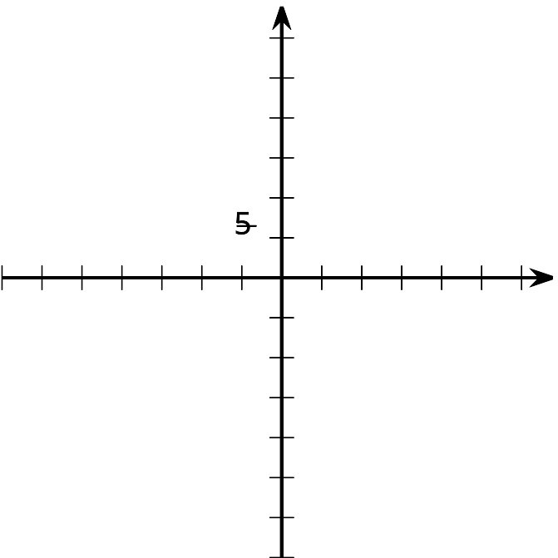

- Here are some expressions that define quadratic functions. Match each function $t$, $u$, $v$, and $w$ with an expression that defines it.
  - $3x^{2}+1$
  - $\text{-}3(x−4)^{2}+1$
  - $3(x−4)^{2}+1$
  - $\text{-}3x^{2}+1$

Activity Synthesis
© CC BY 2019 by Illustrative Mathematics®

