Lesson 2: Square Roots and Cube Roots
- Let’s think about square and cube roots.

2.1: It’s a Square
Find the area of square $ABCD$.

2.2: Squares and Their Side Lengths
- Complete the table with the area of each square in square units, and its exact side length in units.
- figure | - A | - B | - C | - D | - E
- area
- side length
- This table includes areas in square units and side lengths in units of some more squares. Complete the table.
- area | - 9 |  | - 23 |  | - 89
- side length |  | - 4 |  | - 6.4

Are you ready for more?
In the first question, all of the squares have vertices at grid points.
- Is there a square whose vertices are at grid points and whose area is 7 square units? Explain how you know.
- Is there a square whose vertices are at grid points and whose area is 10 square units? Explain how you know.

2.3: Cube It
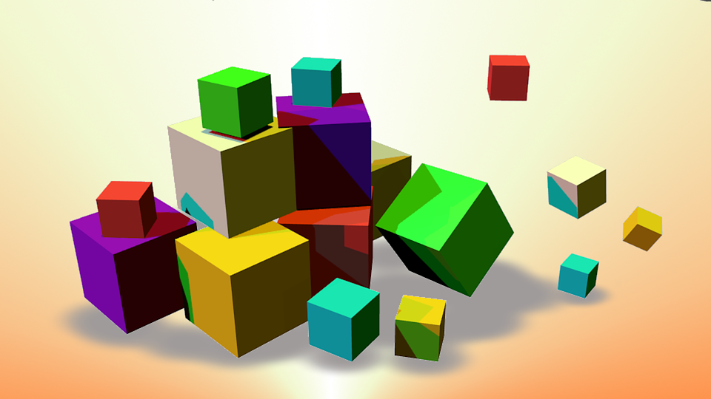
- A cube has edge length 3 units. What is the volume of the cube?
- A cube has edge length 4 units. What is the volume of the cube?
- A cube has volume 8 units. What is the edge length of the cube?
- A cube has volume 7 units. What is the edge length of the cube?
- $\sqrt[3]{1,​200}$ is between 10 and 11 because ${10}^{3}=1,​000$ and ${11}^{3}=1,​331$. Determine the whole numbers that each of these cube roots lies between:
- $\sqrt[3]{5}$ | - $\sqrt[3]{10}$ | - $\sqrt[3]{50}$ | - $\sqrt[3]{100}$ | - $\sqrt[3]{500}$

between | 1 and 2 | 2 and 3 | 3 and 4 | 4 and 5 | 5 and 6 | 6 and 7 | 7 and 8 | 8 and 9

Lesson 2 Summary
If a square has side length $s$, then the area is $s^{2}$. If a square has area $A$, then the side length is $\sqrt{A}$. For a positive number $b$, the square root of $b$ is defined as the positive number that squares to make $b$, and it is written as $\sqrt{b}$. In other words, ${\left(\sqrt{b}\right)}^{2}=b$. We can also think of $\sqrt{b}$ as a solution to the equation $x^{2}=b$. This square has an area of $b$ because its sides have length $\sqrt{b}$:
Similarly, if a cube has edge length $s$, then the volume is $s^{3}$. If a cube has volume $V$, then the edge length is $\sqrt[3]{V}$. The number $\sqrt[3]{a}$ is defined as the number that cubes to make $a$. In other words, ${\left(\sqrt[3]{a}\right)}^{3}=a$. We can also think of $\sqrt[3]{a}$ as a solution to the equation $x^{3}=a$. This cube has a volume of $a$ because its sides have length $\sqrt[3]{a}$:
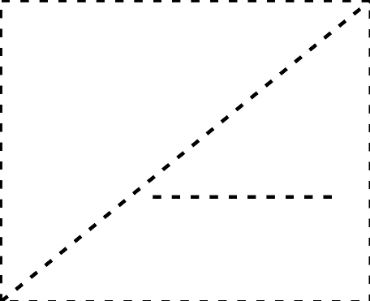
© CC BY 2019 by Illustrative Mathematics®

