Unit 2 Lesson 8 Cumulative Practice Problems
- In 2016, the cost of 2 ounces of pure gold was $2,640. Complete the double number line to show the cost for 1, 3, and 4 ounces of gold.
- 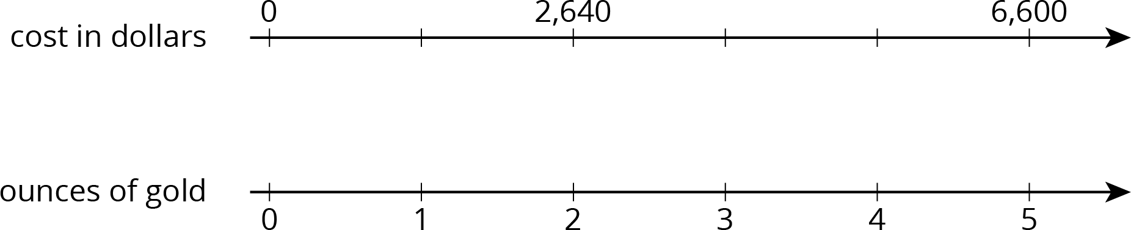
- The double number line shows that 4 pounds of tomatoes cost $14. Draw tick marks and write labels to show the prices of 1, 2, and 3 pounds of tomatoes.
- 4 movie tickets cost $48. At this rate, what is the cost of:
  - 5 movie tickets?
  - 11 movie tickets?
- Priya bought these items at the grocery store. Find each unit price.
  - 12 eggs for $3. How much is the cost per egg?
  - 3 pounds of peanuts for $7.50. How much is the cost per pound?
  - 4 rolls of toilet paper for $2. How much is the cost per roll?
  - 10 apples for $3.50. How much is the cost per apple?
- Clare made a smoothie with 1 cup of yogurt, 3 tablespoons of peanut butter, 2 teaspoons of chocolate syrup, and 2 cups of crushed ice.
  - Kiran tried to double this recipe. He used 2 cups of yogurt, 6 tablespoons of peanut butter, 5 teaspoons of chocolate syrup, and 4 cups of crushed ice. He didn’t think it tasted right. Describe how the flavor of Kiran's recipe compares to Clare's recipe.
  - How should Kiran change the quantities that he used so that his smoothie tastes just like Clare's?
- (From Unit 2, Lesson 3.)
- A drama club is building a wooden stage in the shape of a trapezoidal prism. The height of the stage is 2 feet. Some measurements of the stage are shown here.
- 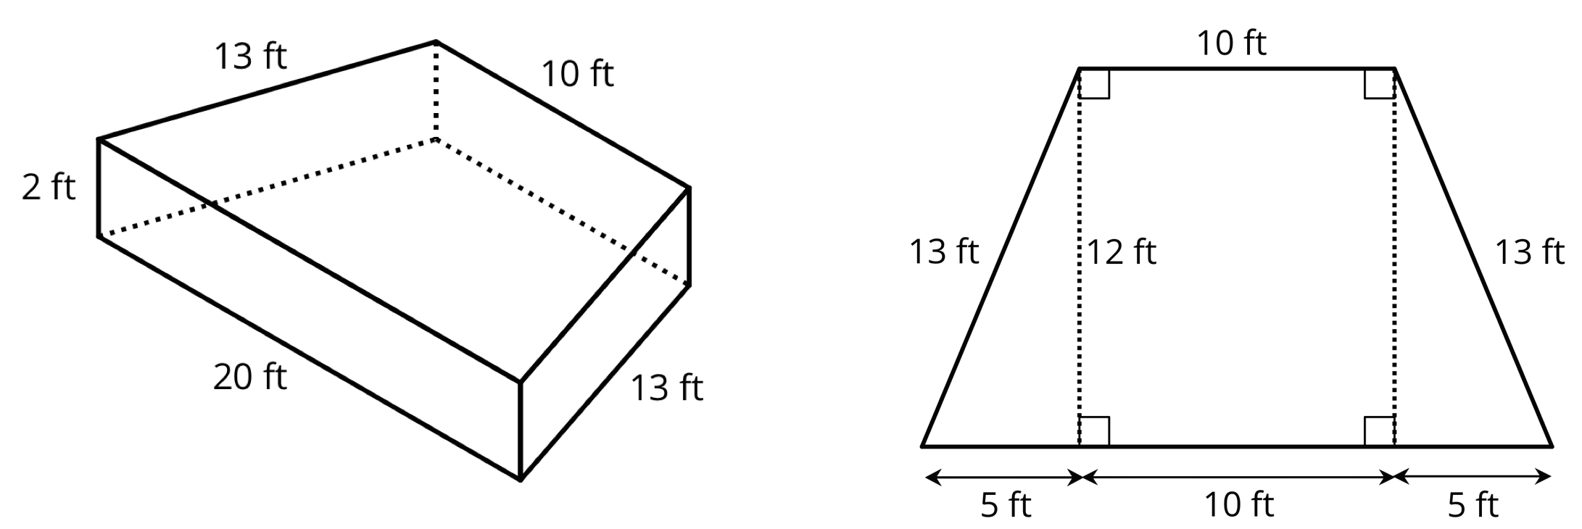
- What is the area of all the faces of the stage, excluding the bottom? Show your reasoning. If you get stuck, consider drawing a net of the prism.
- (From Unit 1, Lesson 15.)
© CC BY Open Up Resources. Adaptations CC BY IM.

