Lesson 8 Practice Problems
- Classify the graph of the equation $x^{2}+y^{2}−8x+4y=29$.
  - circle
  - exponential curve
  - line
  - parabola
- Write an equation that states $\left(x,y\right)$ is the same distance from $\left(4,1\right)$ as it is from the $x$-axis.
- Select all equations which describe the parabola with focus $\left(\text{-}1,\text{-}7\right)$ and directrix $y=3$.
  - ${\left(x−1\right)}^{2}+{\left(y−7\right)}^{2}={\left(y+3\right)}^{2}$
  - ${\left(x+1\right)}^{2}+{\left(y+7\right)}^{2}={\left(y−3\right)}^{2}$
  - $y=\text{-}20{\left(x+1\right)}^{2}−2$
  - $y=\text{-}20{\left(x+1\right)}^{2}+2$
  - $y=\text{-}\frac{1}{20}{\left(x+1\right)}^{2}−2$
  - $y=\text{-}\frac{1}{20}{\left(x+1\right)}^{2}+2$
- Parabola A and parabola B both have the $x$-axis as the directrix. Parabola A has its focus at $\left(3,2\right)$ and parabola B has its focus at $\left(5,4\right)$. Select all true statements.
  - Parabola A is wider than parabola B.
  - Parabola B is wider than parabola A.
  - The parabolas have the same line of symmetry.
  - The line of symmetry of parabola A is to the right of that of parabola B.
  - The line of symmetry of parabola B is to the right of that of parabola A.
- (From Unit 6, Lesson 7.)
- A parabola has focus $\left(5,1\right)$ and directrix $y=\text{-}3$. Where is the parabola’s vertex?
- (From Unit 6, Lesson 7.)
- Select the value needed in the box in order for the expression to be a perfect square trinomial.
- x2+7x+3
  - 3.5
  - 7
  - 12.25
  - 14.5
- (From Unit 6, Lesson 6.)
- Rewrite each expression as the product of 2 factors.
  - $x^{2}+3x$
  - $x^{2}−6x−7$
  - $x^{2}+4x+4$
- (From Unit 6, Lesson 5.)
- Suppose this two-dimensional figure is rotated 360 degrees using the vertical axis shown. Each small square on the grid represents 1 square inch. What is the volume of the three-dimensional figure?
- 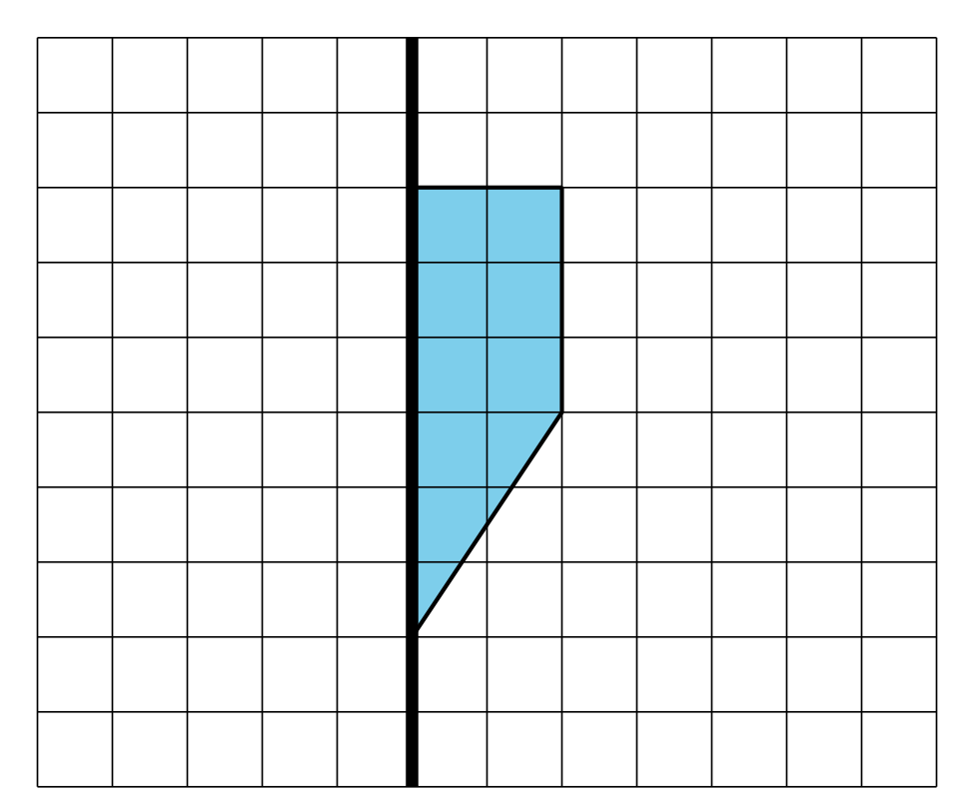
- (From Unit 5, Lesson 15.)
© CC BY 2019 by Illustrative Mathematics®

