Unit 2 Lesson 4 Cumulative Practice Problems
- Triangle $ABC$ is dilated using $D$ as the center of dilation with scale factor 2.
- The image is triangle $A^{′}B^{′}C^{′}$. Clare says the two triangles are congruent, because their angle measures are the same. Do you agree? Explain how you know.
- 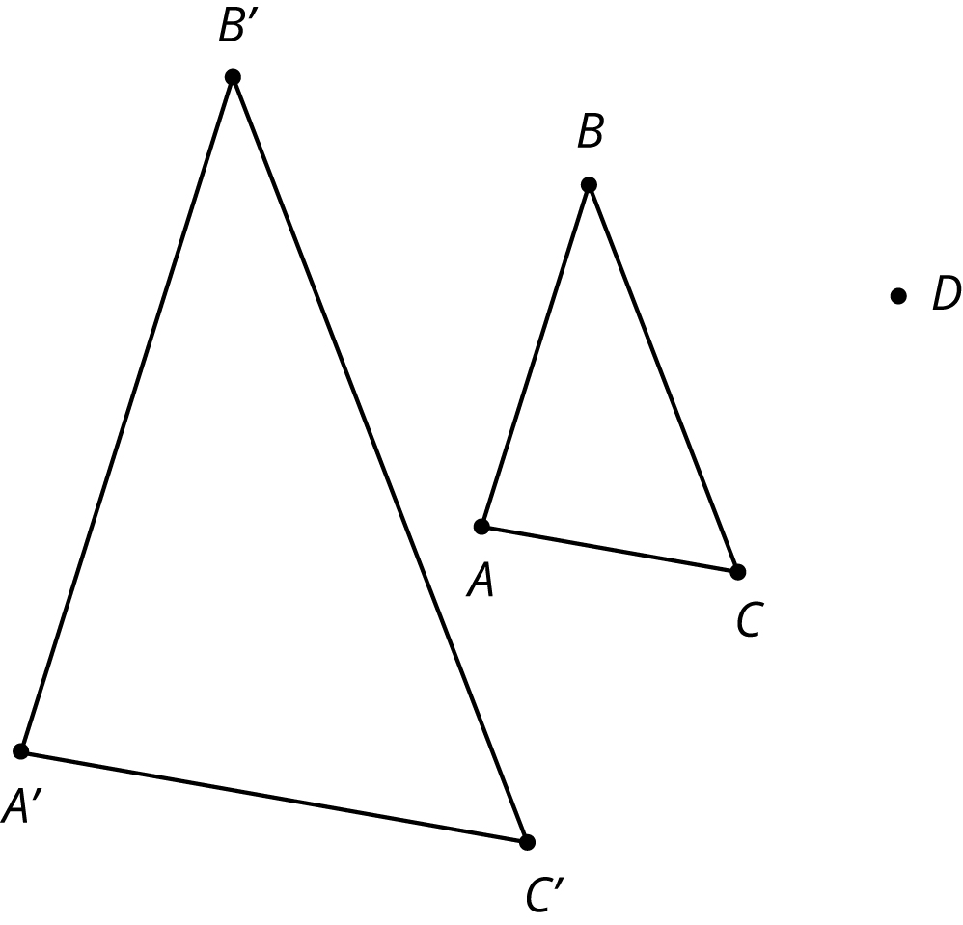
- On graph paper, sketch the image of quadrilateral PQRS under the following dilations:
  - The dilation centered at $R$ with scale factor 2.
  - The dilation centered at $O$ with scale factor $\frac{1}{2}$.
  - The dilation centered at $S$ with scale factor $\frac{1}{2}$.
- 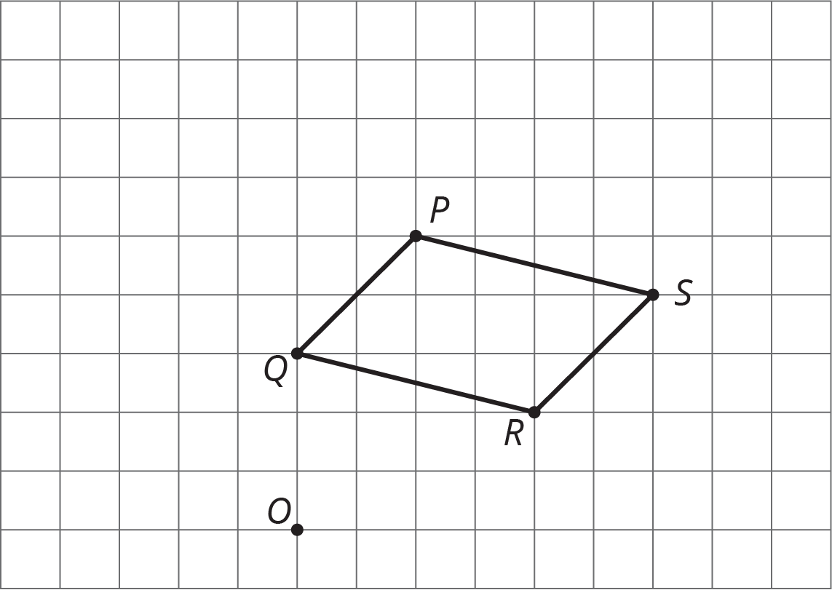
- The diagram shows three lines with some marked angle measures.
- 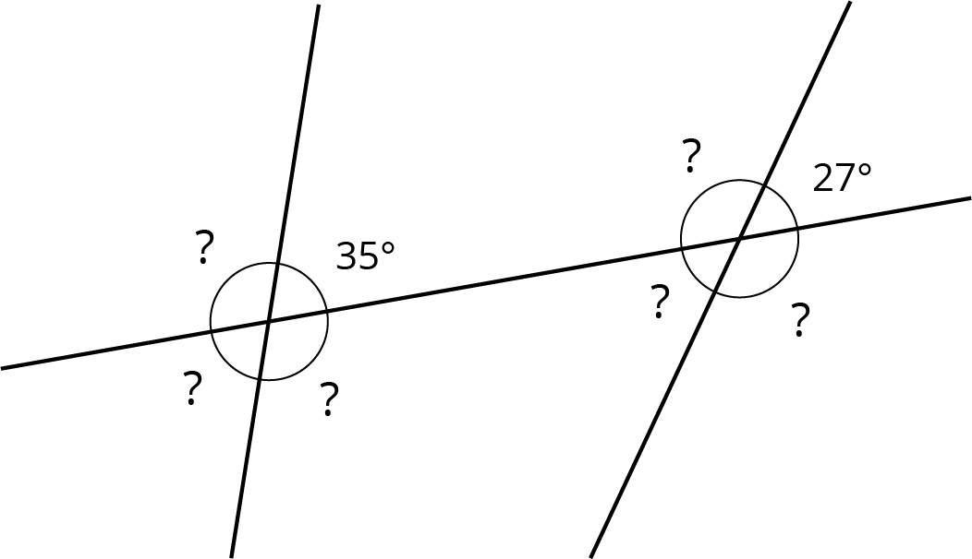
- Find the missing angle measures marked with question marks.
- (From Unit 1, Lesson 14.)
- Describe a sequence of translations, rotations, and reflections that takes Polygon P to Polygon Q.
- 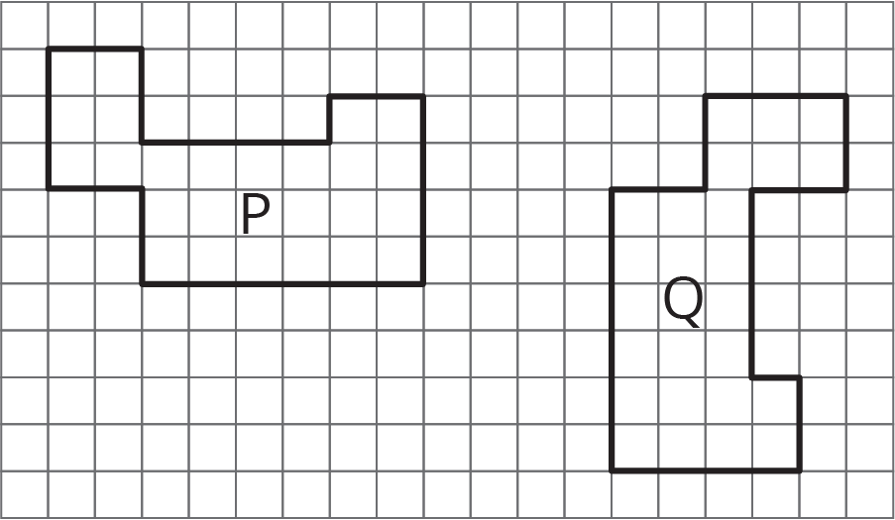

- (From Unit 1, Lesson 4.)
- Point $B$ has coordinates $(\text{-}2,\text{-}5)$. After a translation 4 units down, a reflection across the $y$-axis, and a translation 6 units up, what are the coordinates of the image?
- (From Unit 1, Lesson 6.)
© CC BY Open Up Resources. Adaptations CC BY IM.

