Unit 3 Lesson 4: Measure and Estimate in Centimeters

WU Which One Doesn’t Belong: Length (Warm up)

Student Task Statement
Which one doesn't belong?
A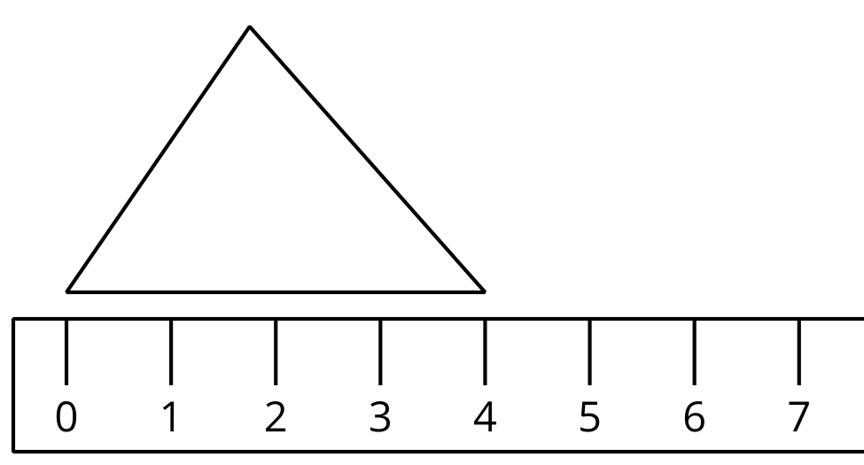
B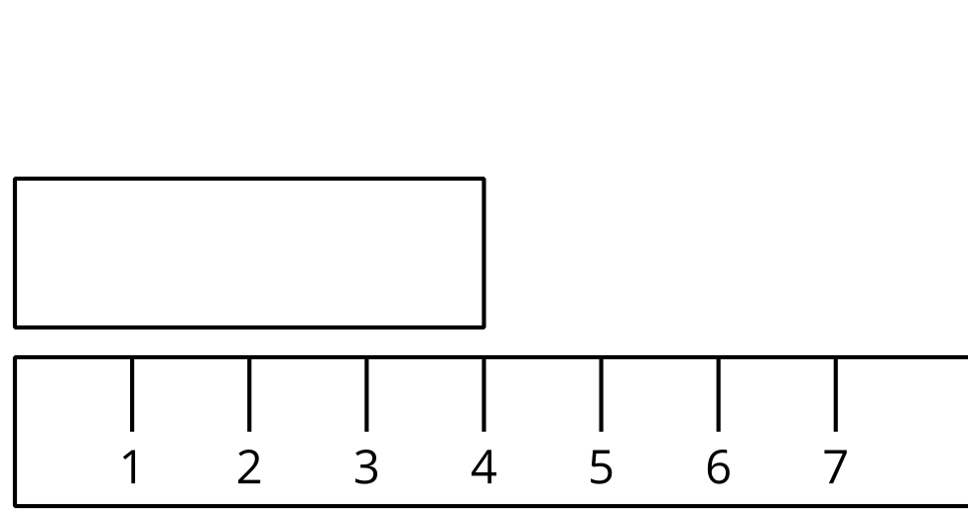
C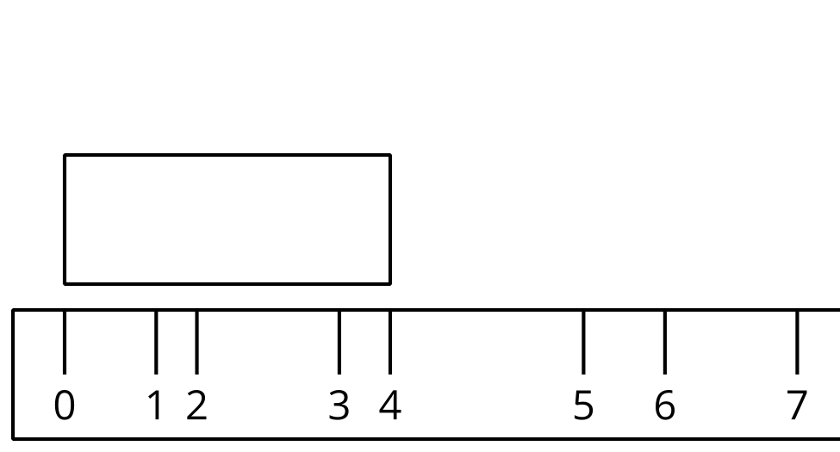
D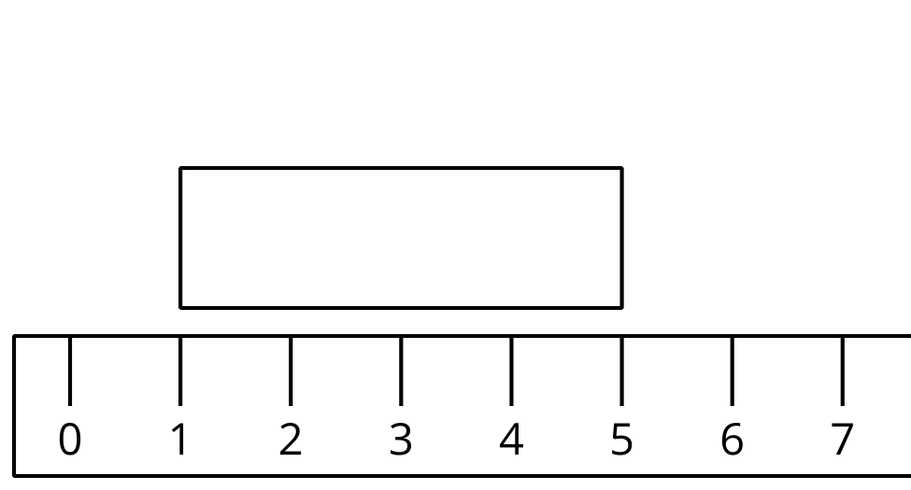

1 Estimate Length in Centimeters

Images for Launch
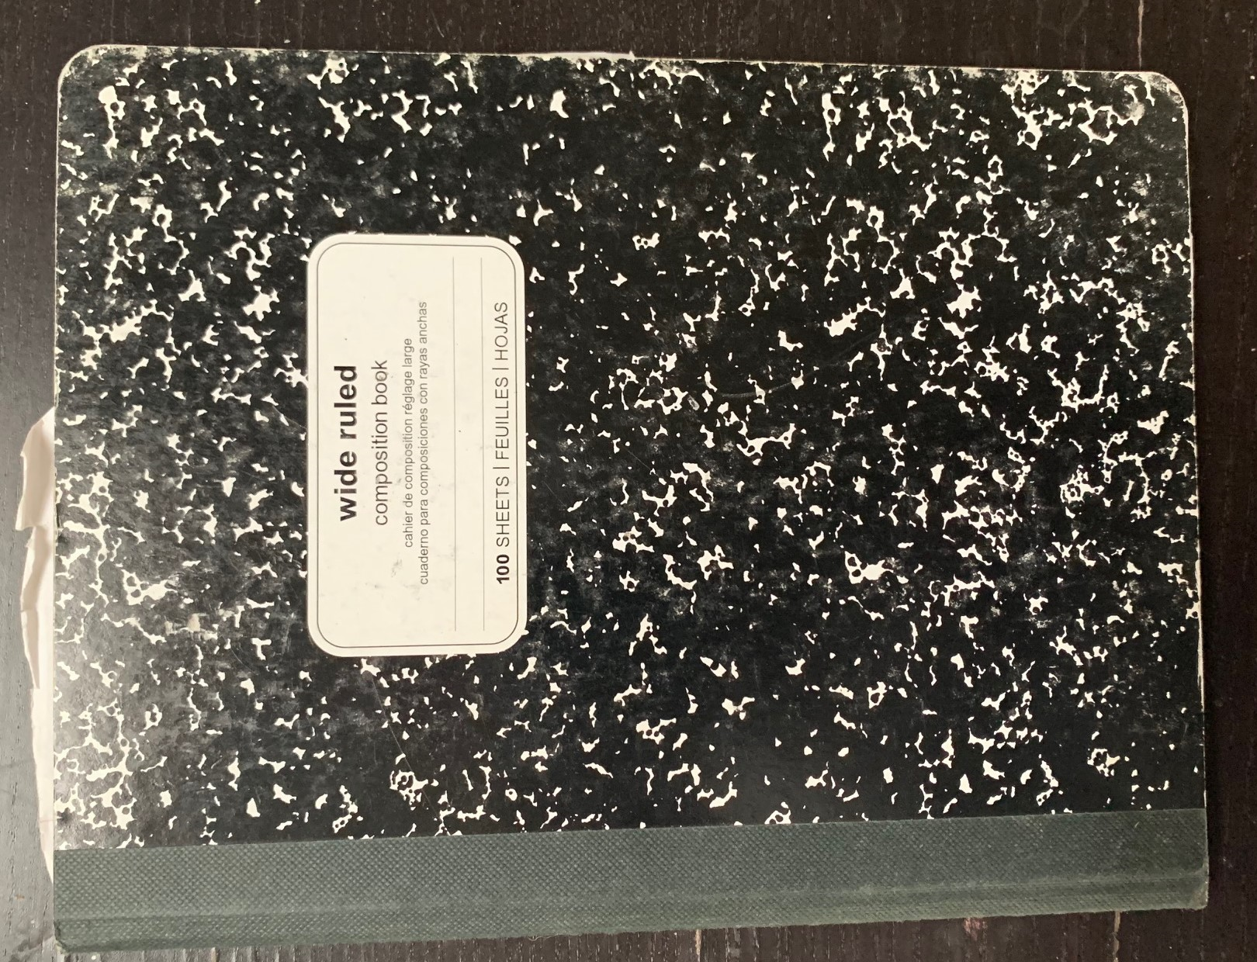
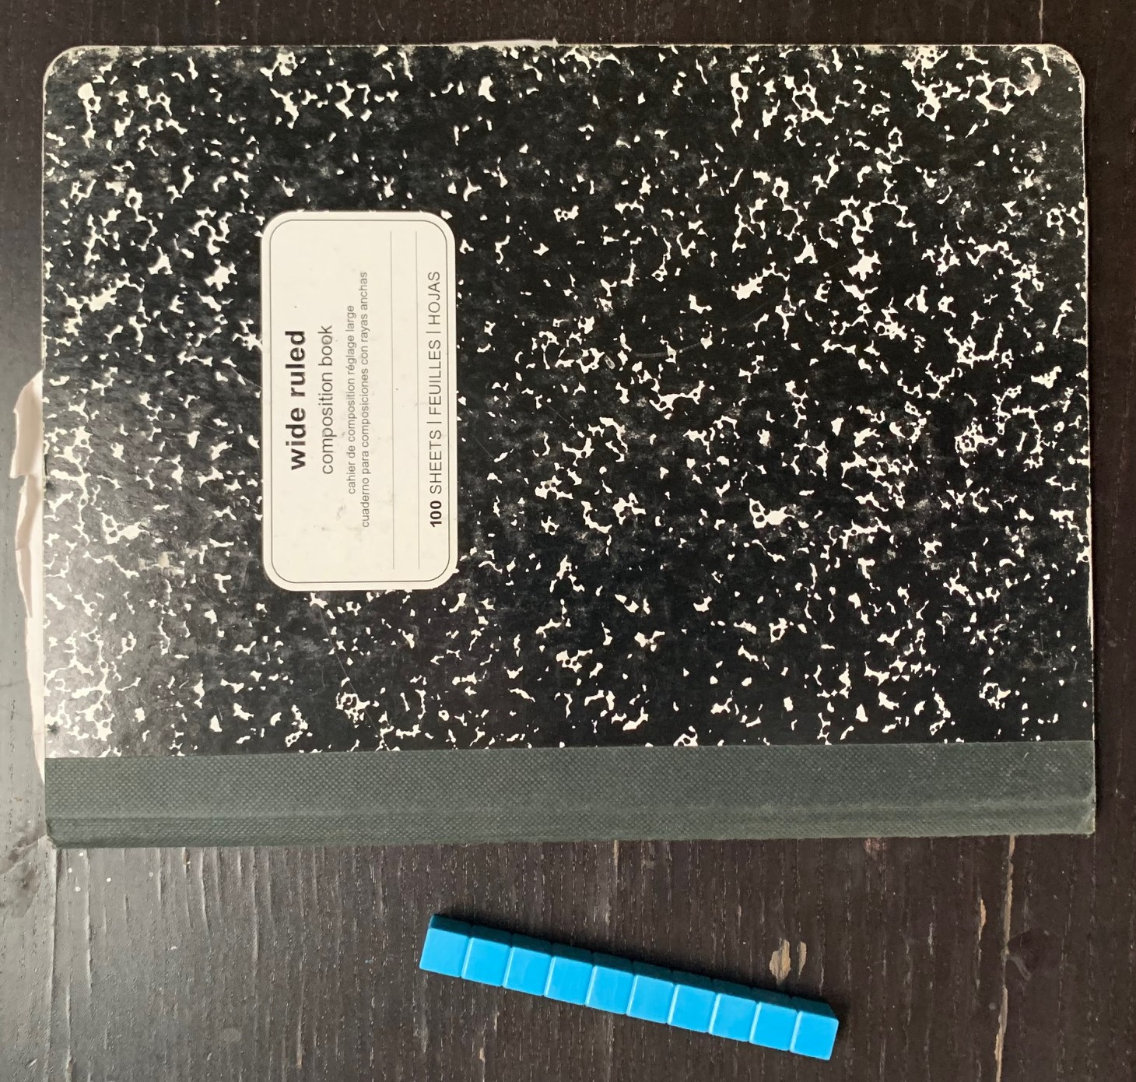

Student Task Statement
- Record an estimate that is:
- too low | - about right | - too high
- Record an estimate that is:
- too low | - about right | - too high
- Record an estimate for each object on the recording sheet.
- Tell your partner why you think your estimates are “about right.”
Recording Sheet
object | estimate | measurement
Choose an object:

2 Measure and Compare

Student Task Statement
- Measure each object on your recording sheet. Record each length in centimeters.
- Compare your measurements to your estimates.
© CC BY 2021 Illustrative Mathematics®

