Lesson 17: Compare and Order Numbers
- Let’s compare and order numbers.

Warm-up: Which One Doesn’t Belong: Comparison Statements
Which one doesn’t belong?
A
B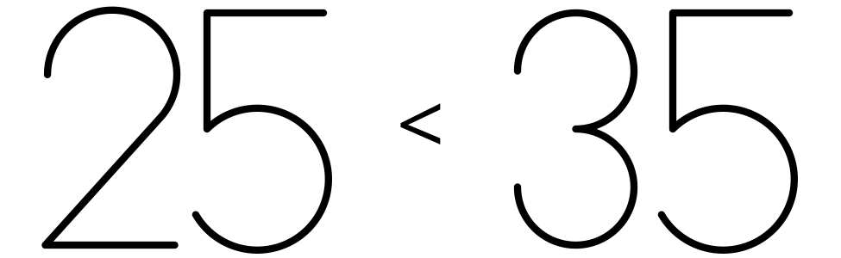
C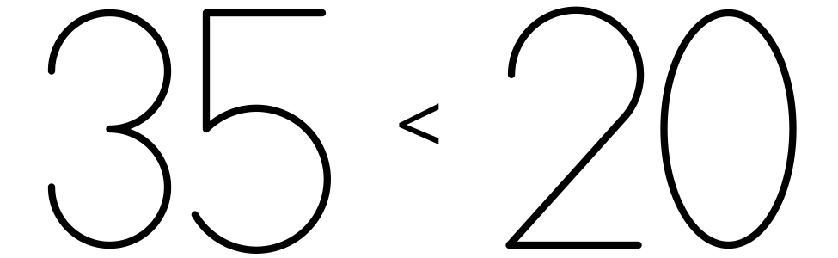
D

17.1: Compare and Order Quantities
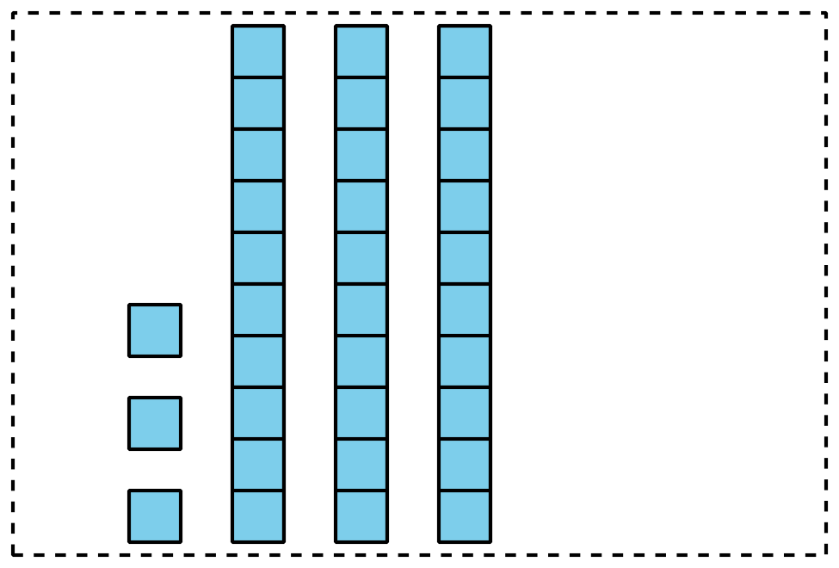
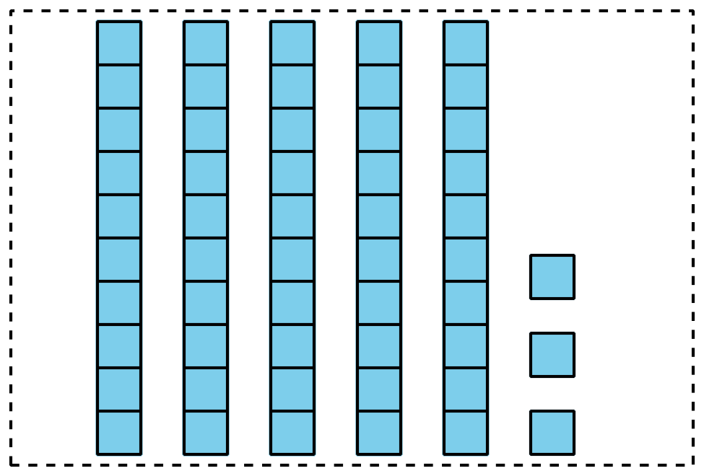
Pick a set of cards.
Put the cards in order from least to greatest.
Be ready to explain how you ordered your cards.
Write the numbers in order from least to greatest.
Set A: ______________________________________________
Set B: ______________________________________________
Set C: ______________________________________________
Set D: ______________________________________________
If you have time:
Mix two sets of cards together.
Put them in order from least to greatest.
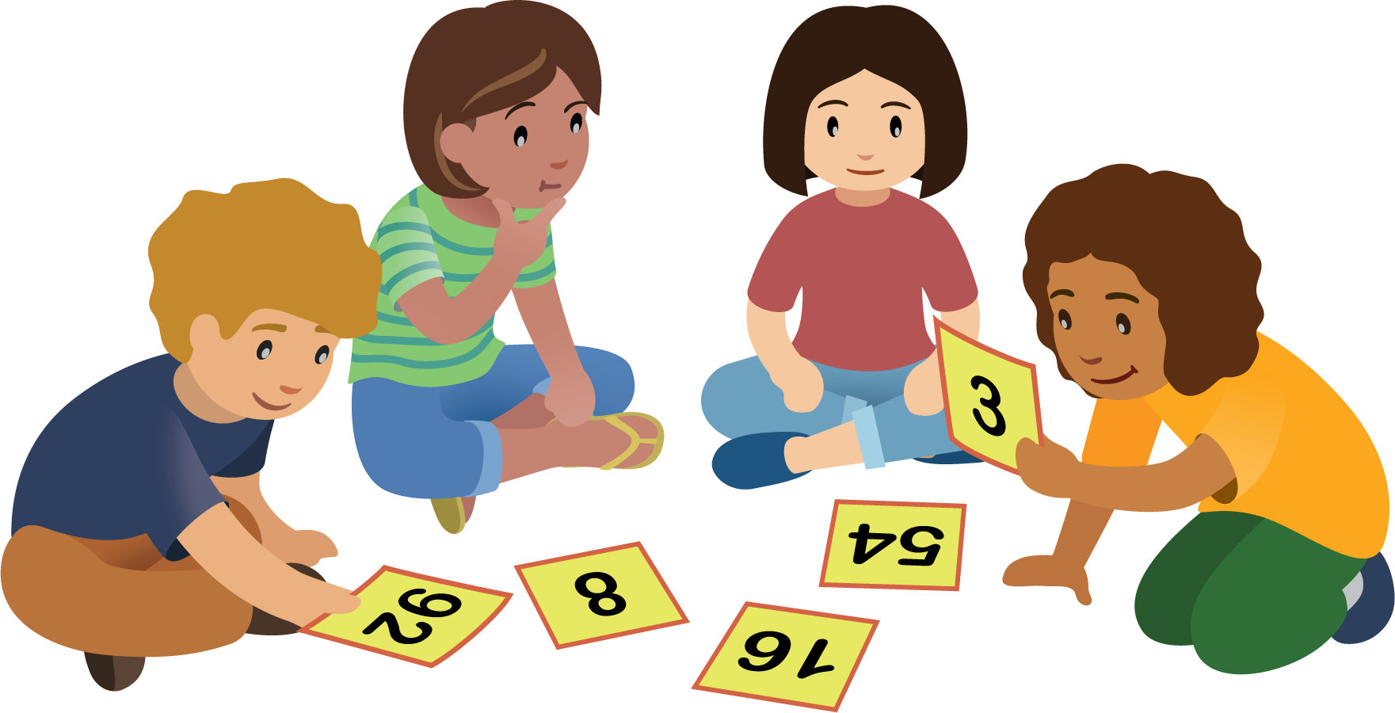

17.2: Order Numbers
- Here are some numbers in order:
- 1
- 5
- 10
- 50
- 99
- Add these numbers to the list:
  - 49
  - 8
  - 25
  - 98
  - 13
- Make sure all the numbers are in order from least to greatest.
- Choose 2 numbers. Explain how you knew where to place them.
  - I knew where to place aaaiaaai because
  - I knew where to place aaaiaaai because
- Write a number that makes each comparison statement true.
- 25<aaaiaaai
- 25>aaaiaaai

Section Summary
Section Summary
We compared numbers using the number of tens and ones.
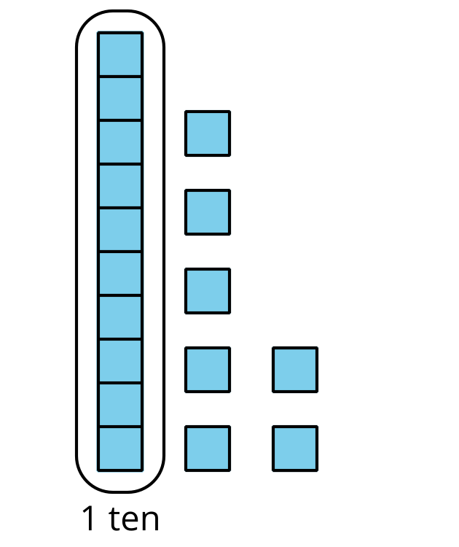
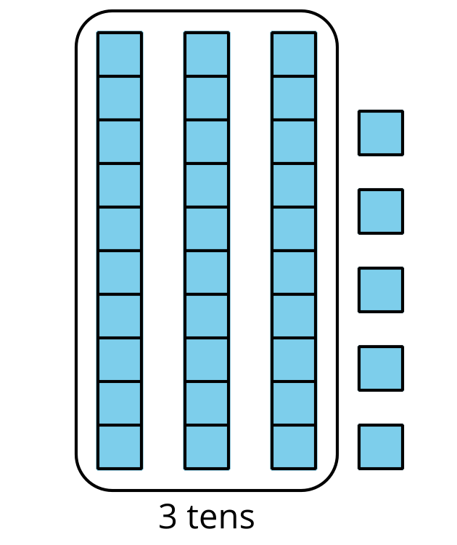
17 has 1 ten and 35 has 3 tens so 17 is less than 35.
$17<35$
17 is less than 35.
$35>17$
35 is greater than 17.
$35=35$
35 is equal to 35.
© CC BY 2021 Illustrative Mathematics®

