Unit 1 Lesson 8 Cumulative Practice Problems
  - Draw parallel lines $AB$ and $CD$.
  - Pick any point $E$. Rotate $AB$ 90 degrees clockwise around $E$.
  - Rotate line $CD$ 90 degrees clockwise around $E$.
  - What do you notice?
- Use the diagram to find the measures of each angle. Explain your reasoning.
  - $m∠ABC$
  - $m∠EBD$
  - $m∠ABE$
- 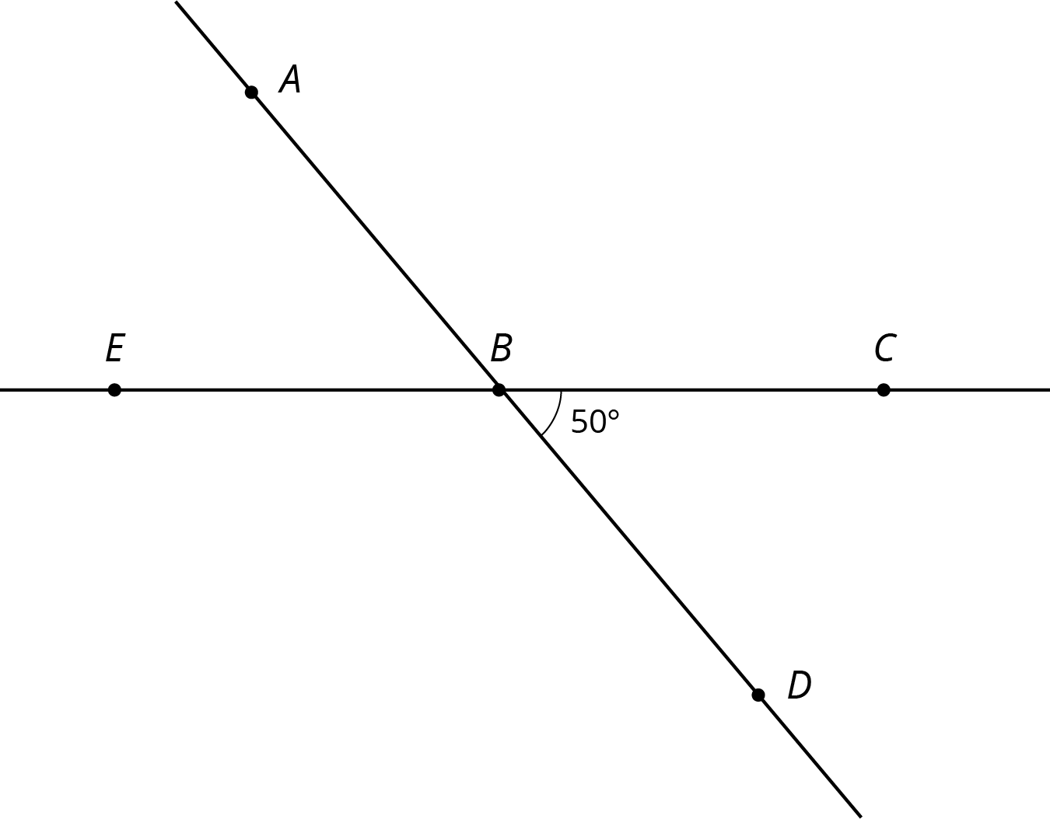
- Points $P$ and $Q$ are plotted on a line.
- 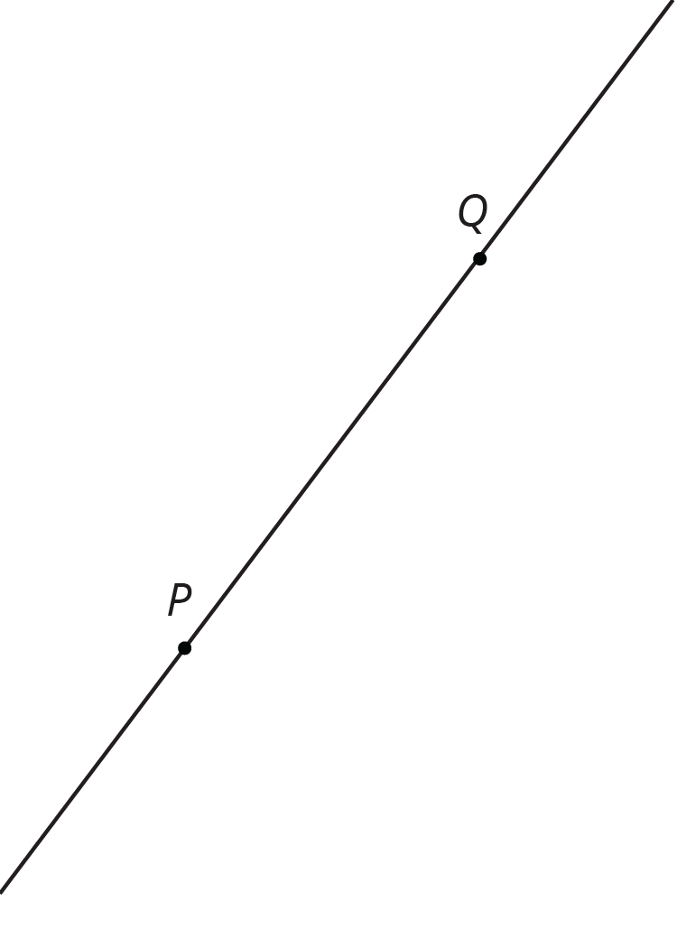
  - Find a point $R$ so that a 180-degree rotation with center $R$ sends $P$ to $Q$ and $Q$ to $P$.
  - Is there more than one point $R$ that works for part a?
- In the picture triangle $A^{′}B^{′}C^{′}$ is an image of triangle $ABC$ after a rotation. The center of rotation is $D$.
- 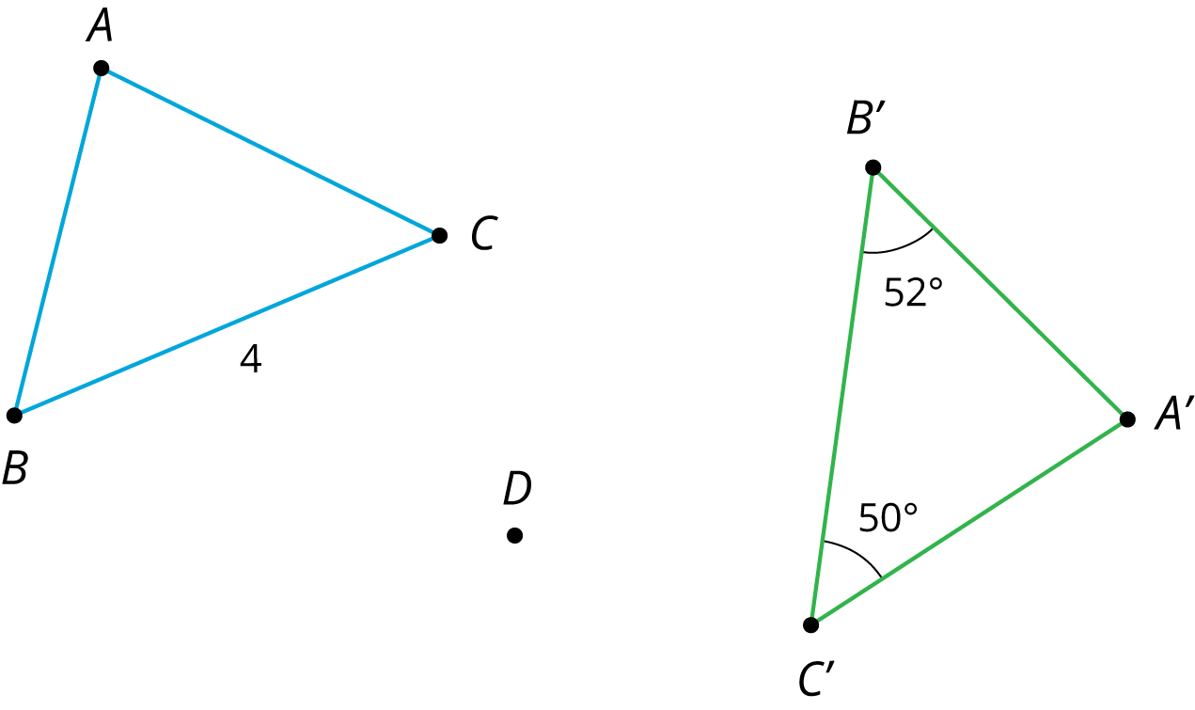
  - What is the length of side $B^{′}C^{′}$? Explain how you know.
  - What is the measure of angle $B$? Explain how you know.
  - What is the measure of angle $C$? Explain how you know.
- (From Unit 1, Lesson 6.)
- The point $(\text{-}4,1)$ is rotated 180 degrees counterclockwise using center $(0,0)$. What are the coordinates of the image?
  - $(\text{-}1,\text{-}4)$
  - $(\text{-}1,4)$
  - $(4,1)$
  - $(4,\text{-}1)$
- (From Unit 1, Lesson 5.)
© CC BY Open Up Resources. Adaptations CC BY IM.

