Lesson 2 Practice Problems
- Twenty pounds of strawberries are being shared equally by a group of friends. The equation $20÷5=4$ represents the division of strawberries.
  - If the 5 represents the number of people, what does the 4 represent?
  - If the 5 represents the pounds of strawberries per person, what does the 4 represent?
- A sixth-grade science club needs $180 to pay for the tickets to a science museum. All tickets cost the same amount.
- What could $180÷15$ mean in this situation? Describe two different possible meanings of this expression. Then, find the quotient and explain what it means in each case.
- Write a division or multiplication equation that represents each situation. Use a “?” for the unknown quantity.
  - 2.5 gallons of water are poured into 5 equally sized bottles. How much water is in each bottle?
  - A large bucket of 200 golf balls is divided into 4 smaller buckets. How many golf balls are in each small bucket?
  - Sixteen socks are put into pairs. How many pairs are there?
- Consider the problem: Mai has $36 to spend on movie tickets. Each movie ticket costs $4.50. How many tickets can she buy?
  - Write a multiplication equation and a division equation to represent this situation.
  - Find the answer. Draw a diagram, if needed.
  - Use the multiplication equation to check your answer.
- Kiran said that this diagram can show the solution to $16÷8=?$ or $16÷2=?$, depending on how we think about the equations and the “?”.
- Explain or show how Kiran is correct.
- 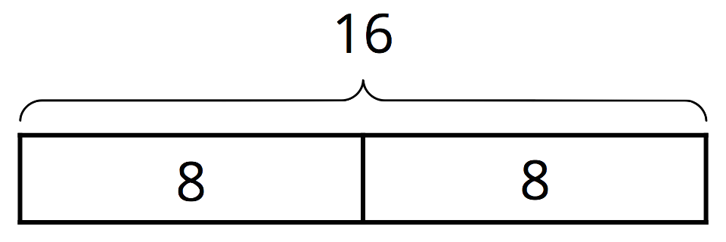
- Complete the table. Write each percentage as a percent of 1.
- fraction | - decimal | - percentage
- $\frac{1}{4}$ | - 0.25 | - 25% of 1
 | - 0.1
 |  | - 75% of 1
- $\frac{1}{5}$
 | - 1.5
 |  | - 140% of 1
- (From Unit 2, Lesson 23.)
- Mini muffins cost $3.00 per dozen.
  - Andre says, “I have $2.00, so I can afford 8 muffins.”
  - Elena says, “I want to get 16 muffins, so I’ll need to pay $4.00."
- Do you agree with either of them? Explain your reasoning.
- (From Unit 2, Lesson 18.)
© CC BY Open Up Resources. Adaptations CC BY IM.

