Unit 6 Lesson 15: Preparing for Vertex Form

1 Which One Doesn’t Belong: Four Graphs (Warm up)

Student Task Statement
Each graph represents either a linear or quadratic function. Which one doesn’t belong?

A
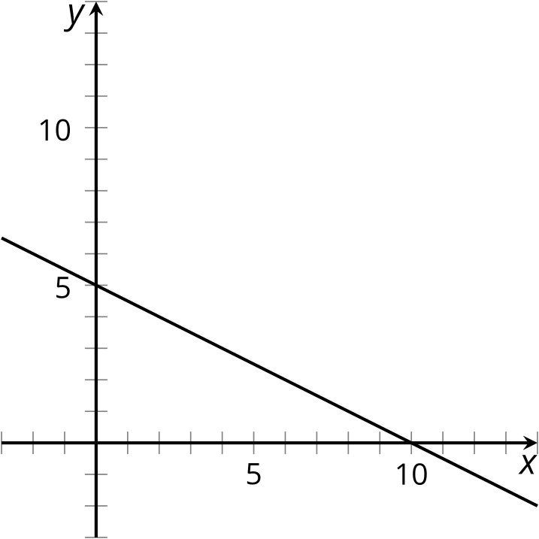

B
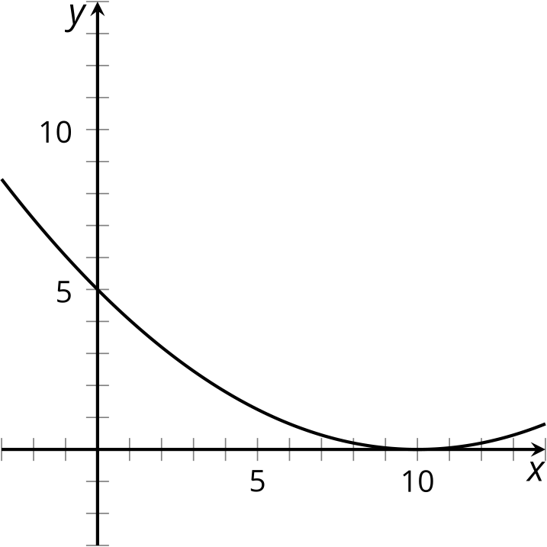

C
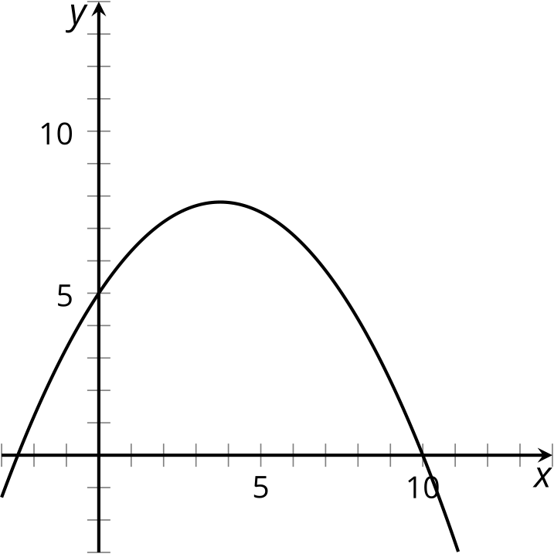

D
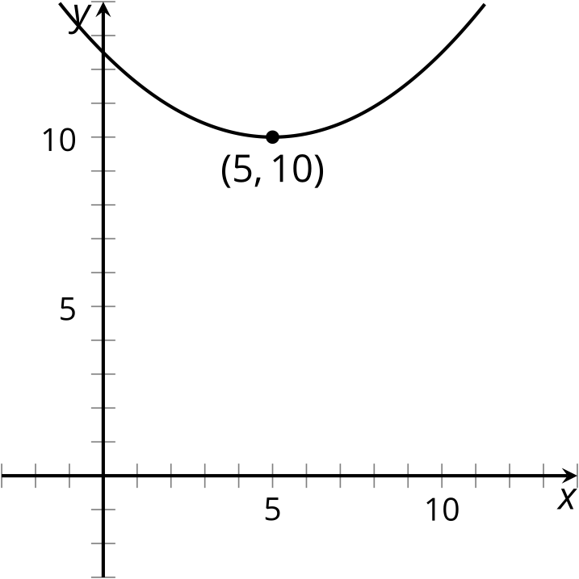

2 Shift That Line Around

Student Task Statement
Using graphing technology, graph $y=2x$.
- Keep that graph, and add a second graph with each of the following changes to the equation. See how it compares to the graph of $y=2x$. Complete the table. For the last two rows, think about how the original equation should be modified so that the graph has the specified $x$-intercept or $y$-intercept.
- changes to $y=2x$ | - $x$-intercept | - $y$-intercept
- no change | - $\left(0,0\right)$ | - $\left(0,0\right)$
- add 5 to $2x$: $y=2x+5$
- subtract 8 from $2x$: $y=2x−8$
- add or subtract a number of your choice to $2x$.
- write the new equation:
 |  | - $\left(0,12\right)$
 | - $\left(3,0\right)$
- Experiment with each of the following changes to the equation and see how it affects the graph. Complete the table. For the last two rows, think about how the original equation should be modified so that the graph has the specified $x$-intercept or $y$-intercept.
- changes to $y=2x$ | - $x$-intercept | - $y$-intercept
- no change | - $\left(0,0\right)$ | - $\left(0,0\right)$
- add 5 to $x$ before it is multiplied by 2: $y=2\left(x+5\right)$
- subtract 8 from $x$ before it is multiplied by 2: $y=2\left(x−8\right)$
- add to or subtract from $x$ another number of your choice before it is multiplied by 2.
- write the new equation:
 |  | - $\left(0,12\right)$
 | - $\left(3,0\right)$
- Elena says the graph of $y=2\left(x−3\right)+5$ is the graph of $y=2x$ shifted 3 units to the right and up 5 units. Clare says that means the $y$-intercept is $\left(0,5\right)$ and the $x$-intercept is $\left(3,0\right)$. Do you agree with either or both of them, and why?

3 Finding Equivalent Expressions

Student Task Statement
- Without graphing, predict the location of the $x$- and $y$-intercepts of the graphs of these equations. Then, check using graphing technology.
  - $y=4x+8$
  - $y=4\left(x+8\right)$
  - $y=5x−10$
  - $y=5\left(x−10\right)$
- Sort these expressions into three groups of equivalent expressions. Be prepared to explain how you know they are equivalent.
  - $\text{-}2{\left(x−5\right)}^{2}$
  - $2x^{2}−10x$
  - $\text{-}2\left(x−5\right)\left(x−5\right)$
  - $2\left(x^{2}−5x\right)$
  - $\left(x−5\right)\left(\text{-}2x+10\right)$
  - $\text{-}2x\left(x+5\right)$
  - $2x\left(x−5\right)$
  - $\text{-}2x^{2}−10x$
  - $2x\left(\text{-}x−5\right)$
  - $x\left(2x−10\right)$
  - $\text{-}x\left(2x+10\right)$
  - $\text{-}2x^{2}+20x−50$
© CC BY 2019 by Illustrative Mathematics®

