Lesson 10: A New Kind of Number
- Let’s invent a new number.

10.1: Numbers Are Inventions
Jada was helping her cousin with his math homework. He was supposed to solve the equation $8+x=5$. He said, “If I subtract 8 from both sides, I get $x=5−8$. This doesn’t make sense. You can’t subtract a bigger number from a smaller number. If I have 5 grapes, I can’t eat 8 of them!”
What do you think Jada could say to her cousin to help him understand why $5−8$ actually does make sense?

10.2: The Square Root of Negative One
Numbers on the number line are often called real numbers.
- The equation $x^{2}=9$ has 2 real solutions. How can you see this on the graph of $y=x^{2}$? Draw points on this real number line to represent these 2 solutions.
- How many real solutions does $x^{2}=0$ have? Explain how you can see this on the graph of $y=x^{2}$. Draw the solution(s) on a real number line.
- How many real solutions does $x^{2}=\text{-}1$ have? Explain how you can see this on the graph of $y=x^{2}$. Draw the solution(s) on a real number line.

10.3: Imaginary Numbers
- On the real number line:
  - Draw an arrow starting at 0 that represents 3.
  - Draw an arrow starting at 0 that represents -5.
- This diagram shows an arrow that represents $\sqrt{\text{-}1}$.
- 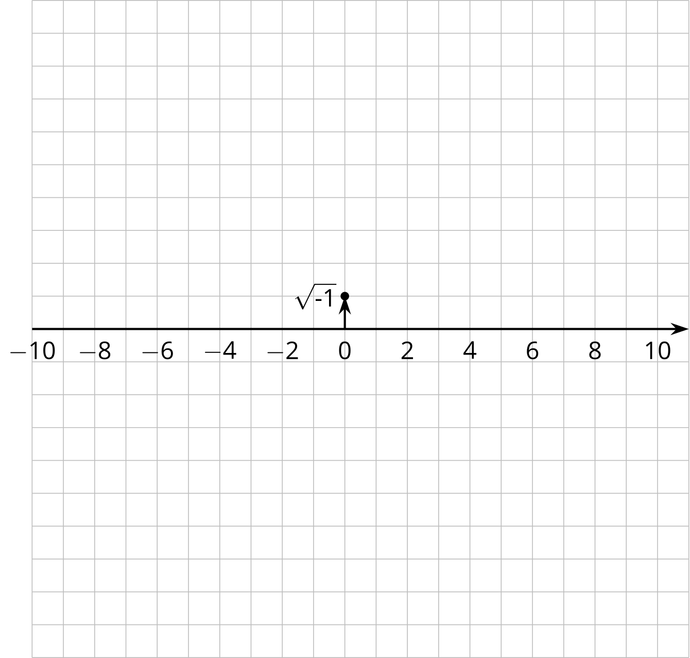
  - Draw an arrow starting at 0 that represents $3\sqrt{\text{-}1}$.
  - Draw an arrow starting at 0 that represents $\text{-}\sqrt{\text{-}1}$.
  - Draw an arrow starting at 0 that represents $\text{-}5\sqrt{\text{-}1}$.

Are you ready for more?
The absolute value of a real number is the length of the arrow that represents it.
- What is the relationship between the absolute value of a real number and the absolute value of the square of that number?
- If we want $\sqrt{\text{-}1}$ and its square to have this same relationship, then what should the absolute value of $\sqrt{\text{-}1}$ be?
- What should the absolute value of $3\sqrt{\text{-}1}$ be?

Lesson 10 Summary
Sometimes people call the number line the real number line.
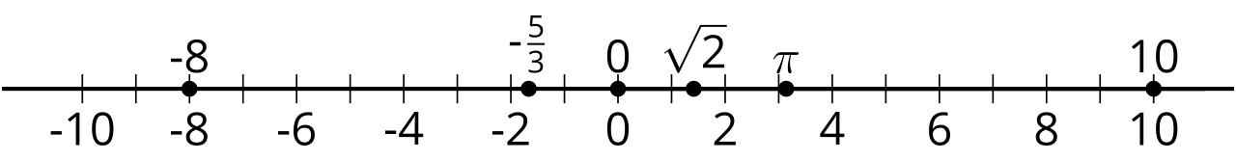
All real numbers are either positive, negative, or 0, and they can be plotted on this line. All the numbers we have used until this lesson have been real numbers. For real numbers, we know that:
- A positive number times a positive number is always positive. So when we square a positive number, the result will always be positive.
- A negative number times a negative number is always positive. So when we square a negative number, the result will always be positive.
- 0 squared is 0.
So squaring a real number never results in a negative number. We can conclude that the equation $x^{2}=\text{-}1$ does not have any real number solutions. In other words, none of the numbers on the real number line satisfy this equation.
Mathematicians invented a new number that is not on the real number line. This new number was invented as a solution to the equation $x^{2}=\text{-}1$. For now, let’s write it $\sqrt{\text{-}1}$ and draw a point to represent this number. We can put it anywhere we want as long as we don’t put it on the real number line. For example, let’s put it here, right above 0 on the real number line:
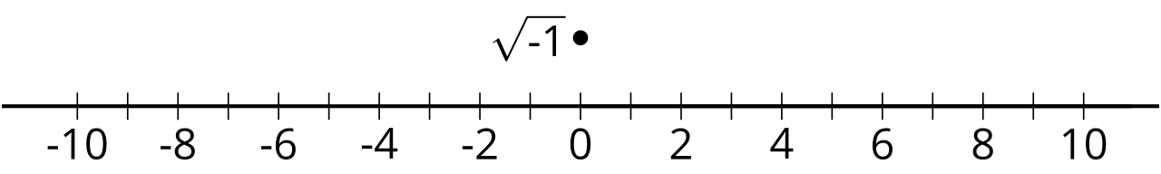
This new number $\sqrt{\text{-}1}$ is a solution to the equation $x^{2}=\text{-}1$, so ${\left(\sqrt{\text{-}1}\right)}^{2}=\text{-}1$. If we draw a line that passes through 0 on the real number line and $\sqrt{\text{-}1}$, we get the imaginary number line. The numbers on the imaginary number line are called the imaginary numbers.
© CC BY 2019 by Illustrative Mathematics®

