Lesson 2 Practice Problems
- A population of ants is 10,000 at the start of April. Since then, it triples each month.
  - Complete the table.
  - What do you notice about the population differences from month to month?
  - If there are $n$ ants one month, how many ants will there be a month later?
- months since April | - number of ants
- 0
- 1
- 2
- 3
- 4
- A swimming pool contains 500 gallons of water. A hose is turned on, and it fills the pool at a rate of 24 gallons per minute. Which expression represents the amount of water in the pool, in gallons, after 8 minutes?
  - $500⋅24⋅8$
  - $500+24+8$
  - $500+24⋅8$
  - $500⋅{24}^{8}$
- The population of a city is 100,000. It doubles each decade for 5 decades. Select all expressions that represent the population of the city after 5 decades.
  - 32,000
  - 320,000
  - $100,​000⋅2⋅2⋅2⋅2⋅2$
  - $100,​000⋅5^{2}$
  - $100,​000⋅2^{5}$
- The table shows the height, in centimeters, of the water in a swimming pool at different times since the pool started to be filled.
  - Does the height of the water increase by the same amount each minute? Explain how you know.
  - Does the height of the water increase by the same factor each minute? Explain how you know.
- minutes | - height
- 0 | - 150
- 1 | - 150.5
- 2 | - 151
- 3 | - 151.5
- Bank account C starts with $10 and doubles each week. Bank account D starts with $1,000 and grows by $500 each week.
- When will account C contain more money than account D? Explain your reasoning.
- (From Unit 5, Lesson 1.)
- Suppose $C$ is a rule that takes time as the input and gives your class on Monday as the output. For example, $C\left(\text{10:15}\right)=\text{Biology}$.
  - Write three sample input-output pairs for $C$.
  - Does each input to $C$ have exactly one output? Explain how you know.
  - Explain why $C$ is a function.
- (From Unit 4, Lesson 2.)
- The rule that defines function $f$ is $f\left(x\right)=x^{2}+1$. Complete the table. Then, sketch a graph of function $f$.
- $x$ | - $f\left(x\right)$
- -4 | - 17
- -2
- 0
- 2
- 4
- 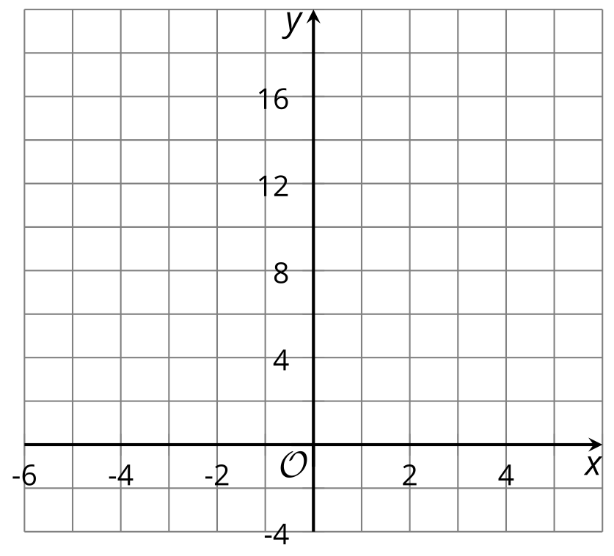
- (From Unit 4, Lesson 4.)
- The scatter plot shows the rent prices for apartments in a large city over ten years.
  - The best fit line is given by the equation $y=134.02x+655.40$, where $y$ represents the rent price in dollars, and $x$ the time in years. Use it to estimate the rent price after 8 years. Show your reasoning.
  - 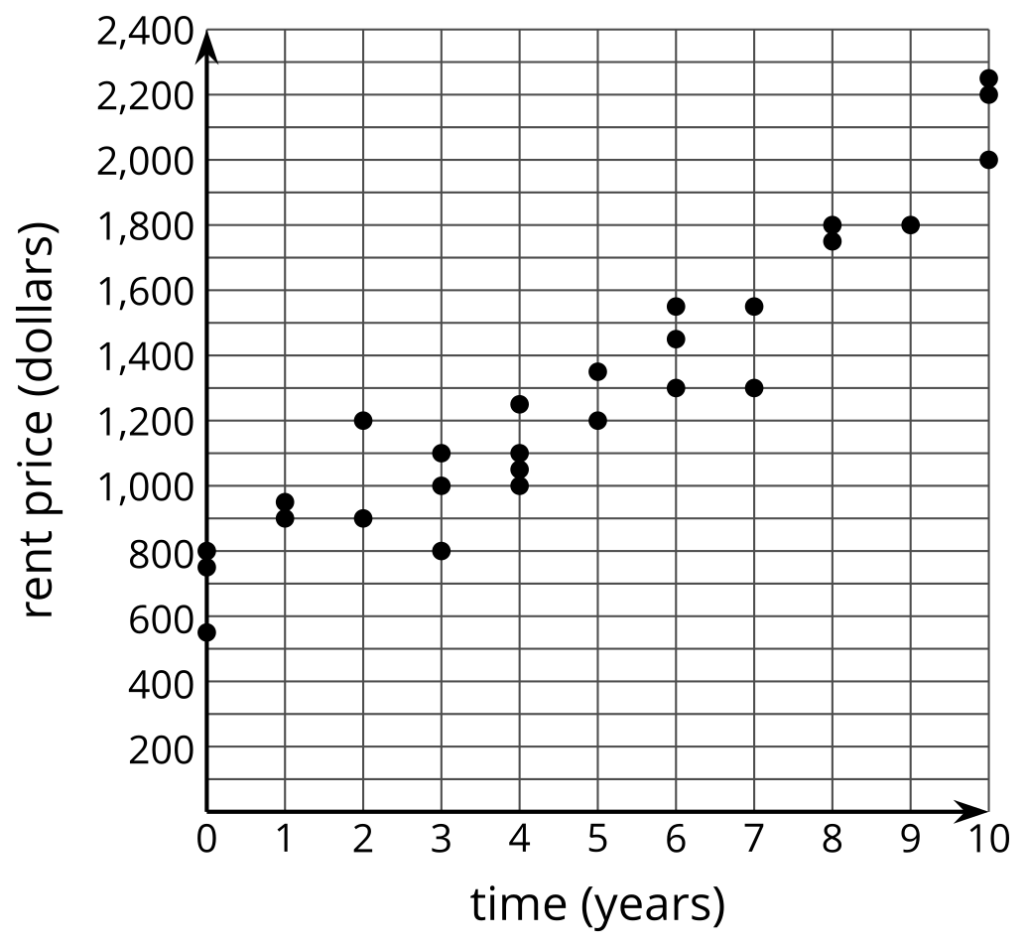

  - Use the best fit line to estimate the number of years it will take the rent price to equal $2,500. Show your reasoning.
- (From Unit 3, Lesson 4.)
© CC BY 2019 by Illustrative Mathematics®

