Lesson 9 Practice Problems
- Select all the equations that represent the graph shown.
- 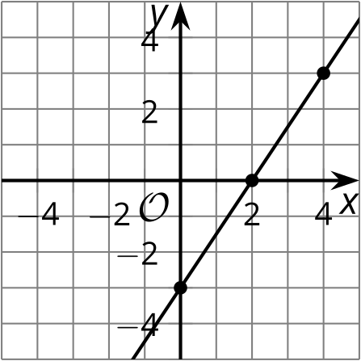
  - $3x−2y=6$
  - $y=\frac{3}{2}x+3$
  - $y=\frac{3}{2}x−3$
  - $y−3=\frac{3}{2}\left(x−4\right)$
  - $y−6=\frac{3}{2}\left(x−2\right)$
- A line with slope $\frac{3}{2}$ passes through the point $\left(1,3\right)$.
  - Explain why $\left(3,6\right)$ is on this line.
  - Explain why $\left(0,0\right)$ is not on this line.
  - Is the point $\left(13,22\right)$ on this line? Explain why or why not.
- Write an equation of the line that passes through $\left(1,3\right)$ and has a slope of $\frac{5}{4}$.
- A parabola has focus $\left(3,\text{-}2\right)$ and directrix $y=2$. The point $\left(a,\text{-}8\right)$ is on the parabola. How far is this point from the focus?
  - 6 units
  - 8 units
  - 10 units
  - cannot be determined
- (From Unit 6, Lesson 8.)
- Write an equation for a parabola with each given focus and directrix.
  - focus: $\left(5,2\right)$; directrix: $x$-axis
  - focus: $\left(\text{-}2,3\right)$; directrix: the line $y=7$
  - focus: $\left(0,7\right)$; directrix: $x$-axis
  - focus: $\left(\text{-}3,\text{-}4\right)$; directrix: the line $y=\text{-}1$
- (From Unit 6, Lesson 8.)
- A parabola has focus $\left(\text{-}1,6\right)$ and directrix $y=4$. Determine whether each point on the list is on this parabola. Explain your reasoning.
  - $\left(\text{-}1,5\right)$
  - $\left(1,7\right)$
  - $\left(3,9\right)$
- (From Unit 6, Lesson 7.)
- Select the center of the circle represented by the equation $x^{2}+y^{2}−8x+11y−2=0$.
  - $\left(8,11\right)$
  - $\left(4,5.5\right)$
  - $\left(\text{-}4,\text{-}5.5\right)$
  - $\left(4,\text{-}5.5\right)$
- (From Unit 6, Lesson 6.)
- Reflect triangle $ABC$ over the line $x=\text{-}6$.
- Translate the image by the directed line segment from $\left(0,0\right)$ to $\left(5,\text{-}1\right)$.
- What are the coordinates of the vertices in the final image?
- 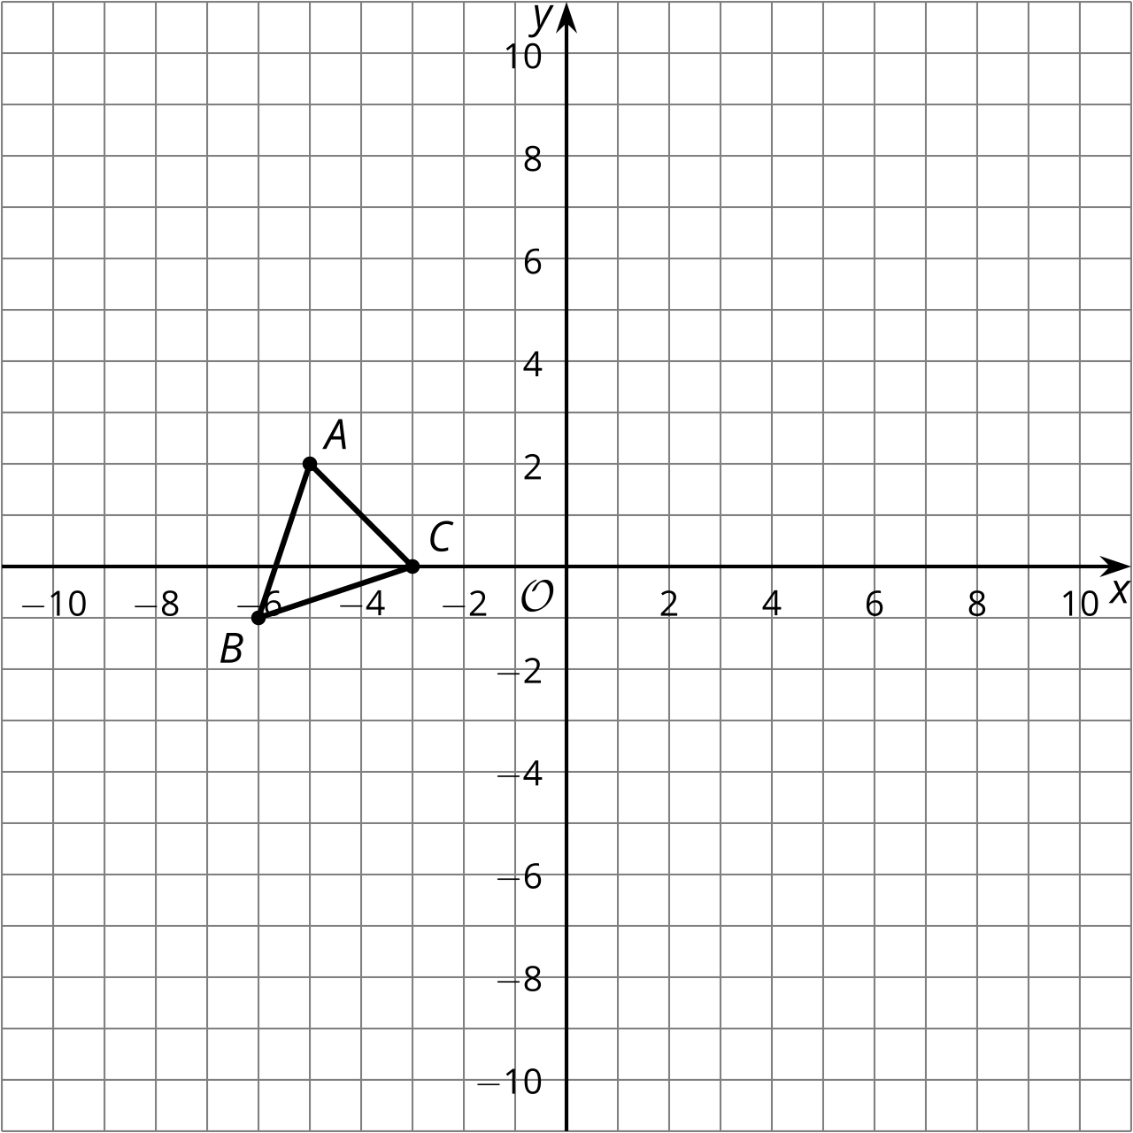
- (From Unit 6, Lesson 1.)
© CC BY 2019 by Illustrative Mathematics®

