Unit 2 Lesson 5 Cumulative Practice Problems
- Quadrilateral $ABCD$ is dilated with center $(0,0)$, taking $B$ to $B^{′}$. Draw $A^{′}B^{′}C^{′}D^{′}$.
- 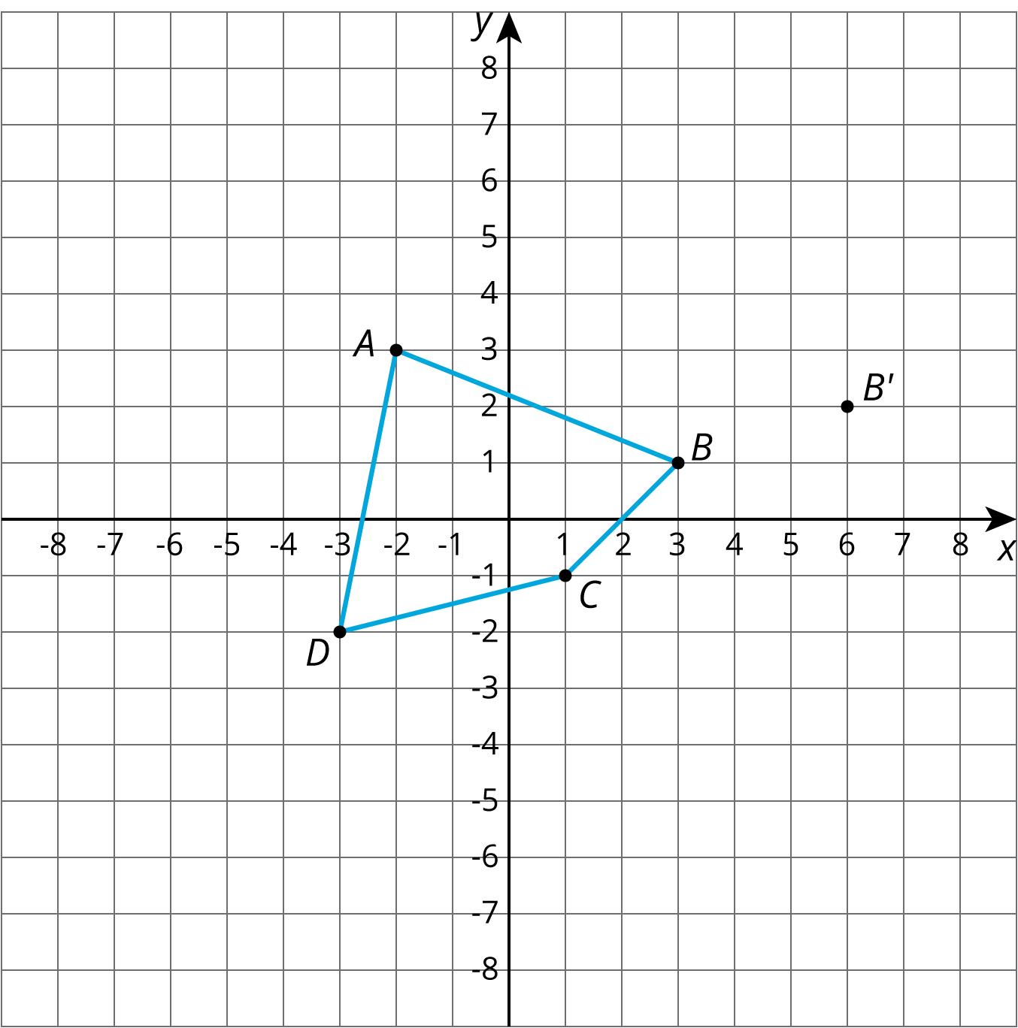
- Triangles $B$ and $C$ have been built by dilating Triangle $A$.
- 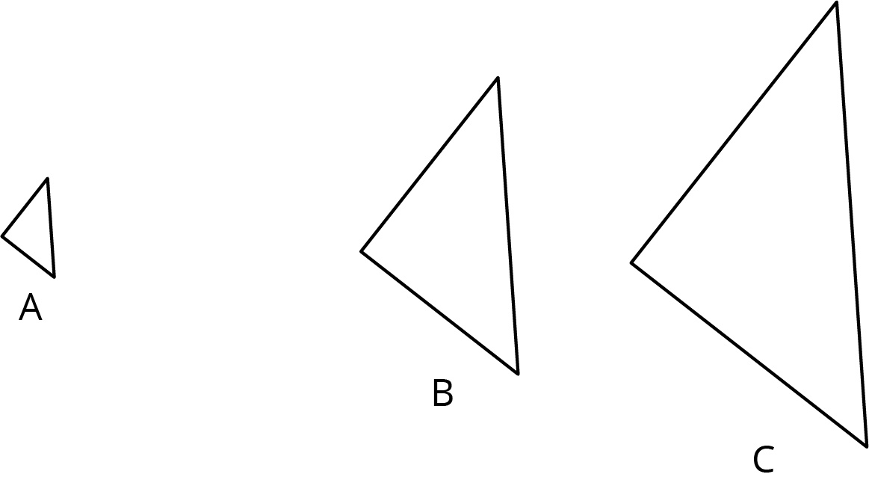
  - Find the center of dilation.
  - Triangle $B$ is a dilation of $A$ with approximately what scale factor?
  - Triangle $A$ is a dilation of $B$ with approximately what scale factor?
  - Triangle $B$ is a dilation of $C$ with approximately what scale factor?
- Here is a triangle.
  - Draw the dilation of triangle $ABC$, with center $(0,0)$, and scale factor 2. Label this triangle $A^{′}B^{′}C^{′}$.
  - Draw the dilation of triangle $ABC$, with center $(0,0)$, and scale factor $\frac{1}{2}$. Label this triangle $A^{″}B^{″}C^{″}$.
  - Is $A^{″}B^{″}C^{″}$ a dilation of triangle $A^{′}B^{′}C^{′}$? If yes, what are the center of dilation and the scale factor?
- 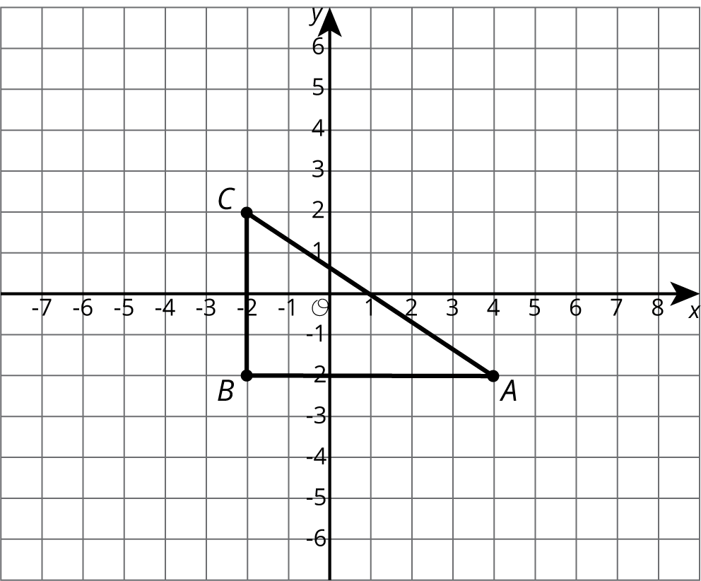

- Triangle $DEF$ is a right triangle, and the measure of angle $D$ is ${28}^{∘}$. What are the measures of the other two angles?
- (From Unit 1, Lesson 15.)
© CC BY Open Up Resources. Adaptations CC BY IM.

