Unit 3 Lesson 5: Measure in Meters

WU Choral Count: Beyond 100 (Warm up)

Student Task Statement

1 Reptiles to Measure

Student Task Statement
Each length of tape on the floor represents the length of a reptile.
A: gila monster
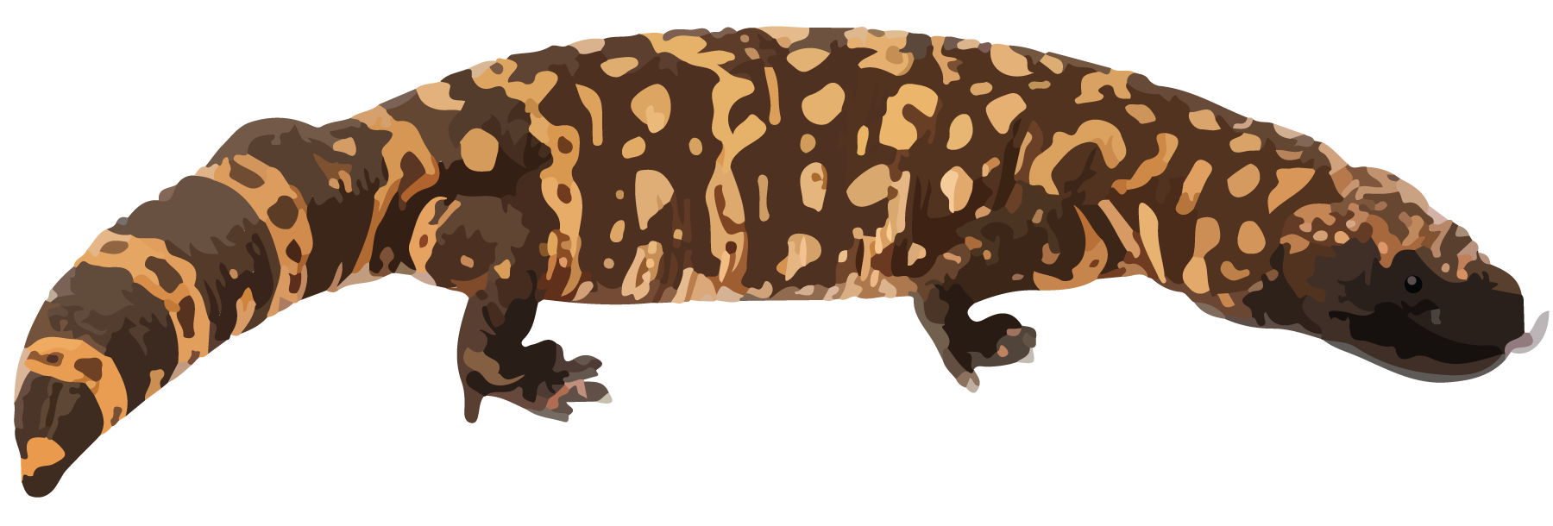
​​​
​​​
B: baby alligator
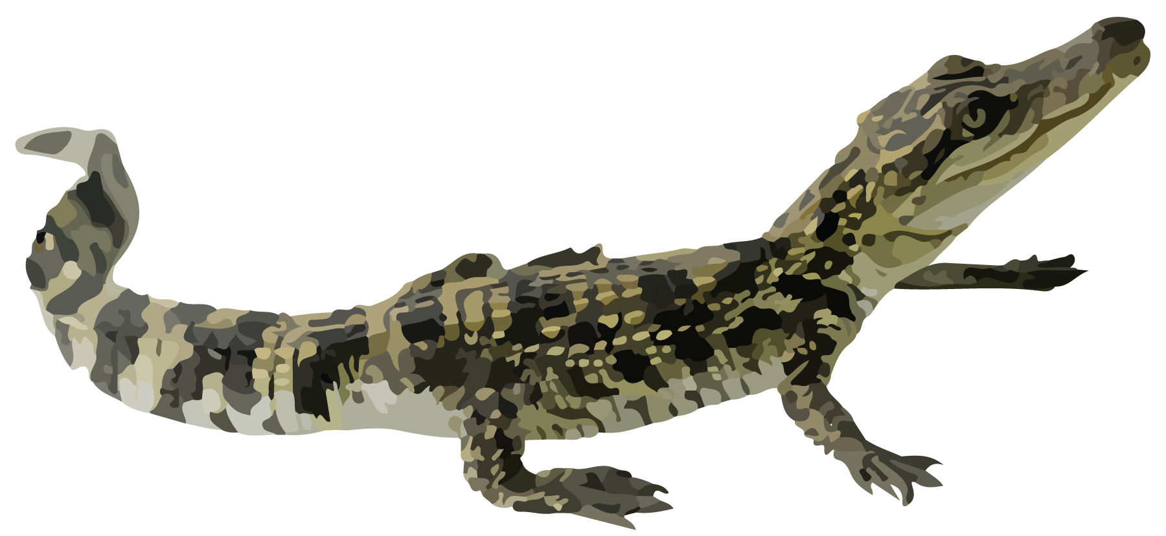
C: baby cobra
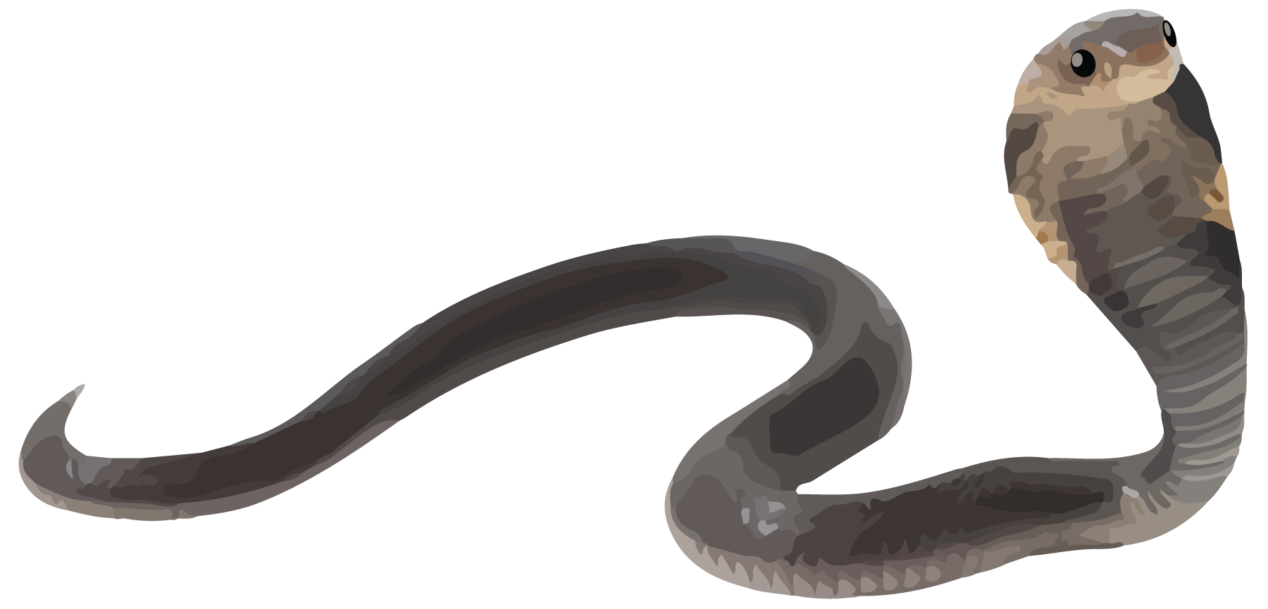
D: komodo dragon
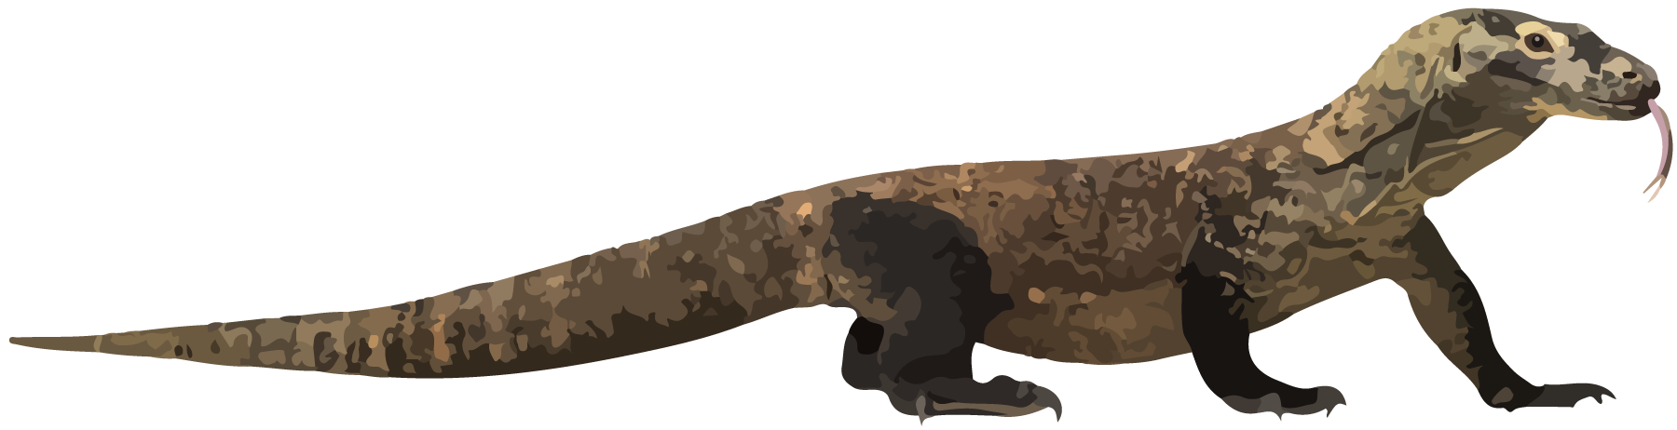
- Measure to find the length of each reptile. Don’t forget the unit.
  - What is the length of a gila monster?
  - What is the length of a baby alligator?
  - What is the length of a baby cobra?
  - What is the length of a komodo dragon?

2 Measure with a Meter Stick

Student Task Statement
D: komodo dragon
E: adult alligator
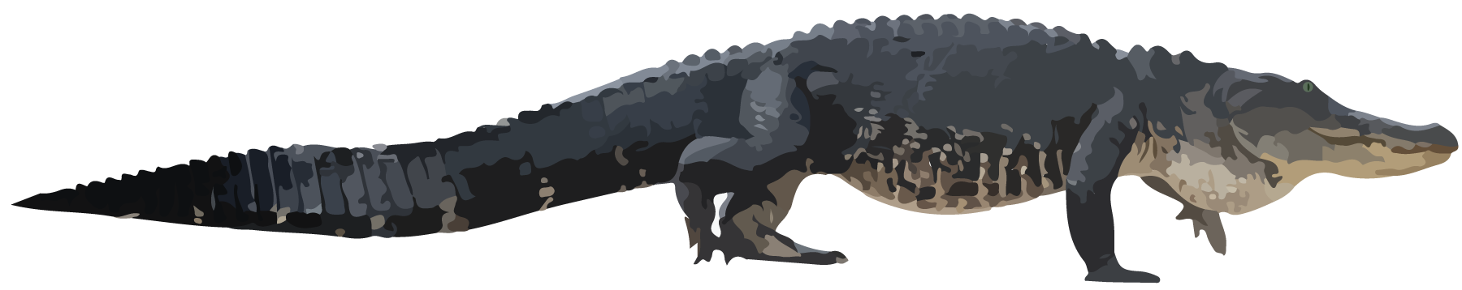
F: adult cobra
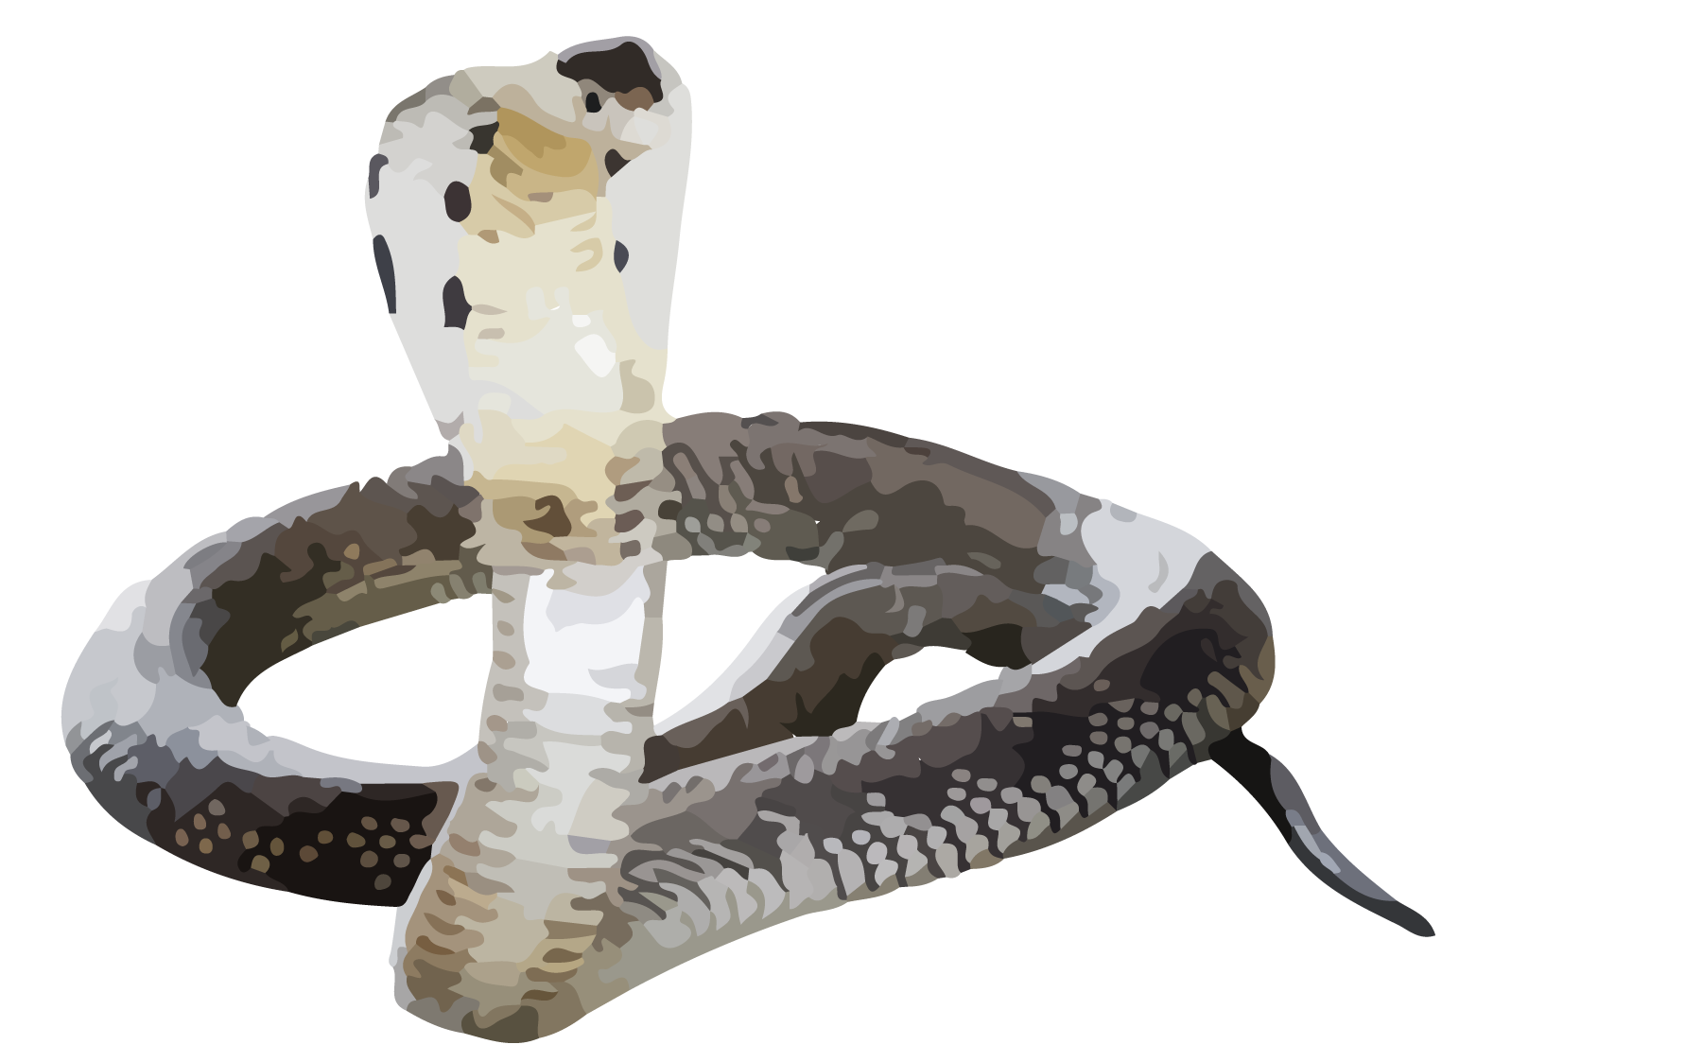
G: ribbon snake
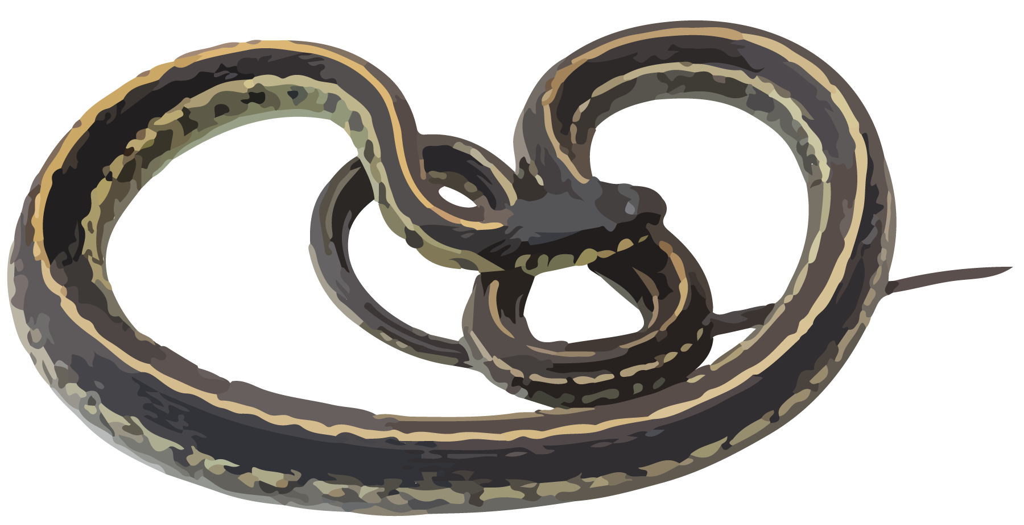
- Measure the length of the komodo dragon in meters.
- What is the same or different about your measurements for the komodo dragon from Activity 1 and Activity 2?
- Measure each reptile in centimeters or meters. Don’t forget the units.
  - How long is an adult alligator?
  - How long is an adult cobra?
  - How long is a ribbon snake?
© CC BY 2021 Illustrative Mathematics®

