Unit 3 Lesson 4: Introduction to Addition Algorithms

WU Which One Doesn’t Belong: 247 (Warm up)

Student Task Statement
Which one doesn’t belong?
A. $200+30+17$
B. 247
C. $200+47+10$
D. $100+140+7$

1 What is an Algorithm?

Student Task Statement
Three students found the value of $362+354$. Their work is shown. Explain how each method works.
- Tyler’s drawing
- 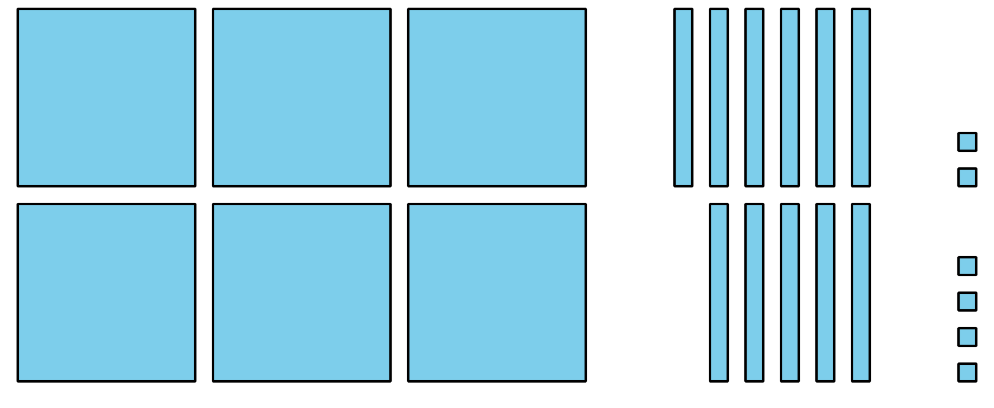
- Lin’s method
- 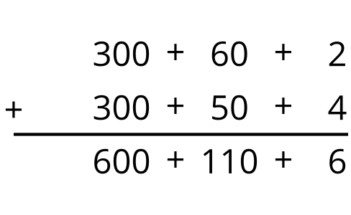
- Han’s method
- 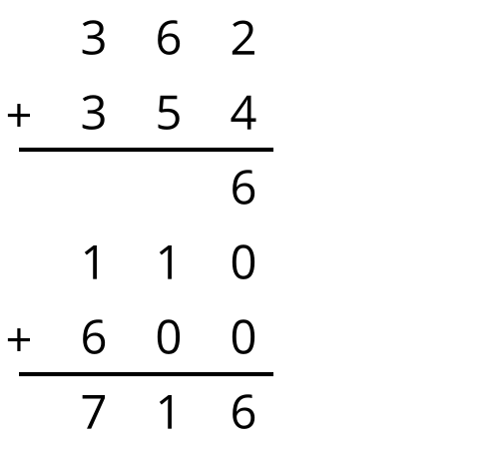
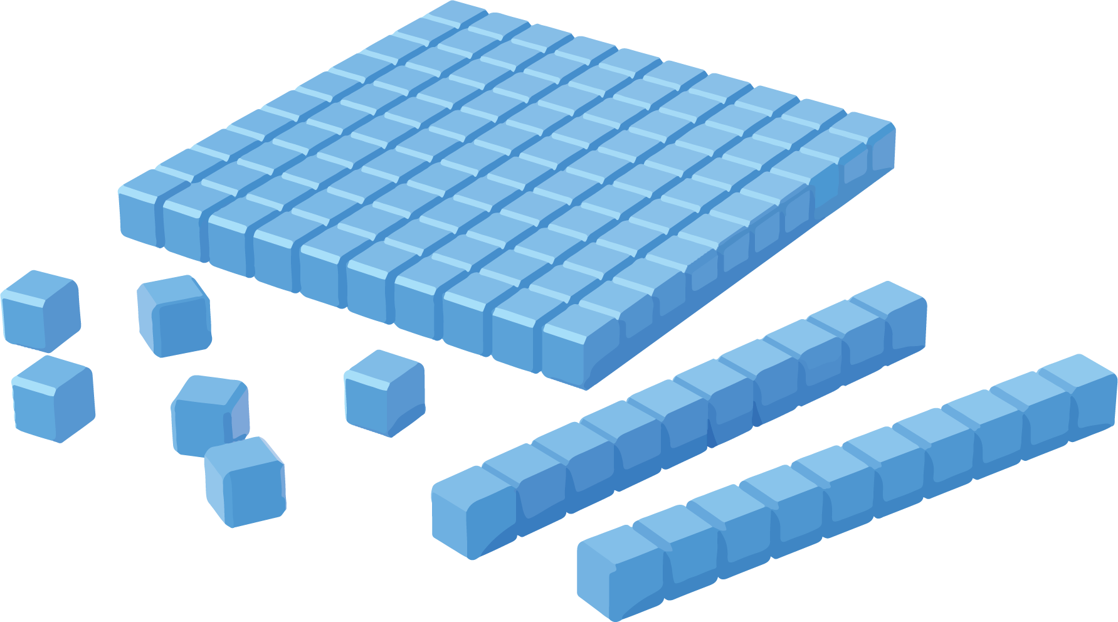

2 Try an Algorithm

Student Task Statement
Try using an algorithm to find the value of each sum. Show your thinking. Organize it so it can be followed by others.
- $475+231$
- $136+389$
- $670+257$

Activity Synthesis
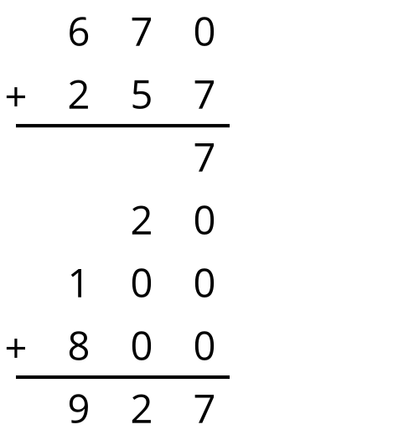
© CC BY 2021 Illustrative Mathematics®

