Lesson 10: Explore Multiplication Strategies with Rectangles

Standards Alignments
Addressing | 3.MD.C.7.c, 3.OA.C.7

Teacher-facing Learning Goals
- Use area diagrams to explore strategies based on properties of multiplication.

Student-facing Learning Goals
- Let’s use rectangles to explore multiplication strategies.

Lesson Purpose
The purpose of this lesson is for students to use area diagrams to explore multiplication strategies based on properties of operations.
Previously, students examined patterns in the multiplication table and used them to find products within 100 and to notice properties of multiplication—the commutative property, in particular. In this lesson, they analyze strategies for finding the area of rectangles to explore distributive and associative properties. They study gridded rectangles that have been decomposed into smaller parts and expressions that represent how the decomposition could help us find the area. Students see how the strategies, along with the diagrams and the expressions that represent them—can help us find the product of two numbers.
As students make sense of expressions and interpret them in terms of parts of area diagrams (MP1), they practice reasoning quantitatively and abstractly (MP2).

Access for:

Students with Disabilities
- Engagement (Activity 2)

English Learners
- MLR8 (Activity 2)

Instructional Routines
How Many Do You See? (Warm-up), MLR2 Collect and Display (Activity 1)

Materials to Gather
- Colored pencils, crayons, or markers: Activity 2

Lesson Timeline
Warm-up | 10 min
Activity 1 | 20 min
Activity 2 | 15 min
Lesson Synthesis | 10 min
Cool-down | 5 min

Teacher Reflection Question
Reflect on times you observed students listening to one another’s ideas today in class. What norms would help each student better attend to their classmates’ ideas in future lessons?

Cool-down
(to be completed at the end of the lesson) 5min
Mark or Shade Parts to Find Area

Standards Alignments
Addressing | 3.MD.C.7.c, 3.OA.C.7

Student-facing Task Statement
Here is a rectangle whose area can be found by finding $6×7$.
- Mark or shade the rectangle to show that we can write $2×\left(3×7\right)$ or $\left(6×5\right)+\left(6×2\right)$ to find its area.
- What is the value of $6×7$? Explain or show your reasoning.
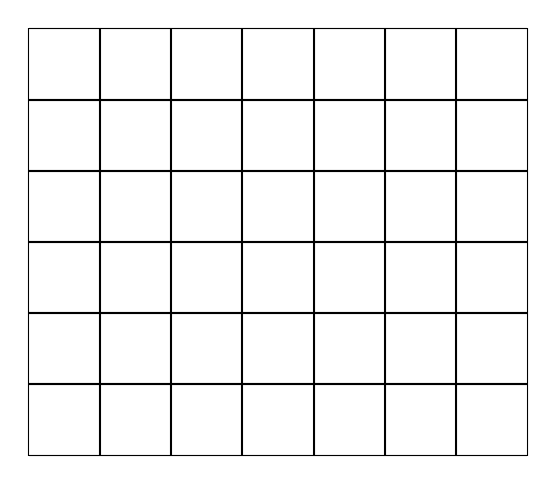

Student Responses
- Sample responses:
- 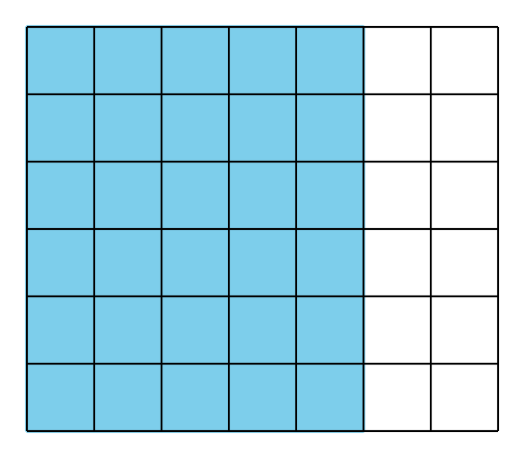
- 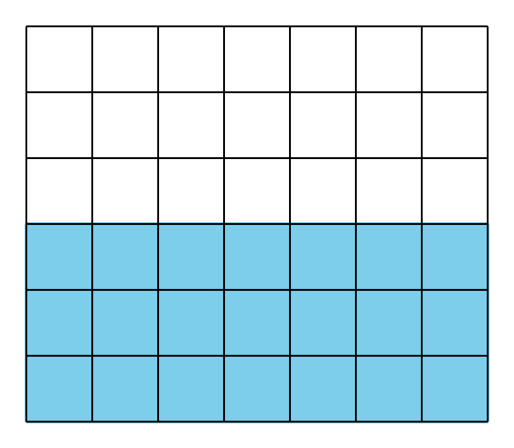
- 42. I know that $6×5$ is 30 and $6×2$ is 12, and $30+12=42$.

