Lesson 3: Are the Expressions Equal?
- Let’s think about how expressions can be equal.

Warm-up: How Many Do You See: Sums within 10
How many do you see?
How do you see them?
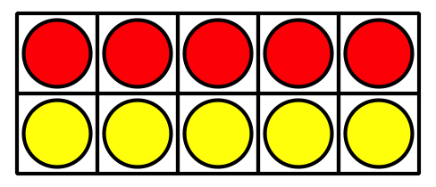
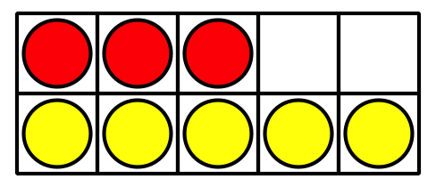
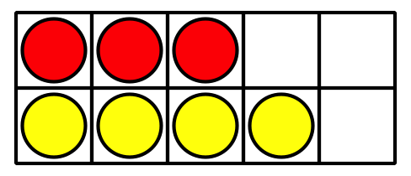

3.2: Are Both Sides Equal?
Determine whether each equation is true or false.
Be ready to explain your reasoning in a way that others will understand.
- $4+2=2+4$
- 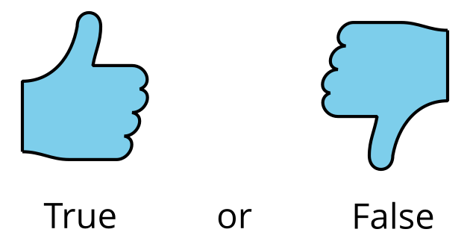
- $3+6=6+4$
- $5+3=1+7$
- $6+4=5+3$
- $6+3=9+2$
If you have time: Change the false equations to make them true.
© CC BY 2021 Illustrative Mathematics®

