Lesson 18: Center Day 3
- Let’s play games about tens and ones.

Warm-up: Number Talk: Start with 32
Find the value of each expression mentally.
- $32+10$
- $32+10+10$
- $32+20$
- $32−20$

18.2: Centers: Choice Time
Choose a center.
Greatest of Them All
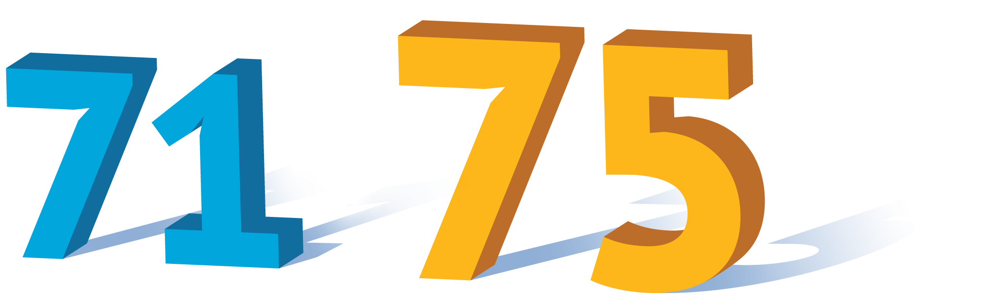
Grab and Count
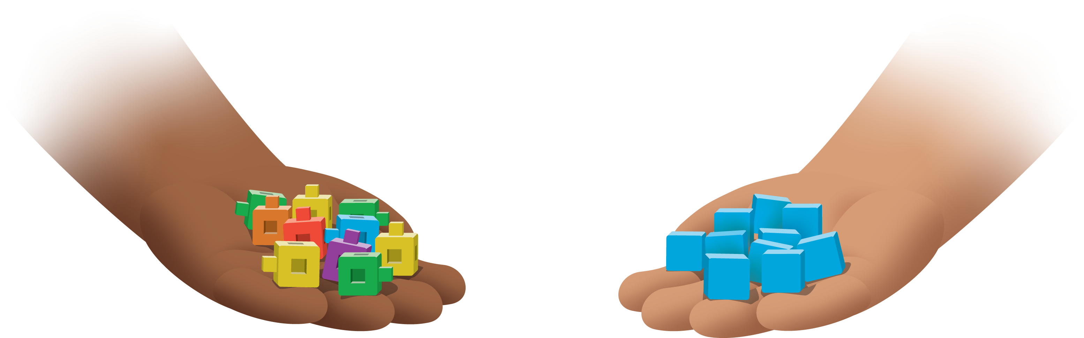
Write Numbers
© CC BY 2021 Illustrative Mathematics®

