Unit 2 Lesson 6 Cumulative Practice Problems
- Each diagram has a pair of figures, one larger than the other. For each pair, show that the two figures are similar by identifying a sequence of translations, rotations, reflections, and dilations that takes the smaller figure to the larger one.
- 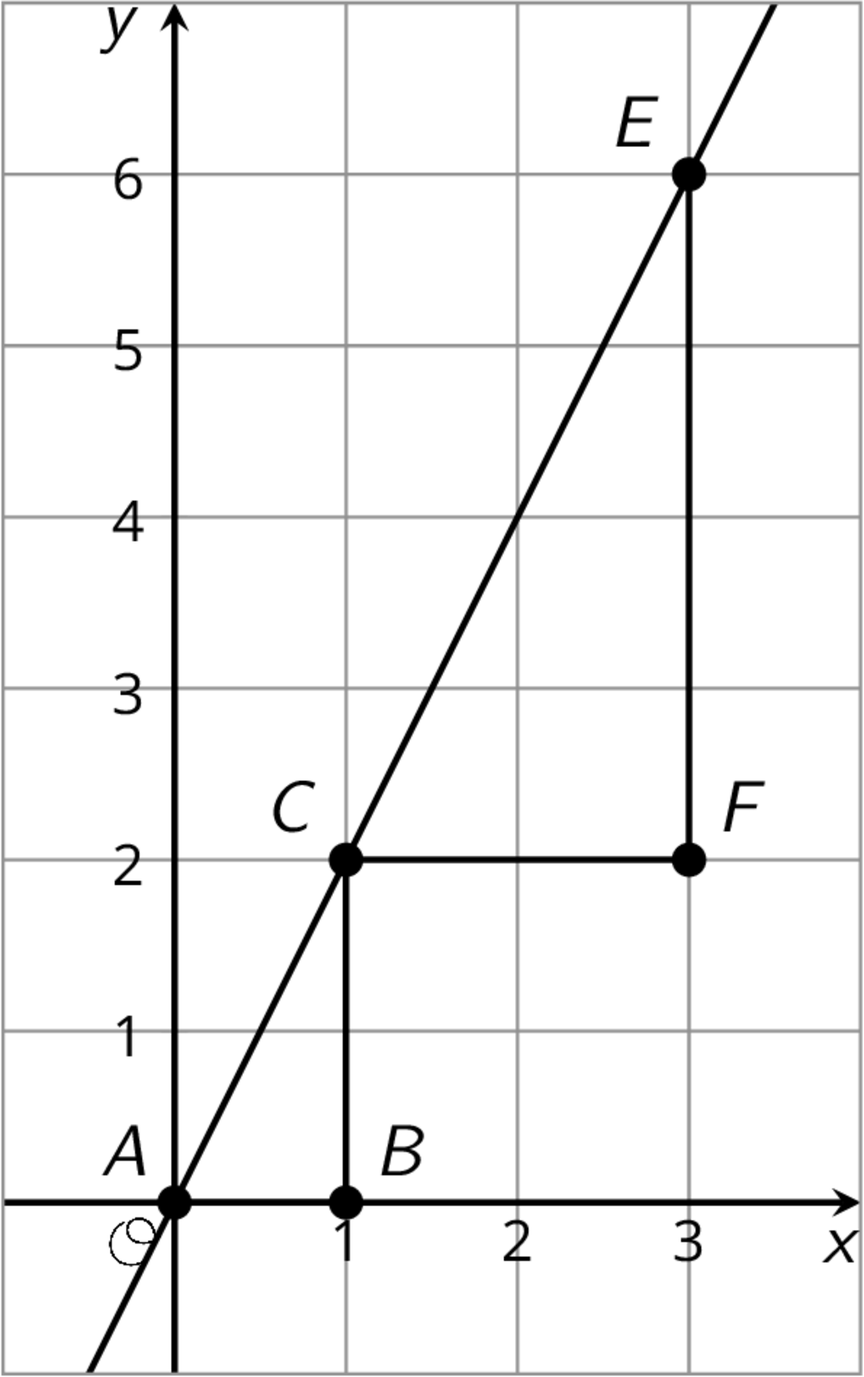
- 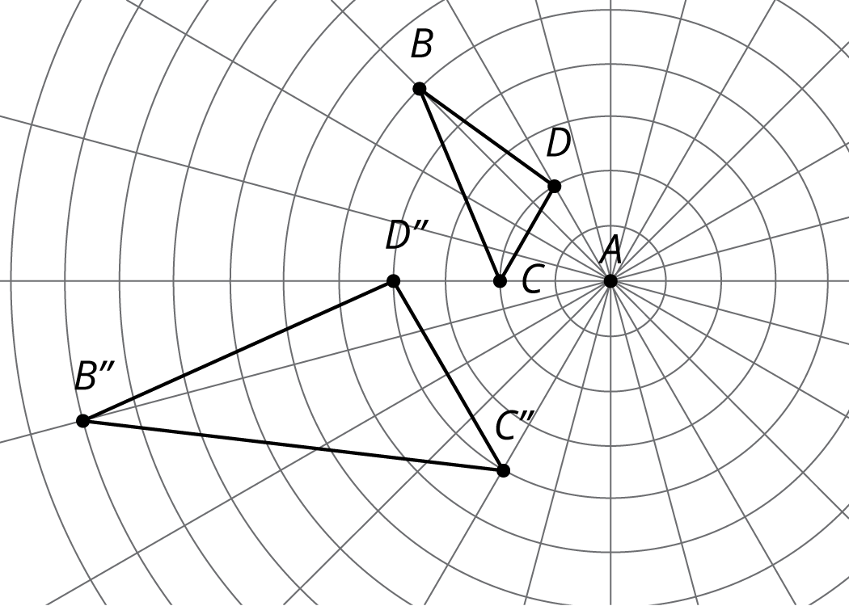
- Here are two similar polygons.
- Measure the side lengths and angles of each polygon. What do you notice?
- 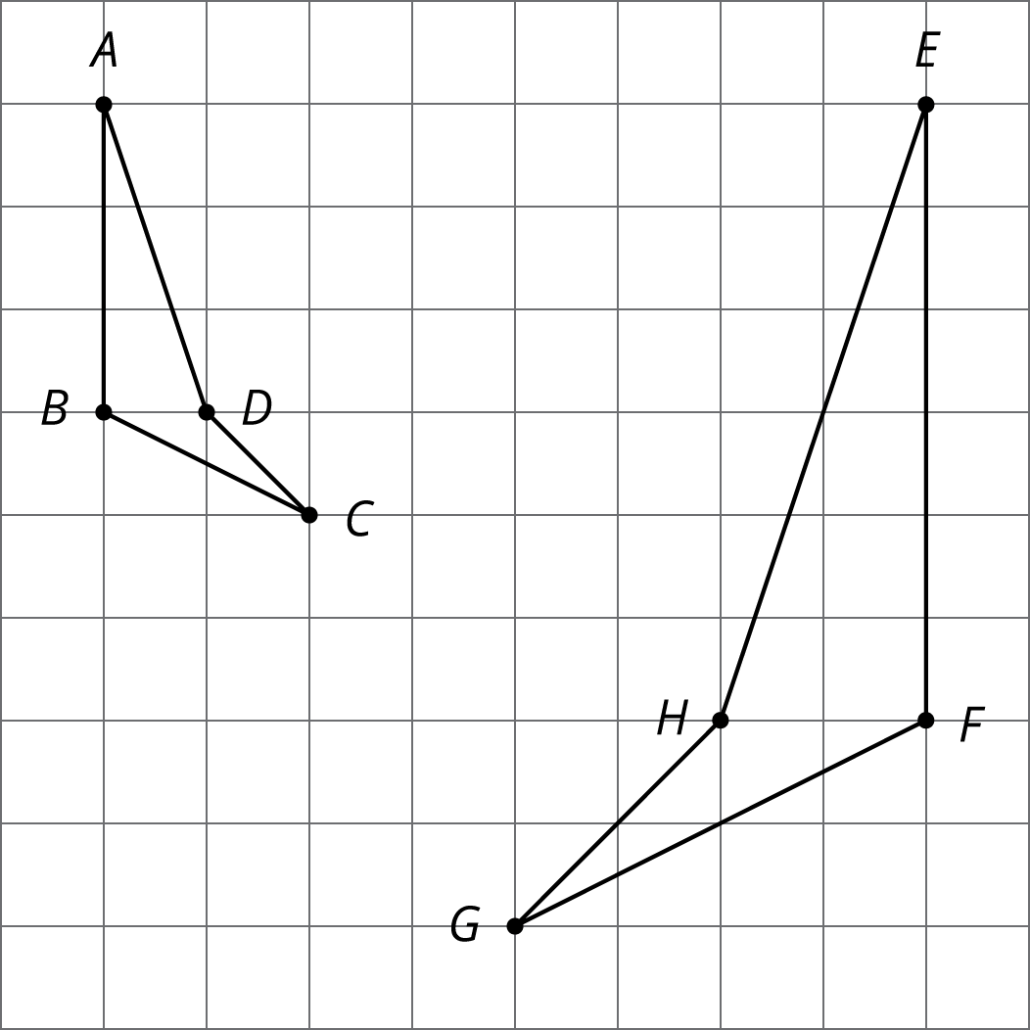
- Each figure shows a pair of similar triangles, one contained in the other. For each pair, describe a point and a scale factor to use for a dilation moving the larger triangle to the smaller one. Use a measurement tool to find the scale factor.
- 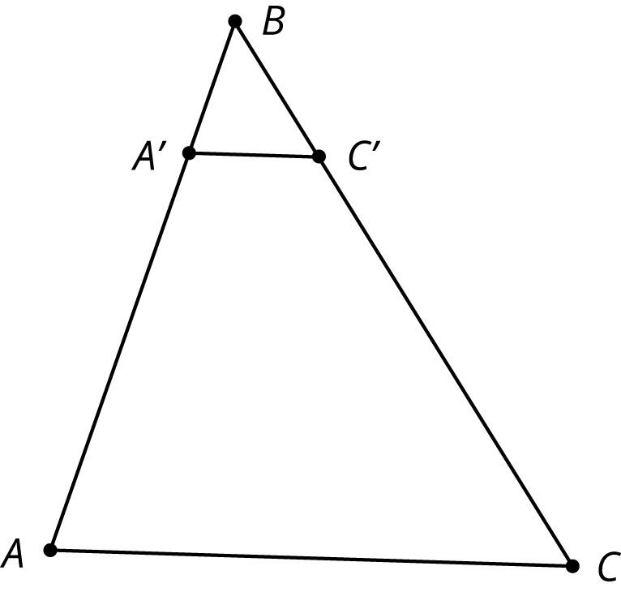
- 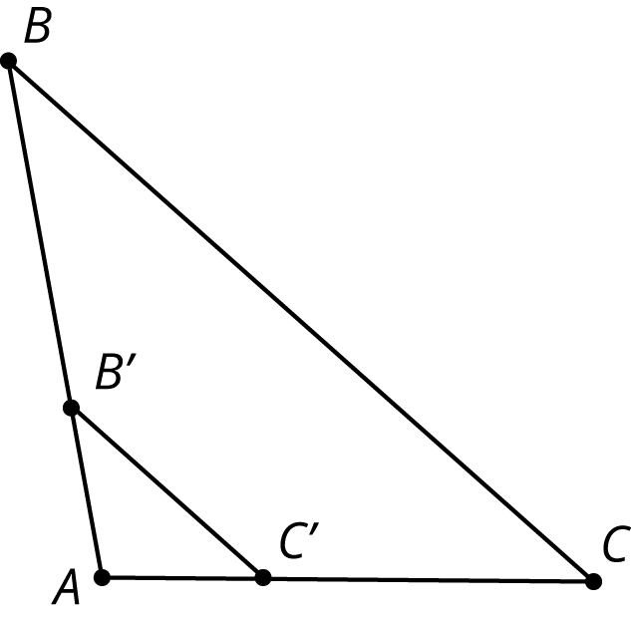
© CC BY Open Up Resources. Adaptations CC BY IM.

