Unit 3 Lesson 6: Compare Reptile Lengths in Story Problems

WU Number Talk: Fives and Tens (Warm up)

Student Task Statement
Find the value of each expression mentally.
- $5+5$
- $15+5$
- $15+15$
- $15+25$

1 Whose Pet is Longer?

Student Task Statement
- Lin's pet lizard is 62 cm long. It is 19 cm shorter than Jada's. How long is Jada's pet lizard?
  - Whose pet is longer? ________________________________
  - Circle the diagram that matches the story.
  - 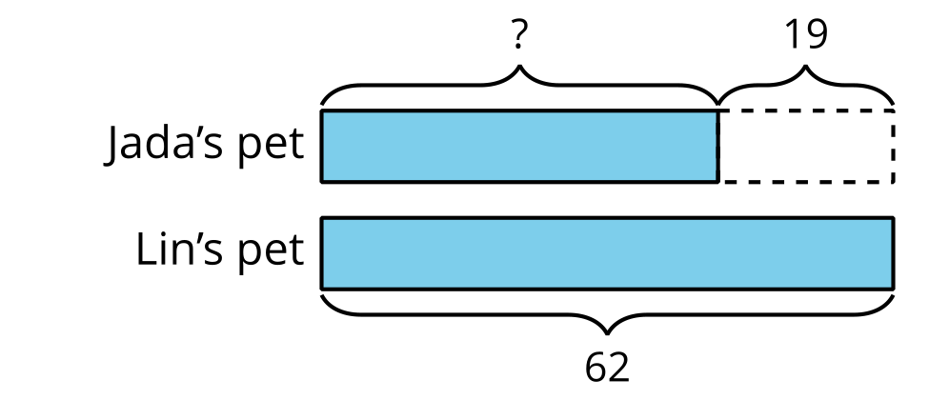
  - 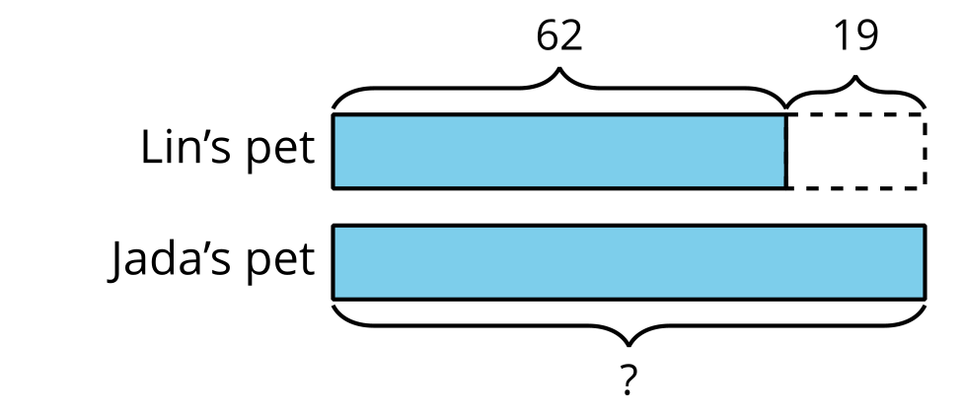
  - Solve. Show your thinking.
  - Jada’s pet lizard is ____________ cm long.
- Diego and Mai have pet snakes. Mai’s snake is 17 cm longer than Diego’s. Mai’s snake is 71 cm. How long is Diego’s pet snake?
  - Whose pet is shorter? ________________________________
  - Circle the diagram that matches the story.
  - 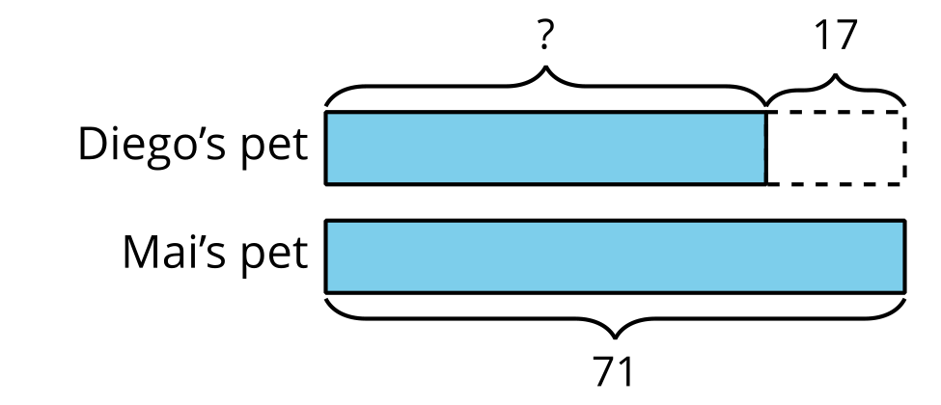
  - 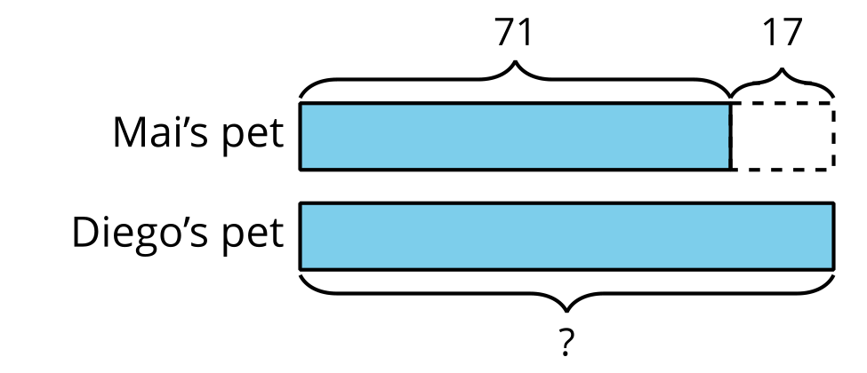
  - Solve. Show your thinking.
  - Diego’s pet snake is ____________ cm long.

2 Guess My Reptiles

Student Task Statement
Partner A's reptiles
Partner B's reptiles
1. day gecko, 28 cm
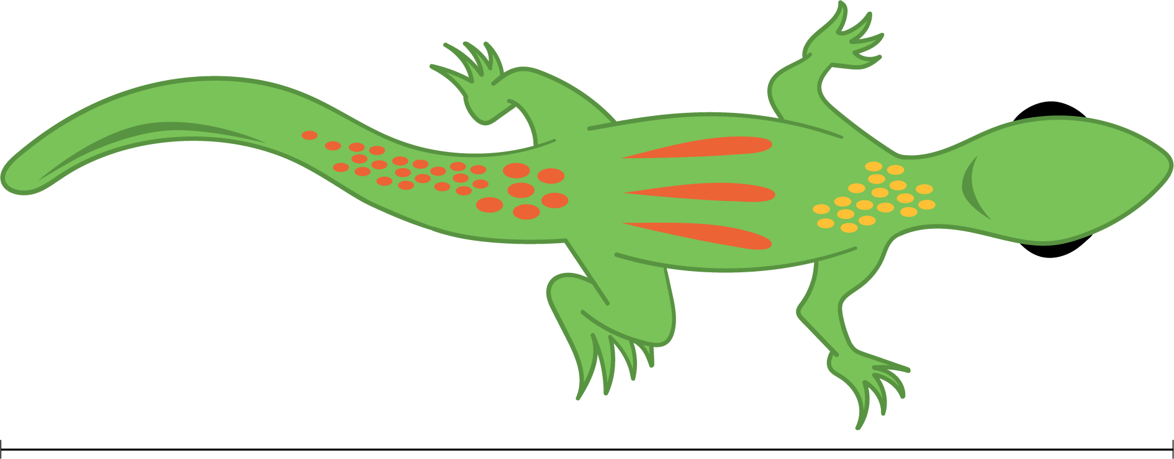
1. ribbon snake, 83 cm
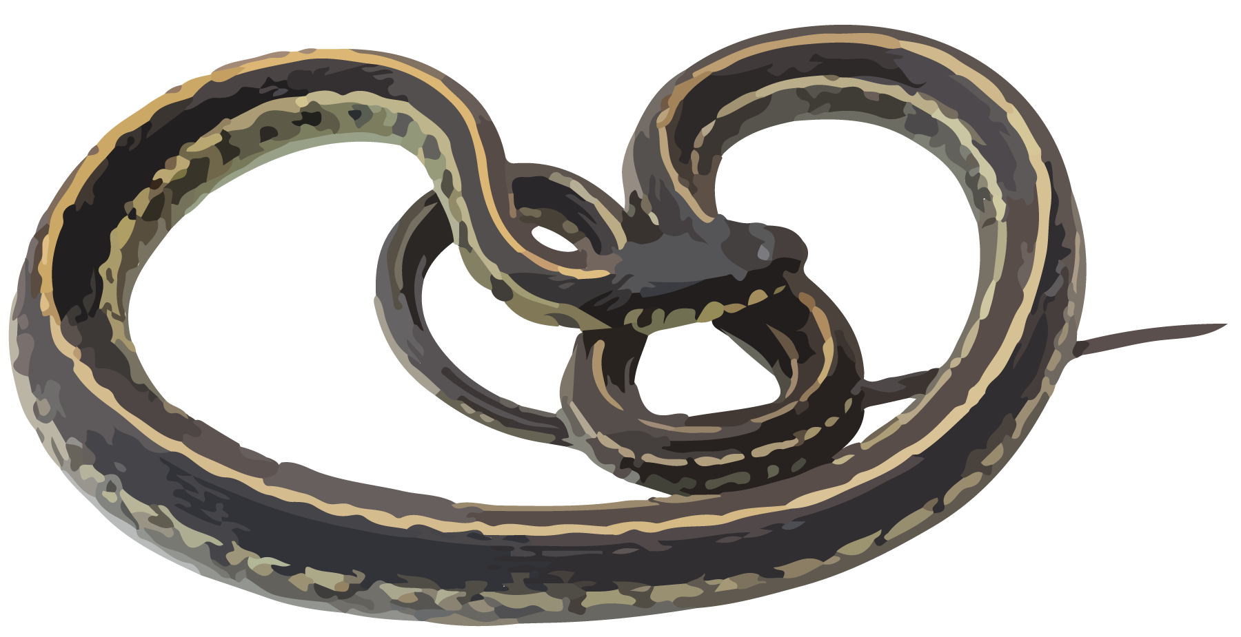
2. komodo dragon, 98 cm
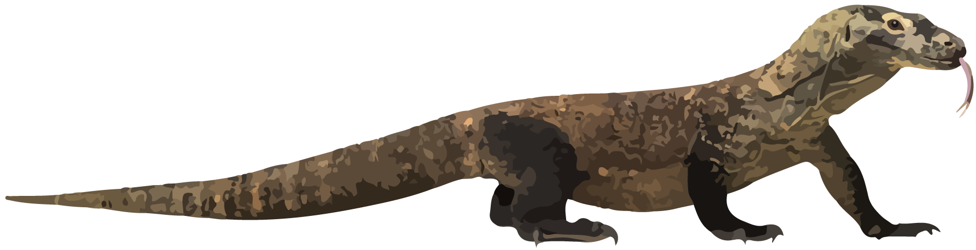
2. gila monster, 55 cm
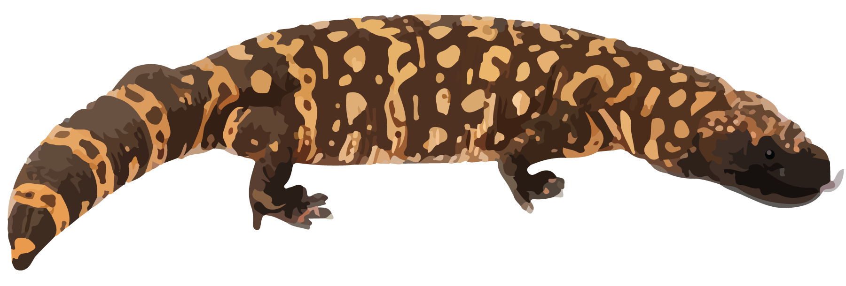
​​​
3. baby cobra, 46 cm
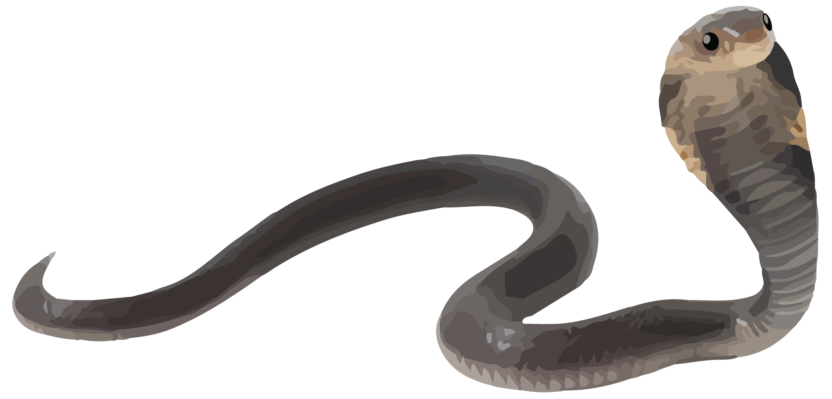
3. baby alligator, 71 cm
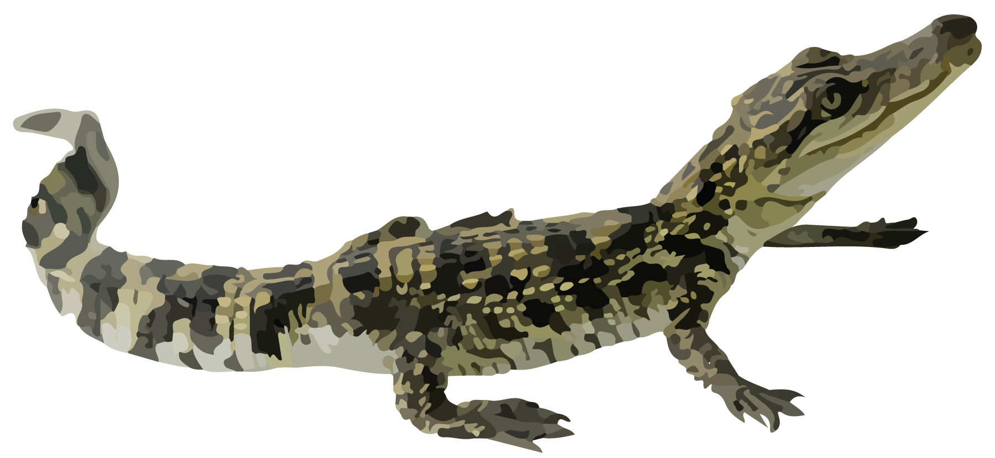
4. iguana, 65 cm
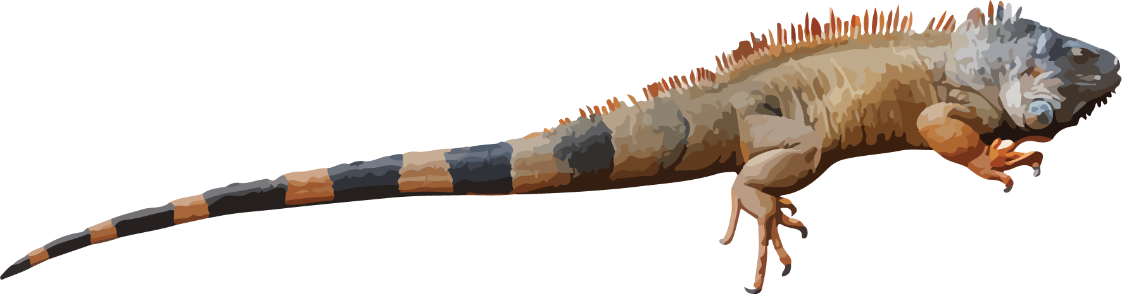
4. ringneck snake, 38 cm
- Choose one reptile from your list and one reptile from your partner’s list.
- Fill in the blanks to create a story problem using the lengths of the reptiles you picked. Then share your sentences with your partner.
- My reptile is ____________ cm long.
- It is ____________ cm ________________________________(shorter/longer) than one of your reptiles.
- Which reptiles did your partner pick? Show your thinking.
© CC BY 2021 Illustrative Mathematics®

