Lesson 4: Sums of 10
- Let’s find all the ways to make 10.

Warm-up: True or False: Equal Expressions
Decide if each statement is true or false.
Be prepared to explain your reasoning.
- $3+5=8$
- $6+3=8$
- $3+5=5+3$

4.2: All The Ways To Make 10
- Show all the ways to make 10.
- How do you know that you have found all the ways?
Be ready to explain your thinking in a way that others will understand.

4.3: Centers: Choice Time
Choose a center.
Number Puzzles
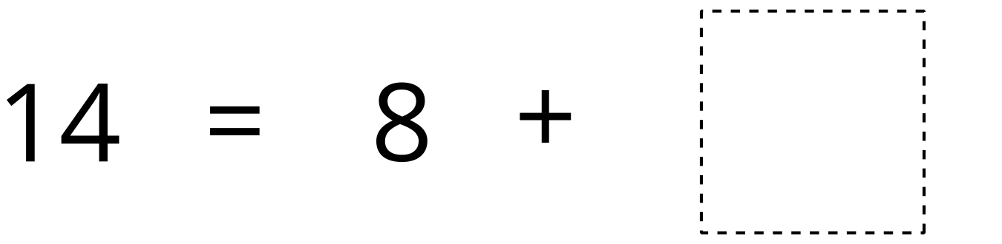
Check it Off
Find the Pair
© CC BY 2021 Illustrative Mathematics®

