Lesson 19: Make Two-digit Numbers
- Let’s make two-digit numbers with tens and ones in different ways.

Warm-up: Which One Doesn’t Belong: Different Ways to Show a Number
Which one doesn’t belong?
A
B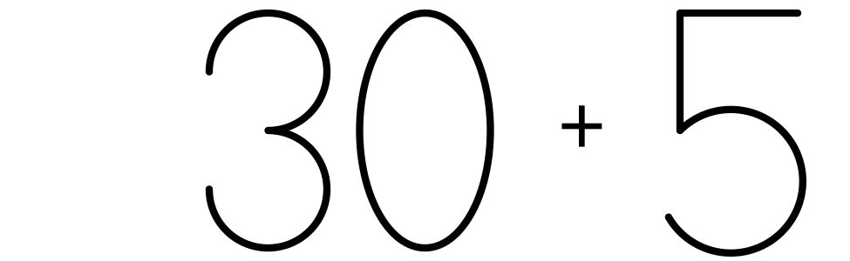
C
D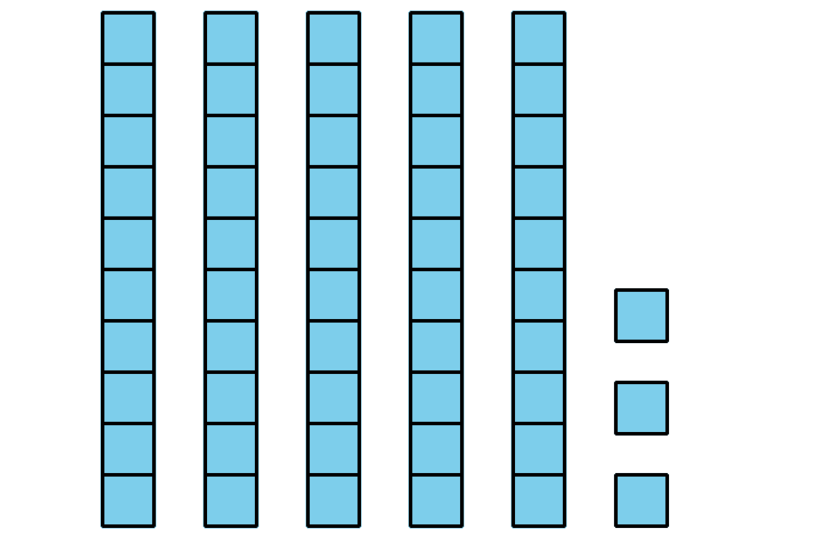

19.1: Make 65 Using Tens and Ones
Create a collection of 65.
You may not break apart any towers.
You may not make any new towers.
Show your collection in a way that others will understand.
If you have time, think of another way to make 65 using the cubes in the bag.

19.2: Make 37 in Different Ways
How many ways can you make 37?
Show your thinking using drawings, numbers, or words.

19.3: Centers: Choice Time
Choose a center.
Greatest of Them All
Get Your Numbers in Order
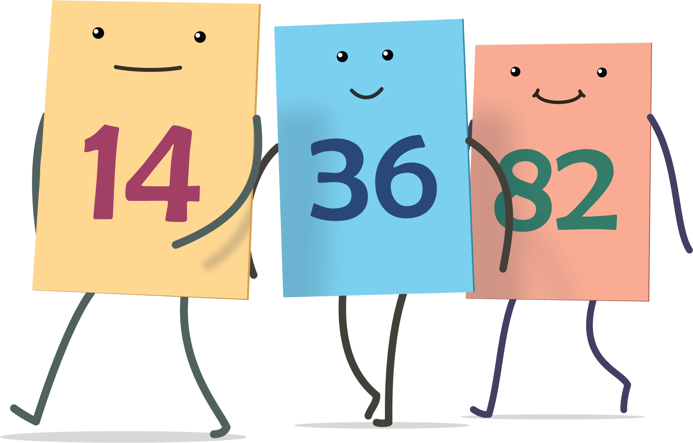
Grab and Count
© CC BY 2021 Illustrative Mathematics®

