Unit 1 Lesson 10 Cumulative Practice Problems
- If two rectangles have the same perimeter, do they have to be congruent? Explain how you know.
- Draw two rectangles that have the same area, but are not congruent.
- For each pair of shapes, decide whether or not the two shapes are congruent. Explain your reasoning.

  - 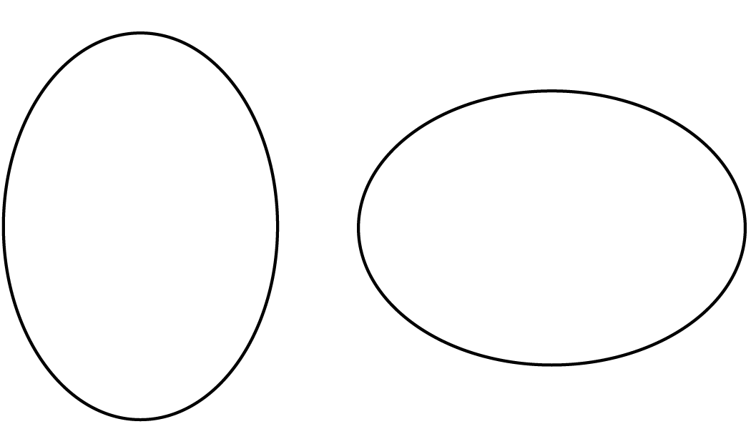

  - 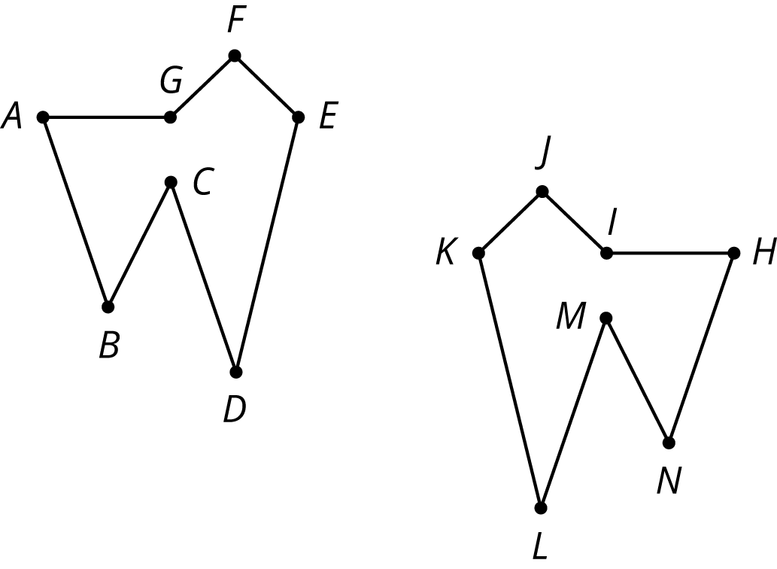
  - Reflect Quadrilateral A over the $x$-axis. Label the image quadrilateral B. Reflect Quadrilateral B over the $y$-axis. Label the image C.
  - 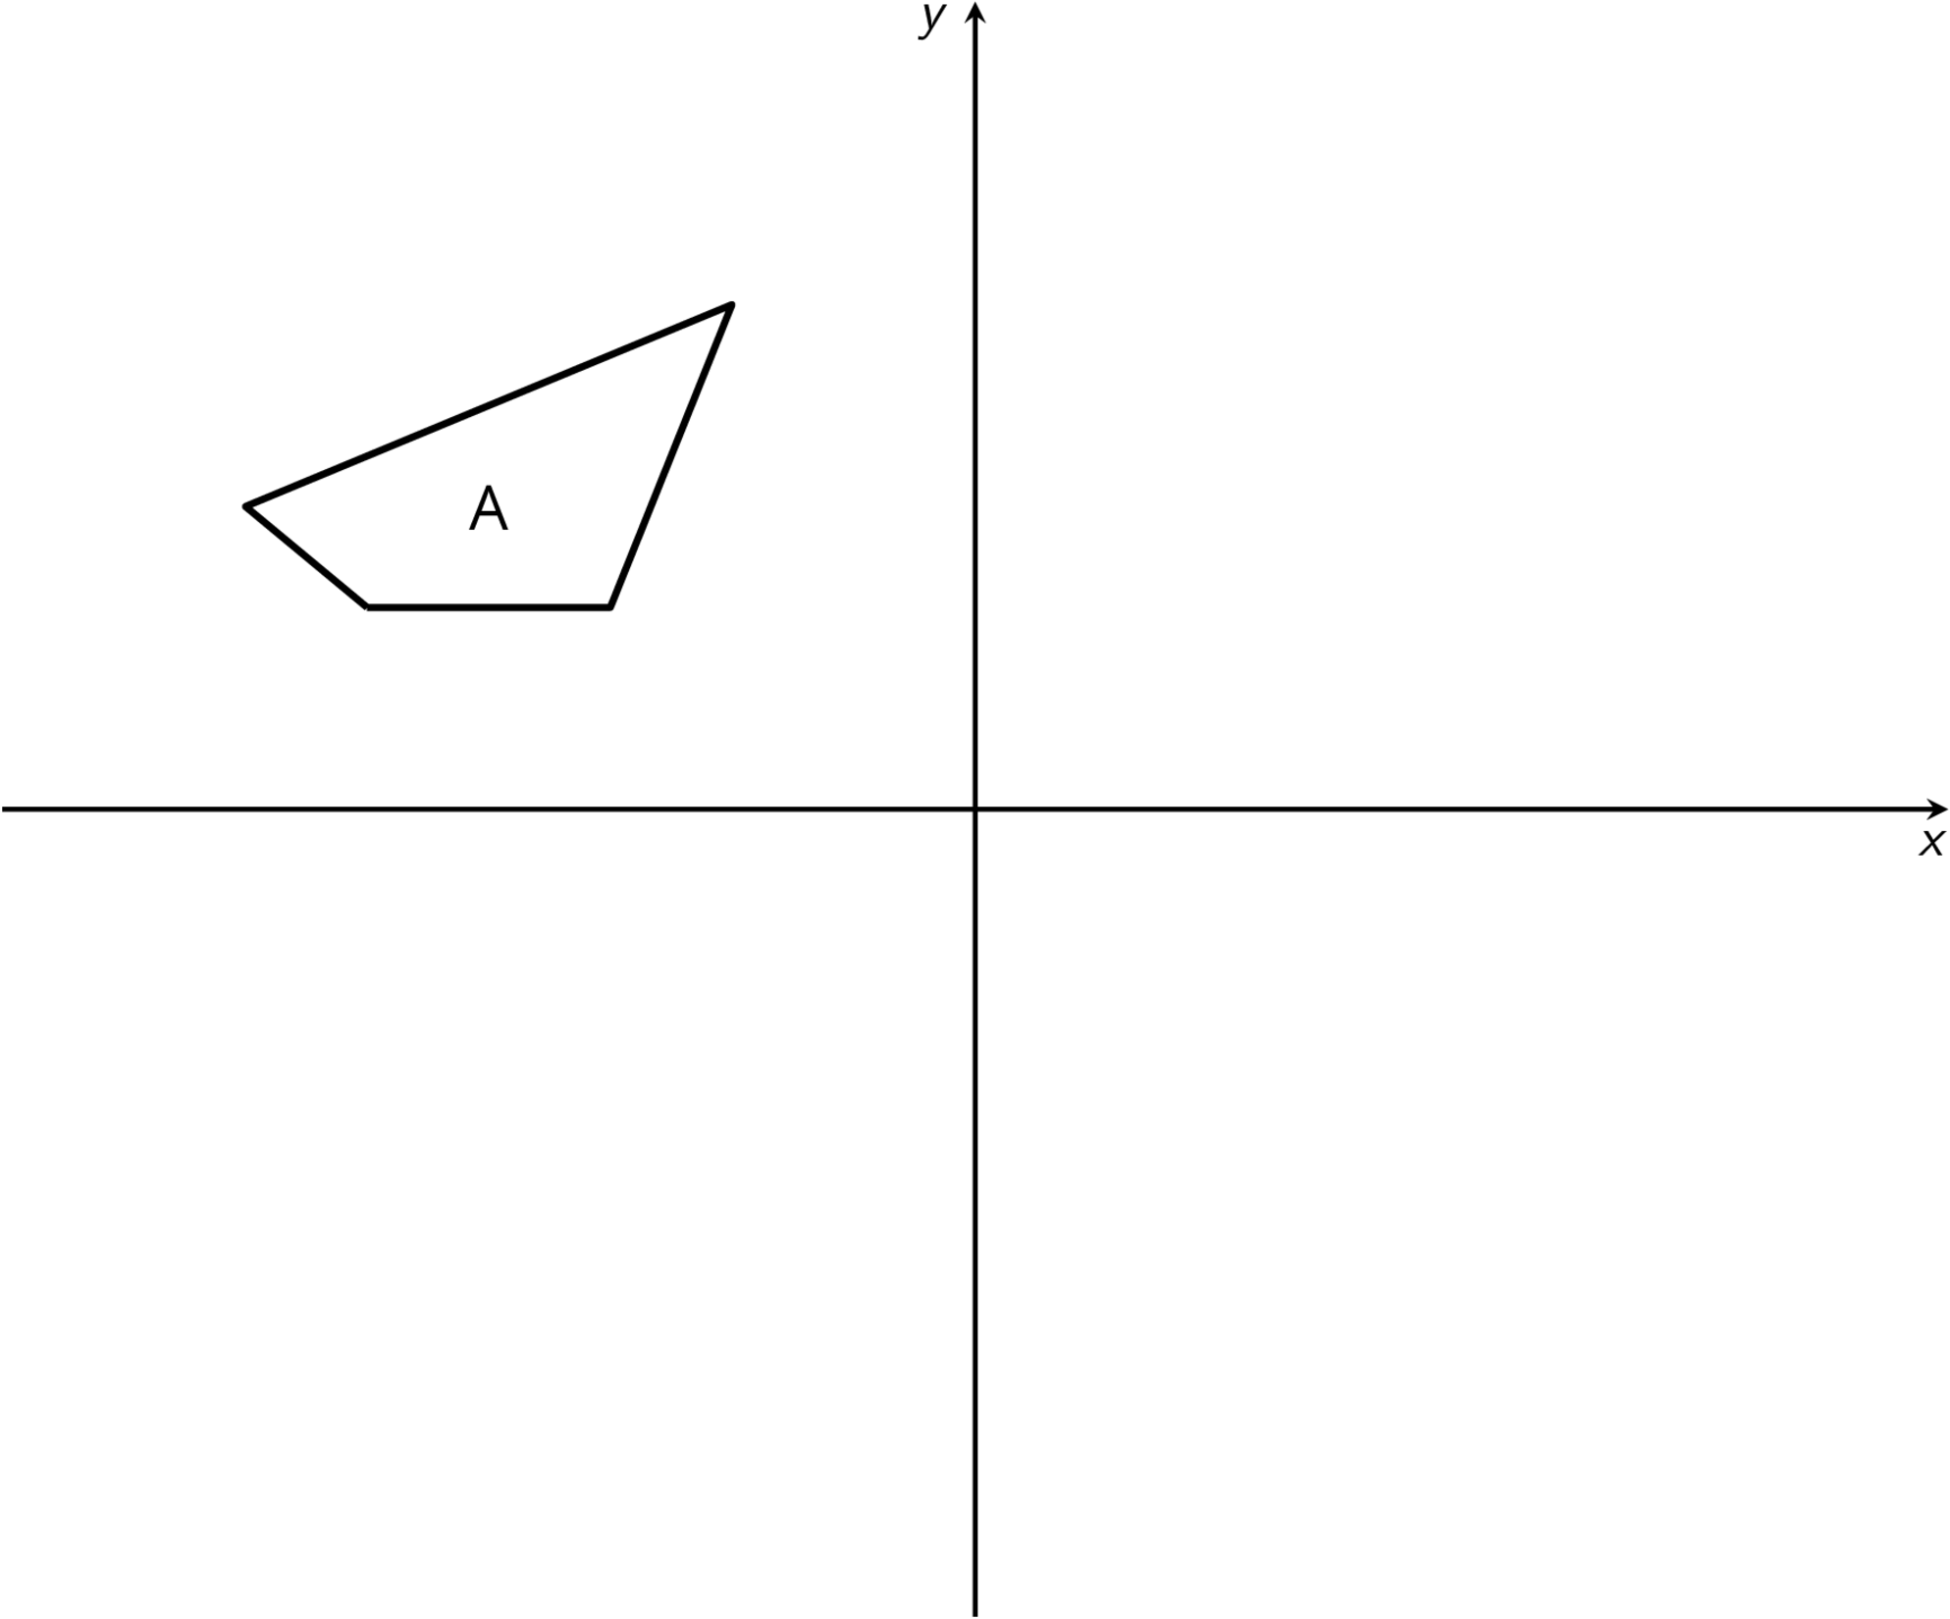
  - Are Quadrilaterals A and C congruent? Explain how you know.
- The point $(\text{-}2,\text{-}3)$ is rotated 90 degrees counterclockwise using center $(0,0)$. What are the coordinates of the image?
  - $(\text{-}3,\text{-}2)$
  - $(\text{-}3,2)$
  - $(3,\text{-}2)$
  - $(3,2)$
- (From Unit 1, Lesson 5.)
- Describe a rigid transformation that takes Polygon A to Polygon B.
- 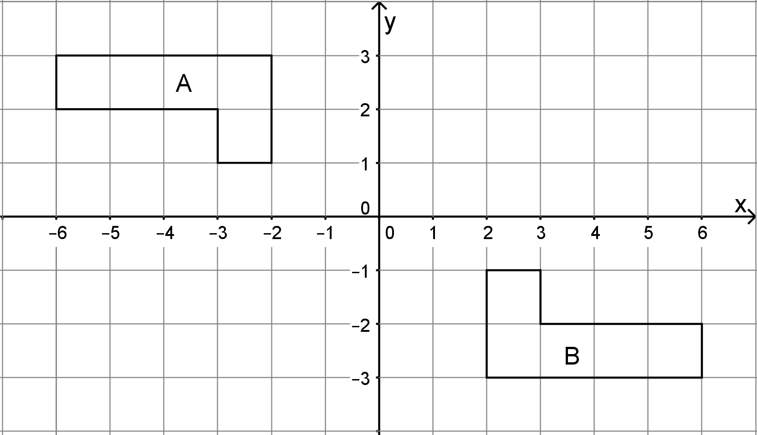
- (From Unit 1, Lesson 6.)
© CC BY Open Up Resources. Adaptations CC BY IM.

