Unit 6 Lesson 18: Subtraction in Equivalent Expressions

1 Number Talk: Additive Inverses (Warm up)

Student Task Statement
Find each sum or difference mentally.
$\text{-}30+\text{-}10$
$\text{-}10+\text{-}30$
$\text{-}30−10$
$10−\text{-}30$

2 A Helpful Observation

Student Task Statement
Lin and Kiran are trying to calculate $7\frac{3}{4}+3\frac{5}{6}−1\frac{3}{4}$. Here is their conversation:
Lin: “I plan to first add $7\frac{3}{4}$ and $3\frac{5}{6}$, so I will have to start by finding equivalent fractions with a common denominator.”
Kiran: “It would be a lot easier if we could start by working with the $1\frac{3}{4}$ and $7\frac{3}{4}$. Can we rewrite it like $7\frac{3}{4}+1\frac{3}{4}−3\frac{5}{6}$?”
Lin: “You can’t switch the order of numbers in a subtraction problem like you can with addition; $2−3$ is not equal to $3−2$.”
Kiran: “That’s true, but do you remember what we learned about rewriting subtraction expressions using addition? $2−3$ is equal to $2+\left(\text{-}3\right)$.”
- Write an expression that is equivalent to $7\frac{3}{4}+3\frac{5}{6}−1\frac{3}{4}$ that uses addition instead of subtraction.
- If you wrote the terms of your new expression in a different order, would it still be equivalent? Explain your reasoning.

3 Organizing Work

Images for Launch
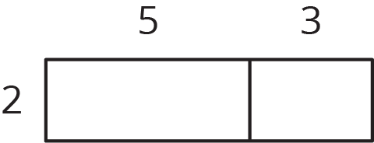
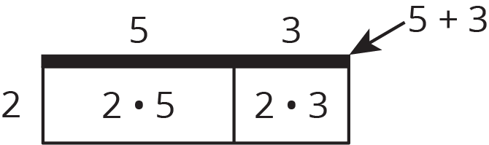

Student Task Statement
- Write two expressions for the area of the big rectangle.
- 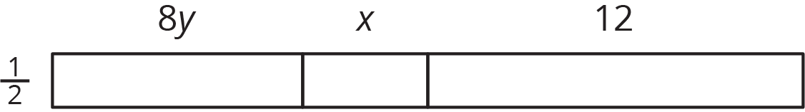
- Use the distributive property to write an expression that is equivalent to $\frac{1}{2}\left(8y+\text{-}x+\text{-}12\right)$. The boxes can help you organize your work.
- 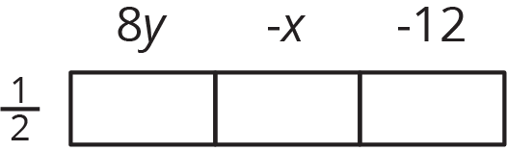
- Use the distributive property to write an expression that is equivalent to $\frac{1}{2}\left(8y−x−12\right)$.

Activity Synthesis
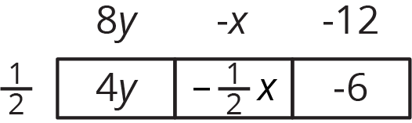
© CC BY Open Up Resources. Adaptations CC BY IM.

