Lesson 10 Practice Problems
- A triangle has sides of length 7 cm, 4 cm, and 5 cm. How many unique triangles can be drawn that fit that description? Explain or show your reasoning.
- A triangle has one side that is 5 units long and an adjacent angle that measures ${25}^{∘}$. The two other angles in the triangle measure ${90}^{∘}$ and ${65}^{∘}$. Complete the two diagrams to create two different triangles with these measurements.
- 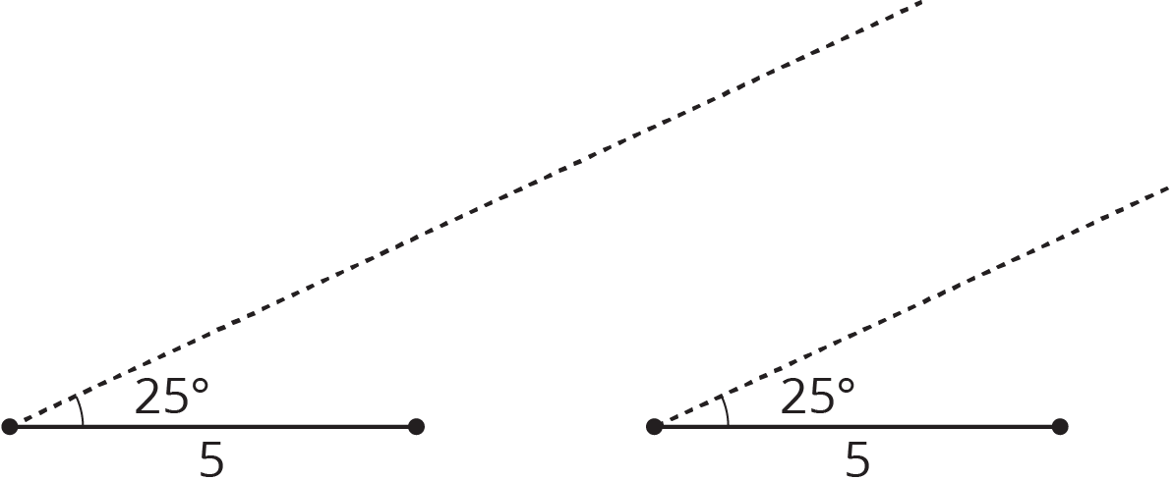
- Is it possible to make a triangle that has angles measuring 90 degrees, 30 degrees, and 100 degrees? If so, draw an example. If not, explain your reasoning.
- Segments $CD$, $AB$, and $FG$ intersect at point $E$. Angle $FEC$ is a right angle. Identify any pairs of angles that are complementary.
- 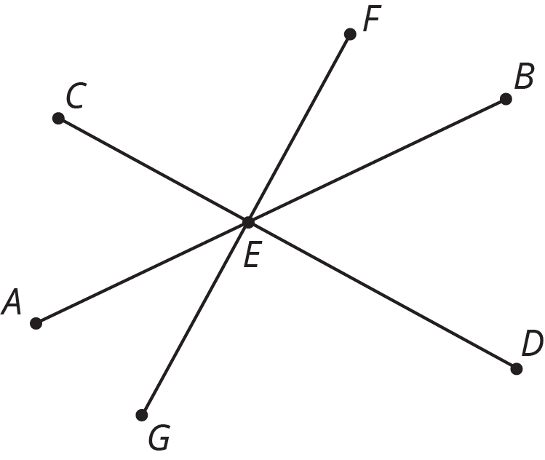
- (From Unit 7, Lesson 2.)
- Match each equation to a step that will help solve the equation for $x$.
  - $3x=\text{-}4$
  - $\text{-}4.5=x−3$
  - $3=\frac{\text{-}x}{3}$
  - $\frac{1}{3}=\text{-}3x$
  - $x−\frac{1}{3}=0.4$
  - $3+x=8$
  - $\frac{x}{3}=15$
  - $7=\frac{1}{3}+x$
  - Add $\frac{1}{3}$ to each side.
  - Add $\frac{\text{-}1}{3}$ to each side.
  - Add $3$ to each side.
  - Add $\text{-}3$ to each side.
  - Multiply each side by 3..
  - Multiply each side by $\text{-}3$.
  - Multiply each side by $\frac{1}{3}$.
  - Multiply each side by $\frac{\text{-}1}{3}$
- (From Unit 5, Lesson 15.)

  - If you deposit $300 in an account with a 6% interest rate, how much will be in your account after 1 year?
  - If you leave this money in the account, how much will be in your account after 2 years?
- (From Unit 4, Lesson 8.)
© CC BY Open Up Resources. Adaptations CC BY IM.

