Unit 4 Lesson 21: Solve Problems Using the Four Operations

Notice and Wonder: Apples Again (Warm up)

Student Task Statement
What do you notice? What do you wonder?
A farmer picked some apples.
Some of the apples are packed into boxes and some are not.

1 Apple Adventure

Student Task Statement
A farmer picked some apples. Some of the apples are packed into boxes and some are not.
From the list, choose 4 numbers that would make sense together in this situation. Write your choices in the table. Be ready to explain how your numbers make sense together.
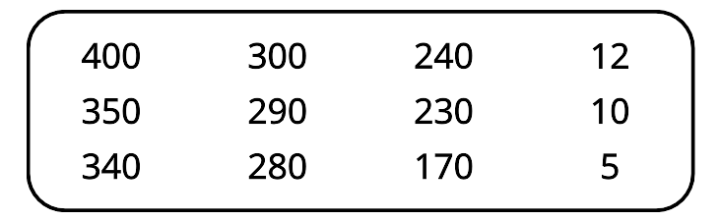
total number of apples | number of apples not in boxes | number of boxes | number of apples in each box
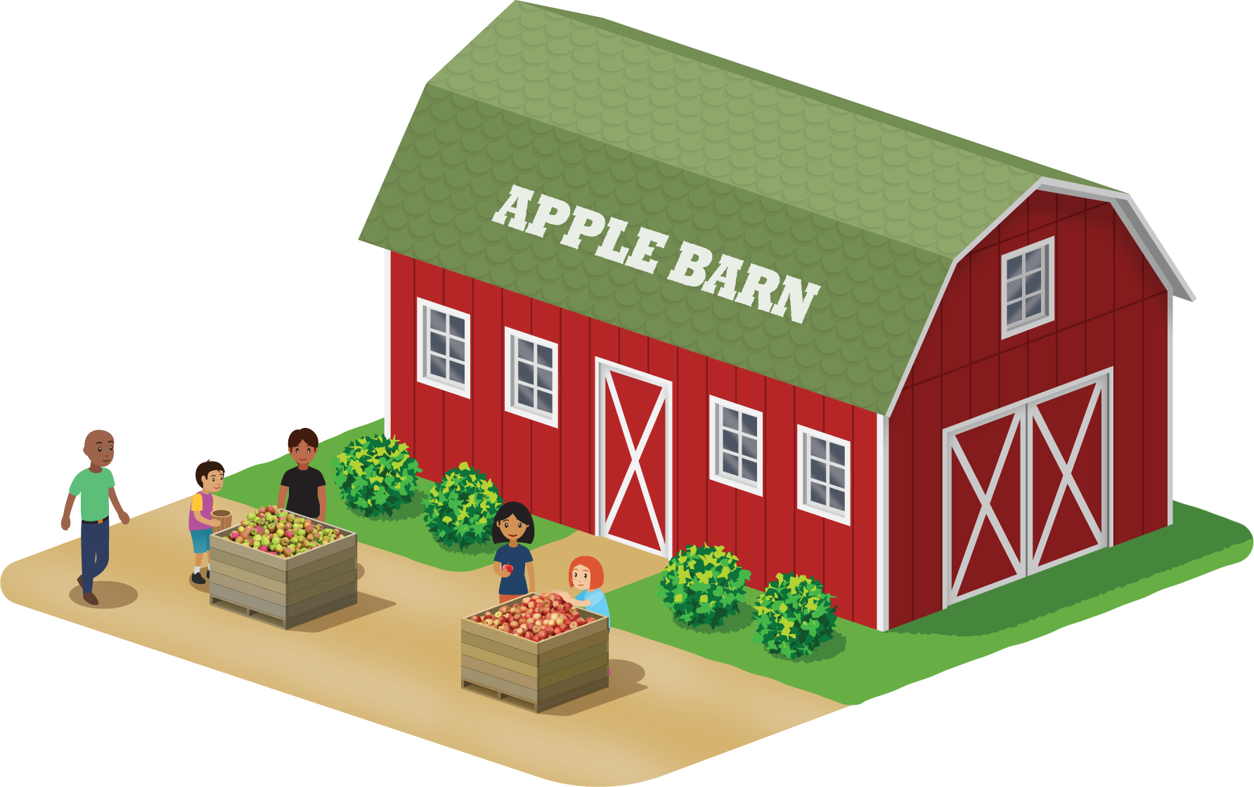

2 Apple Days

Student Task Statement
Tyler and Clare are helping with a festival at an apple orchard.
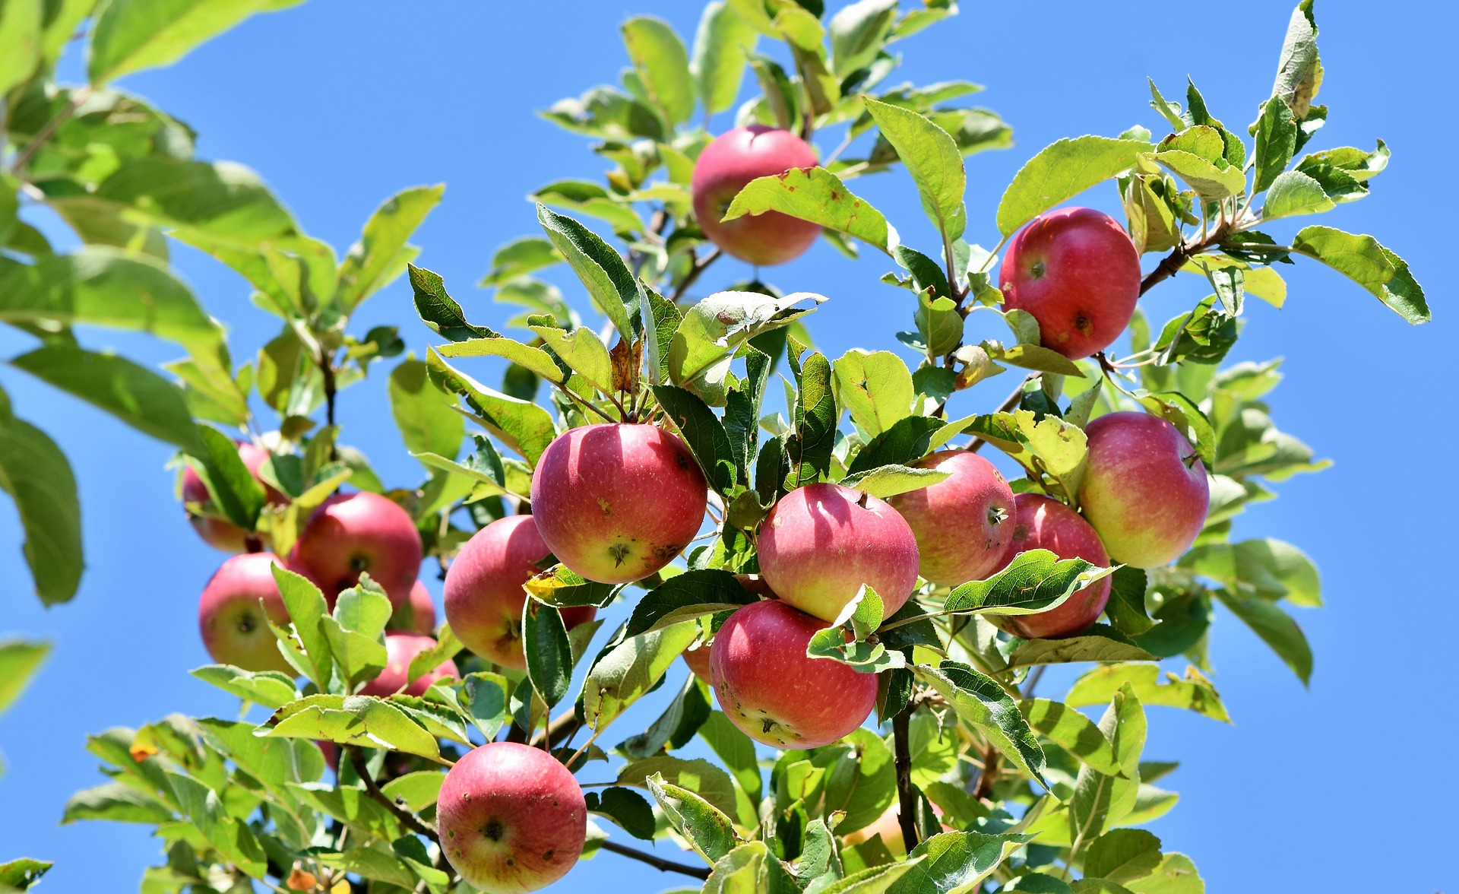
- Tyler is stacking apples to sell at the event. There are 85 apples for his display. He has already made 5 rows of 10 apples. How many apples are left?
  - Write an equation with a letter for the unknown quantity to represent this situation.
  - Solve the problem. Explain or show your reasoning.
- Clare is helping sell baked goods at the event. A customer buys 8 brownies that cost $3 each. Clare adds that money to the cash box and now there is $125 in the cash box. How much money was in the cash box before that purchase?
  - Write an equation with a letter for the unknown quantity to represent this situation.
  - Solve the problem. Explain or show your reasoning.
- The market at the orchard had 200 jars of applesauce for sale. At the end of the event, 184 jars had been sold. The rest of the jars were shared equally among 4 people who work there. How many jars of applesauce did each person get?
  - Write an equation with a letter for the unknown quantity to represent this situation.
  - Solve the problem. Explain or show your reasoning.
© CC BY 2021 Illustrative Mathematics®

