Unit 2 Lesson 7 Cumulative Practice Problems
- Triangle $DEF$ is a dilation of triangle $ABC$ with scale factor 2. In triangle $ABC$, the largest angle measures ${82}^{∘}$. What is the largest angle measure in triangle $DEF$?
  - ${41}^{∘}$
  - ${82}^{∘}$
  - ${123}^{∘}$
  - ${164}^{∘}$
- Draw two polygons that are similar but could be mistaken for not being similar. Explain why they are similar.
- Draw two polygons that are not similar but could be mistaken for being similar. Explain why they are not similar.
- These two triangles are similar. Find side lengths $a$ and $b$. Note: the two figures are not drawn to scale.
- 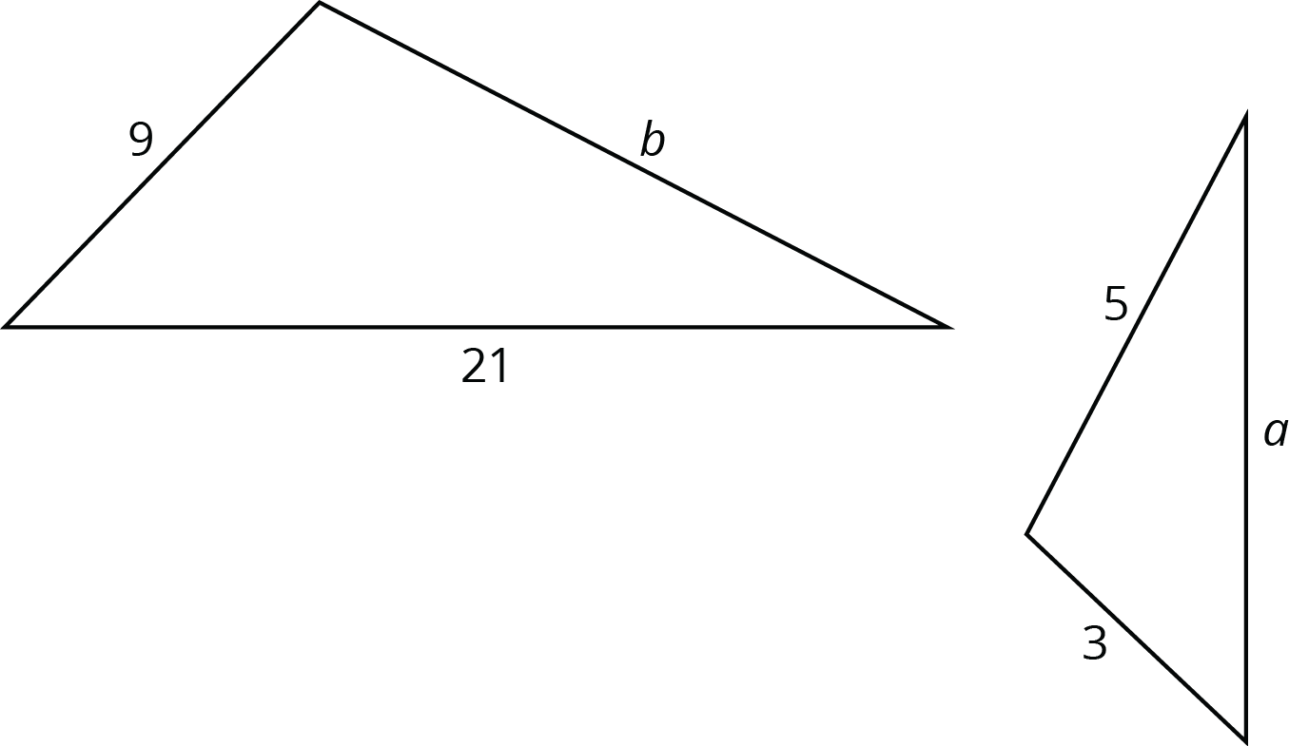
- Jada claims that $B^{′}C^{′}D^{′}$ is a dilation of $BCD$ using $A$ as the center of dilation.
- What are some ways you can convince Jada that her claim is not true?
- 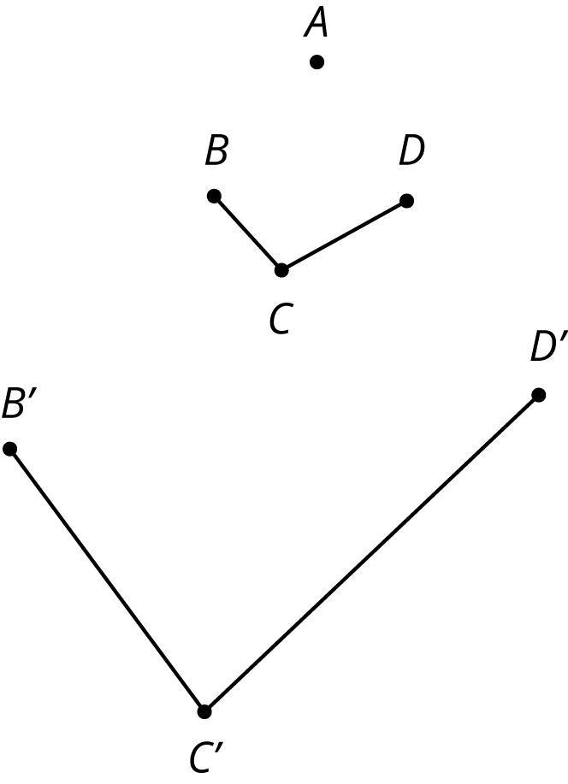
- (From Unit 2, Lesson 3.)
  - Draw a horizontal line segment $AB$.
  - Rotate segment $AB$ ${90}^{∘}$ counterclockwise around point $A$. Label any new points.
  - Rotate segment $AB$ ${90}^{∘}$ clockwise around point $B$. Label any new points.
  - Describe a transformation on segment $AB$ you could use to finish building a square.
- (From Unit 1, Lesson 8.)
© CC BY Open Up Resources. Adaptations CC BY IM.

