Lesson 2: Partners Make Pairs
- Let’s make pairs with groups of objects.

Warm-up: Which One Doesn’t Belong: Laundry Day
Which one doesn’t belong?
A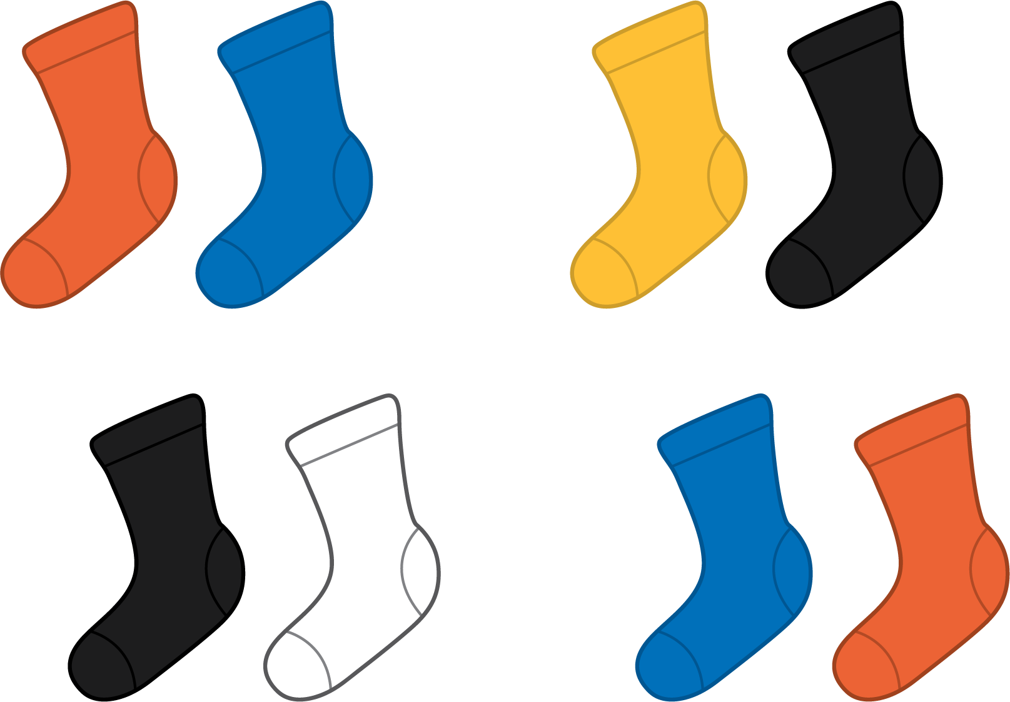
B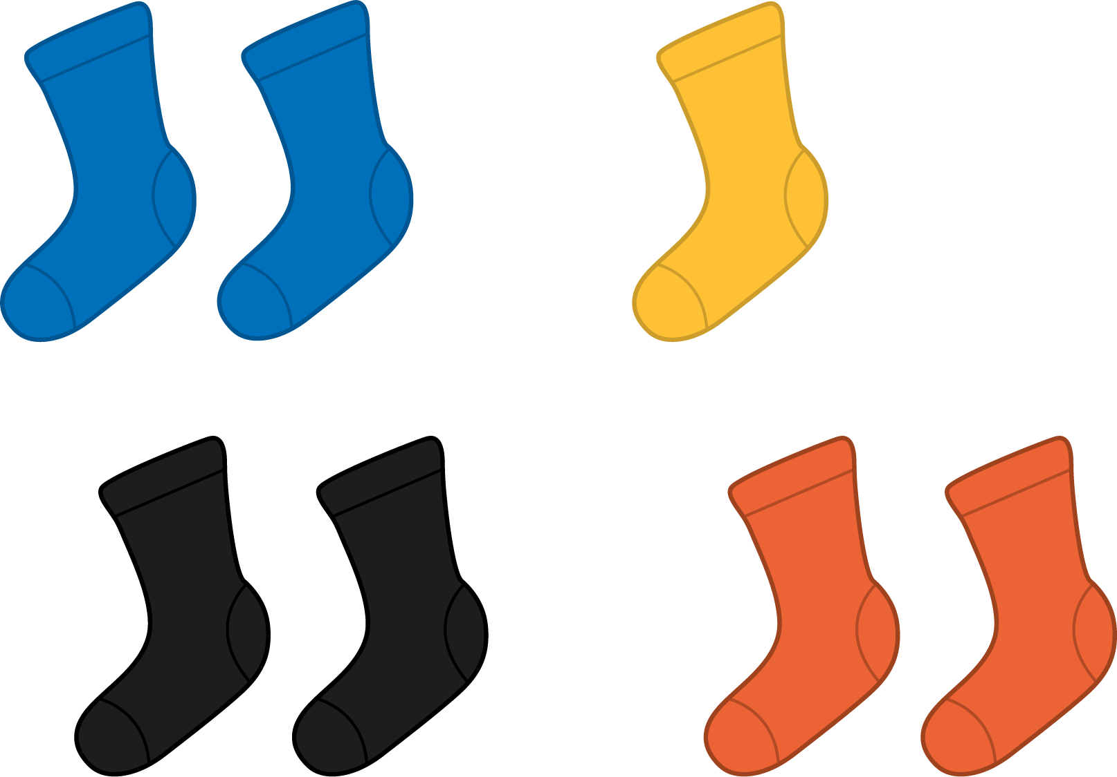
C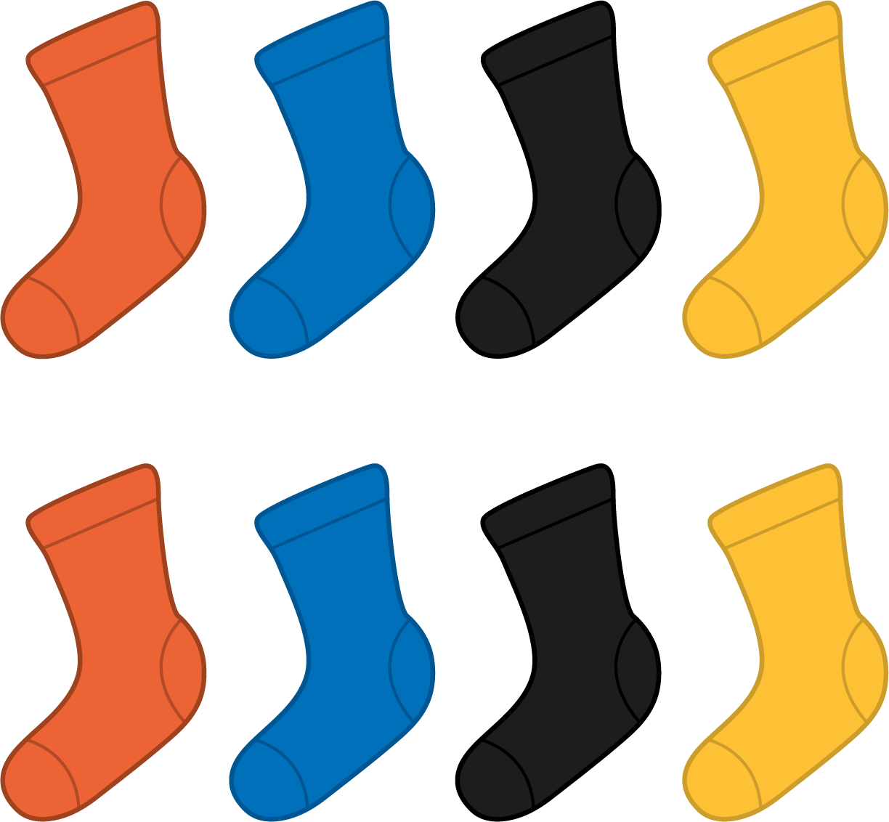
D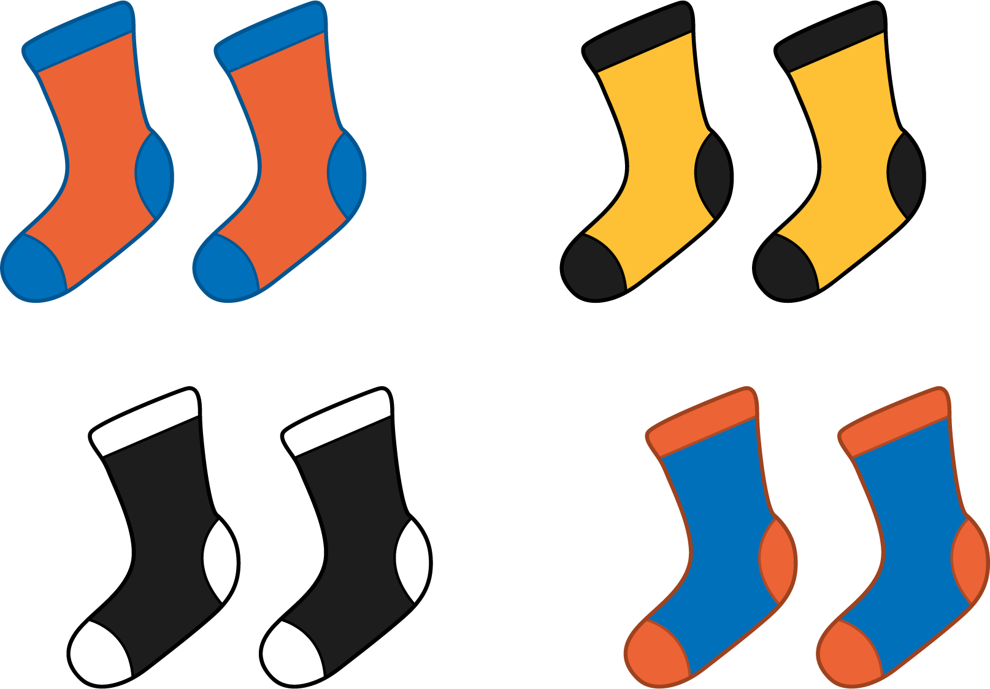

2.1: Pair Up
Make pairs with 1 yellow counter and 1 red counter.
my counters
total counters
leftover counters

2.2: Are You Feeling Left Out?
Show your thinking using diagrams, symbols, or other representations. Use cubes or counters if it helps.
- There are 18 students in Clare’s class today. They will work in pairs. Will everyone be in a group of 2?
- There are 20 students in Priya’s class. Will everyone be in a group of 2?
- There are 19 students in Noah’s class. Will everyone be in a group of 2?
© CC BY 2021 Illustrative Mathematics®

