Unit 3 Lesson 6: Use Strategies and Algorithms to Add

WU Number Talk: Little More, Little Less (Warm up)

Student Task Statement
Find the value of each expression mentally.
- $300+156$
- $299+156$
- $303+156$
- $204+376$

1 Just Ones

Student Task Statement
Two methods of recording the addition of $657+286$ are shown.
Method 1
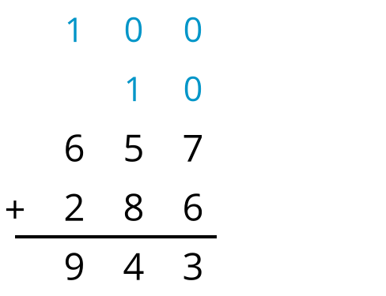
Method 2
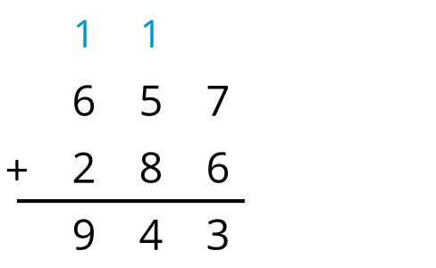
- How is the newly composed ten and hundred recorded differently in each method?
- Try the second method of recording to add these numbers:
  - $602+179$
  - $493+161$
  - $438+364$
  - $329+381$

2 How Would You Add?

Student Task Statement
Use a strategy of your choice to find the value of each sum. Show your reasoning. Organize it so it can be followed by others.
- $199+348$
- $264+359$
- $203+75$
- $316+198$
- $399+499$
© CC BY 2021 Illustrative Mathematics®

