Lesson 5: Find the Difference
- Let’s find differences within 10.

Warm-up: Number Talk: Missing Value Within 10
Find the number that makes each equation true.
- 6+aaaiaaai=10
- 10−6=aaaiaaai
- 8+aaaiaaai=10
- 10−2=aaaiaaai

5.1: Different Ways to Find the Difference
Mai, Diego, and Noah find the value of $10−6$.
- Diego says, “I can take away.”
- 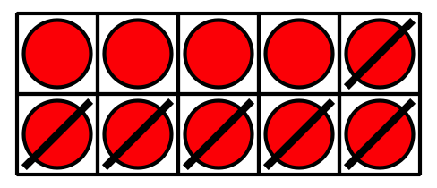
- What does Diego mean?
Be ready to explain your thinking in a way that others will understand.
- Mai says, “I can count on.”
- 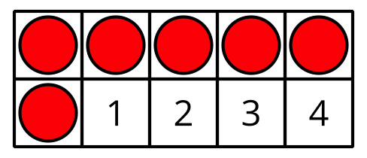
- What does Mai mean?
Be ready to explain your thinking in a way that others will understand.
- Noah says, “I can use what I know about $6+4$ to help me.”
What does Noah mean?
Be ready to explain your thinking in a way that others will understand.

5.2: Subtraction Number Strings
Find the value of each difference in the subtraction string.
Explain what you notice.
Set 1:
$6−1$
$6−2$
$6−3$
$6−4$
What do you notice?
Why do you think this happens?
Be ready to explain your thinking in a way that others will understand.
Set 2:
$9−8$
$9−7$
$9−6$
$9−5$
What do you notice?
Why do you think this happens?
Be ready to explain your thinking in a way that others will understand.

5.3: The Value of the Difference
Find the value of each difference.
- $9−6$
- $10−3$
- $7−3$
- $9−5$
- $8−6$
- $6−5$
- $9−4$
- $10−7$
© CC BY 2021 Illustrative Mathematics®

