Unit 6 Lesson 19: Expanding and Factoring

1 Number Talk: Parentheses (Warm up)

Student Task Statement
Find the value of each expression mentally.
$2+3⋅4$
$\left(2+3\right)\left(4\right)$
$2−3⋅4$
$2−\left(3+4\right)$

2 Factoring and Expanding with Negative Numbers

Student Task Statement
In each row, write the equivalent expression. If you get stuck, use a diagram to organize your work. The first row is provided as an example. Diagrams are provided for the first three rows.
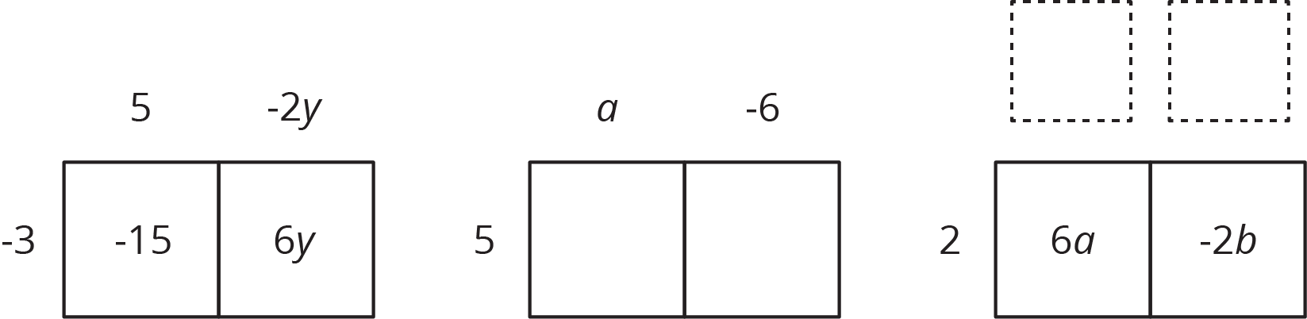
factored | expanded
$\text{-}3\left(5−2y\right)$ | $\text{-}15+6y$
$5\left(a−6\right)$
 | $6a−2b$
$\text{-}4\left(2w−5z\right)$
$\text{-}\left(2x−3y\right)$
 | $20x−10y+15z$
$k\left(4−17\right)$
 | $10a−13a$
$\text{-}2x\left(3y−z\right)$
 | $ab−bc−3bd$
$\text{-}x\left(3y−z+4w\right)$

© CC BY Open Up Resources. Adaptations CC BY IM.

