Lesson 13: Two Graphs for Each Relationship

13.1: True or False: Fractions and Decimals
Decide whether each equation is true or false. Be prepared to explain your reasoning.
- $\frac{3}{2}⋅16=3⋅8$
- $\frac{3}{4}÷\frac{1}{2}=\frac{6}{4}÷\frac{1}{4}$
- $(2.8)⋅(13)=(0.7)⋅(52)$

13.2: Tables, Graphs, and Equations
Your teacher will assign you one of these three points:
$A=(10,4)$, $B=(4,5)$, $C=(8,5)$.
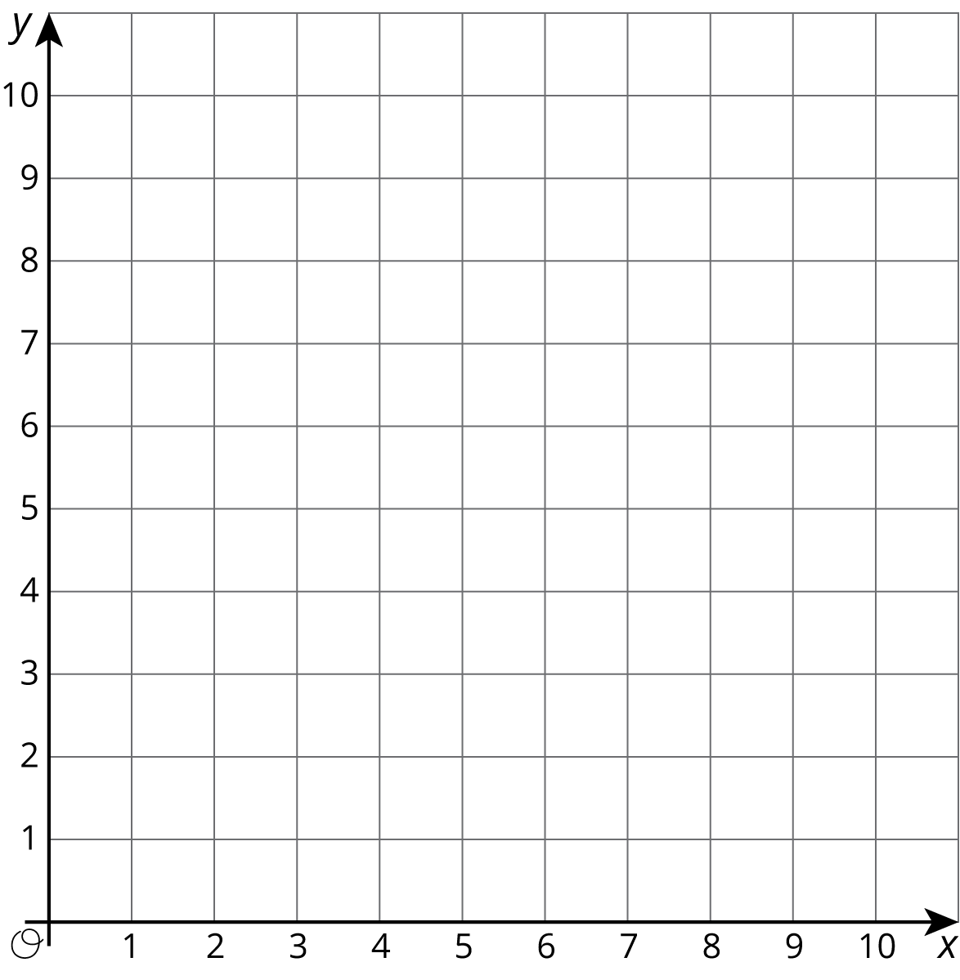
$x$ | $y$ | $\frac{y}{x}$
0 |  | NA
1
2
3
4
5
6
7
8
9
10
- On the graph, plot and label only your assigned point.
- Use a ruler to line up your point with the origin, $(0,0)$. Draw a line that starts at the origin, goes through your point, and continues to the edge of the graph.
- Complete the table with the coordinates of points on your graph. Use a fraction to represent any value that is not a whole number.
- Write an equation that represents the relationship between $x$ and $y$ defined by your point.
- Compare your graph and table with the rest of your group. What is the same and what is different about:
  - your tables?
  - your equations?
  - your graphs?
- What is the $y$-coordinate of your graph when the $x$-coordinate is 1? Plot and label this point on your graph. Where do you see this value in the table? Where do you see this value in your equation?
- Describe any connections you see between the table, characteristics of the graph, and the equation.

Are you ready for more?
The graph of an equation of the form $y=kx$, where $k$ is a positive number, is a line through $(0,0)$ and the point $(1,k)$.
- Name at least one line through $(0,0)$ that cannot be represented by an equation like this.
- If you could draw the graphs of all of the equations of this form in the same coordinate plane, what would it look like?

13.3: Hot Dog Eating Contest
Andre and Jada were in a hot dog eating contest. Andre ate 10 hot dogs in 3 minutes. Jada ate 12 hot dogs in 5 minutes.
Here are two different graphs that both represent this situation.
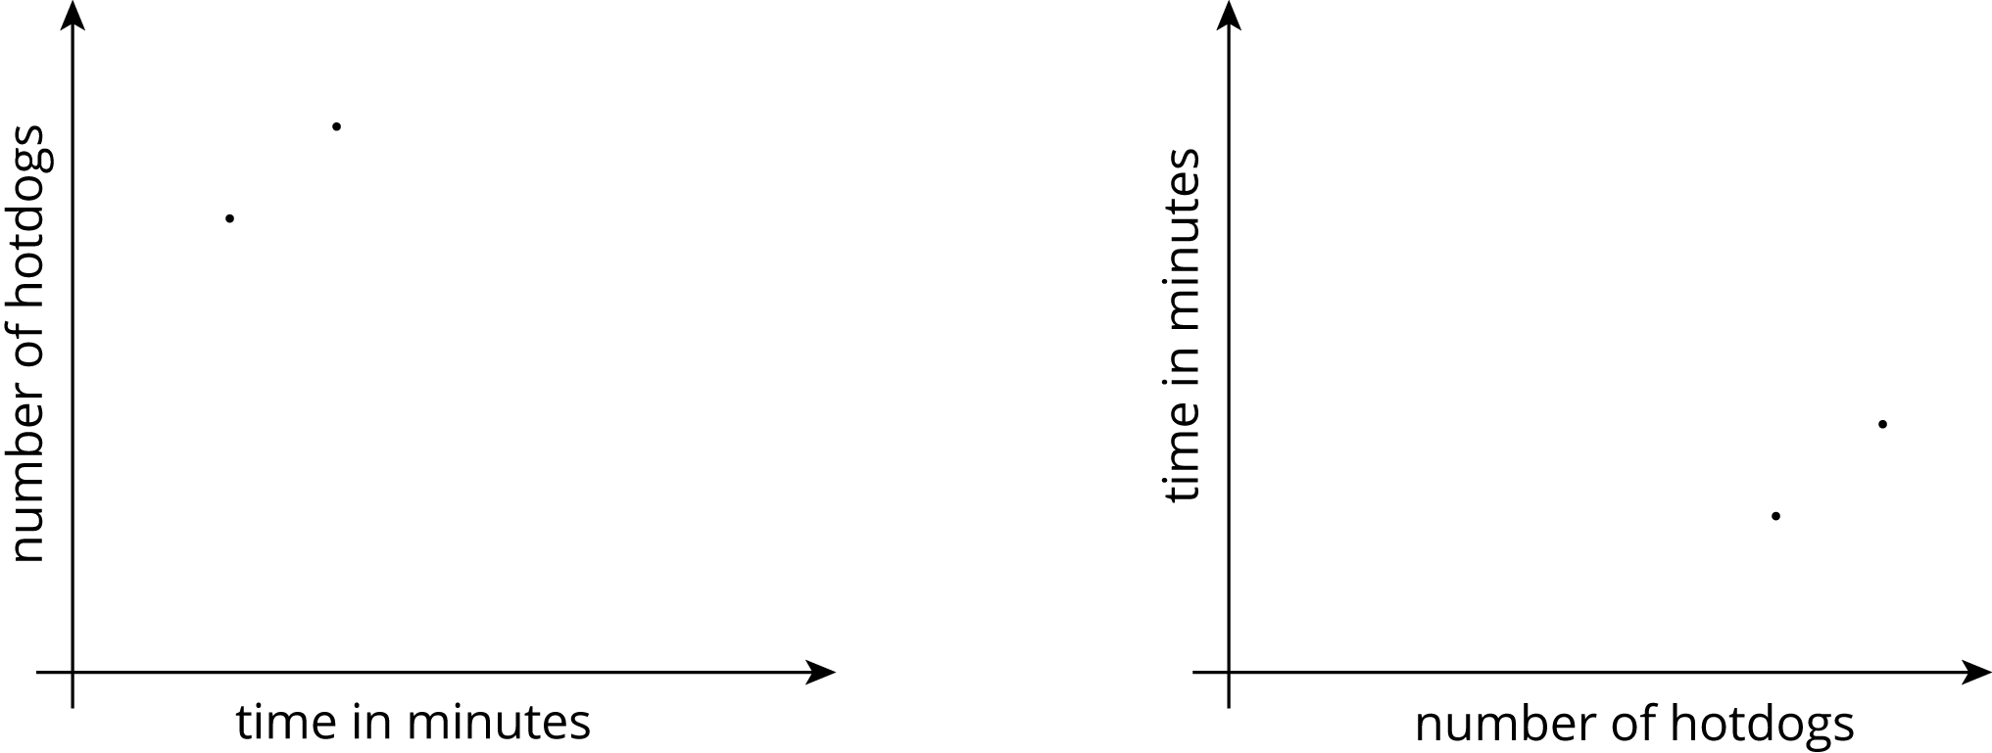
- On the first graph, which point shows Andre’s consumption and which shows Jada’s consumption? Label them.
- Draw two lines: one through the origin and Andre’s point, and one through the origin and Jada’s point.
- Write an equation for each line. Use $t$ to represent time in minutes and $h$ to represent number of hot dogs.
  - Andre:
  - Jada:
- For each equation, what does the constant of proportionality tell you?
- Repeat the previous steps for the second graph.
  - Andre:
  - Jada:

Lesson 13 Summary
Imagine that a faucet is leaking at a constant rate and that every 2 minutes, 10 milliliters of water leaks from the faucet. There is a proportional relationship between the volume of water and elapsed time.
- We could say that the elapsed time is proportional to the volume of water. The corresponding constant of proportionality tells us that the faucet is leaking at a rate of $\frac{1}{5}$ of a minute per milliliter.
- We could say that the volume of water is proportional to the elapsed time. The corresponding constant of proportionality tells us that the faucet is leaking at a rate of 5 milliliters per minute.
Let’s use $v$ to represent volume in milliliters and $t$ to represent time in minutes. Here are graphs and equations that represent both ways of thinking about this relationship:
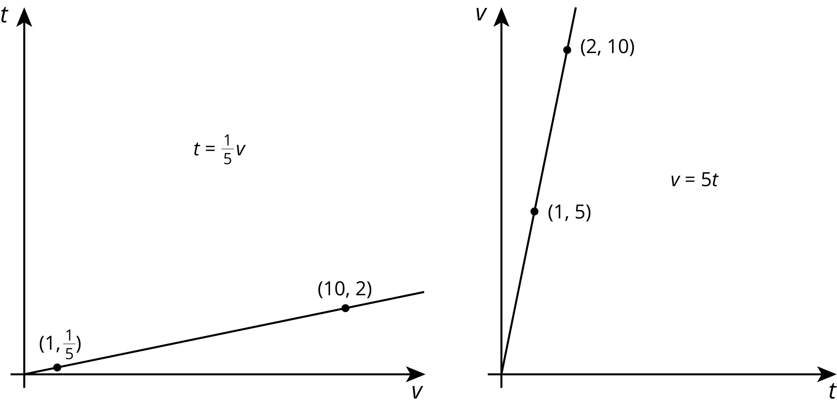
Even though the relationship between time and volume is the same, we are making a different choice in each case about which variable to view as the independent variable. The graph on the left has $v$ as the independent variable, and the graph on the right has $t$ as the independent variable.
© CC BY Open Up Resources. Adaptations CC BY IM.

