Lesson 11 Practice Problems
- The right triangles are drawn in the coordinate plane, and the coordinates of their vertices are labeled. For each right triangle, label each leg with its length.
- 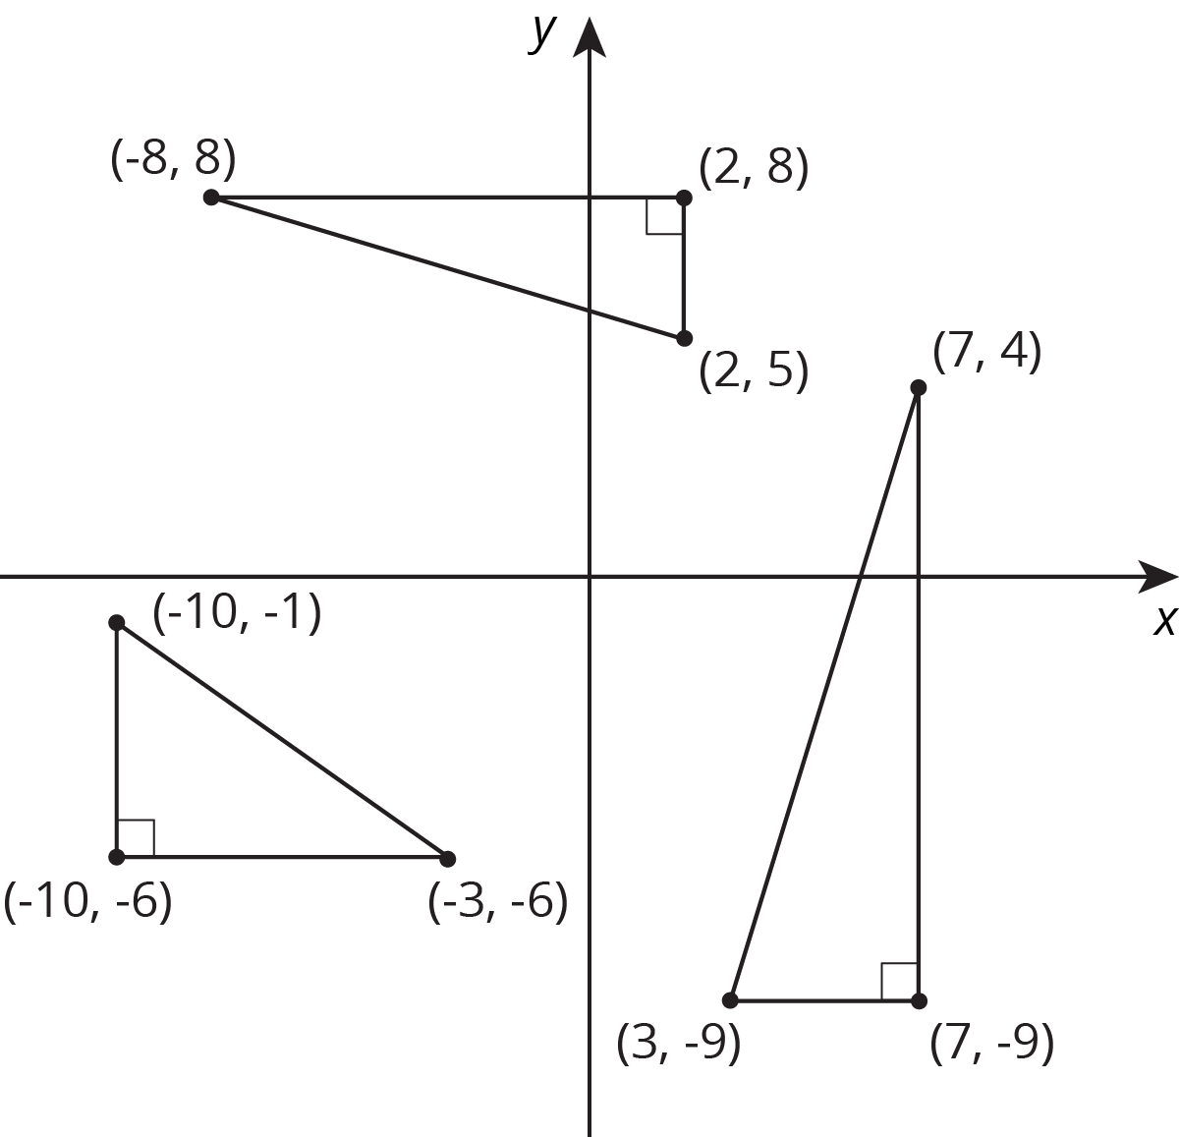

- Find the distance between each pair of points. If you get stuck, try plotting the points on graph paper.
  - $M=\left(0,\text{-}11\right)$ and $P=\left(0,2\right)$
  - $A=\left(0,0\right)$ and $B=\left(\text{-}3,\text{-}4\right)$
  - $C=\left(8,0\right)$ and $D=\left(0,\text{-}6\right)$

  - Find an object that contains a right angle. This can be something in nature or something that was made by humans or machines.
  - Measure the two sides that make the right angle. Then measure the distance from the end of one side to the end of the other.
  - Draw a diagram of the object, including the measurements.
  - Use the Pythagorean Theorem to show that your object really does have a right angle.
- (From Unit 8, Lesson 9.)
- Which line has a slope of 0.625, and which line has a slope of 1.6? Explain why the slopes of these lines are 0.625 and 1.6.
- 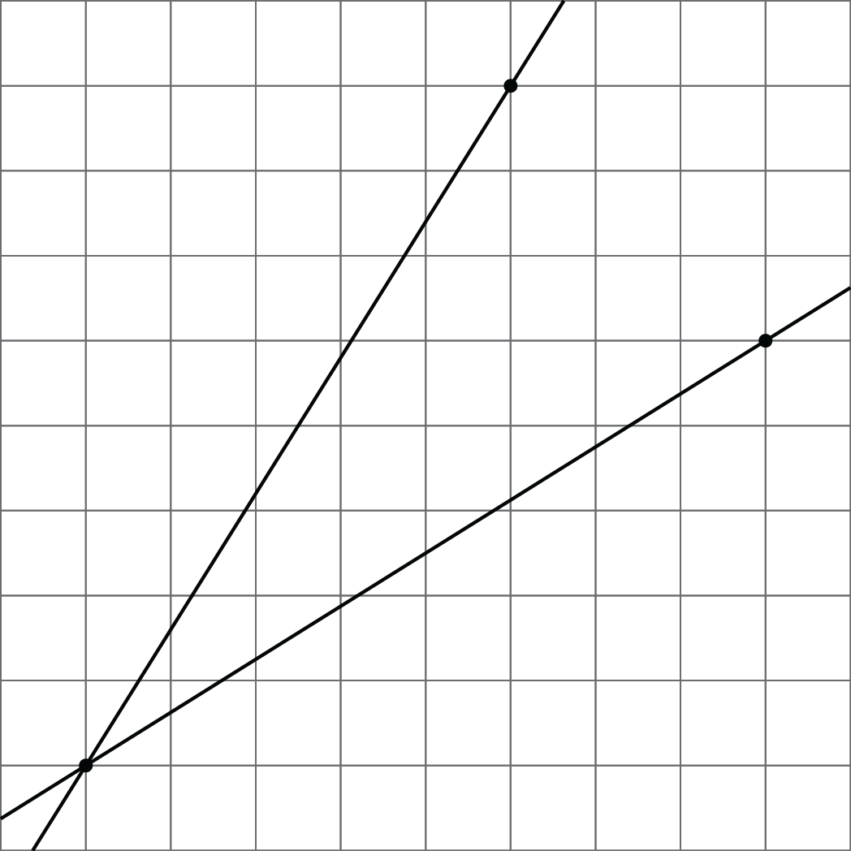

- (From Unit 2, Lesson 10.)
- Write an equation for the graph.
- 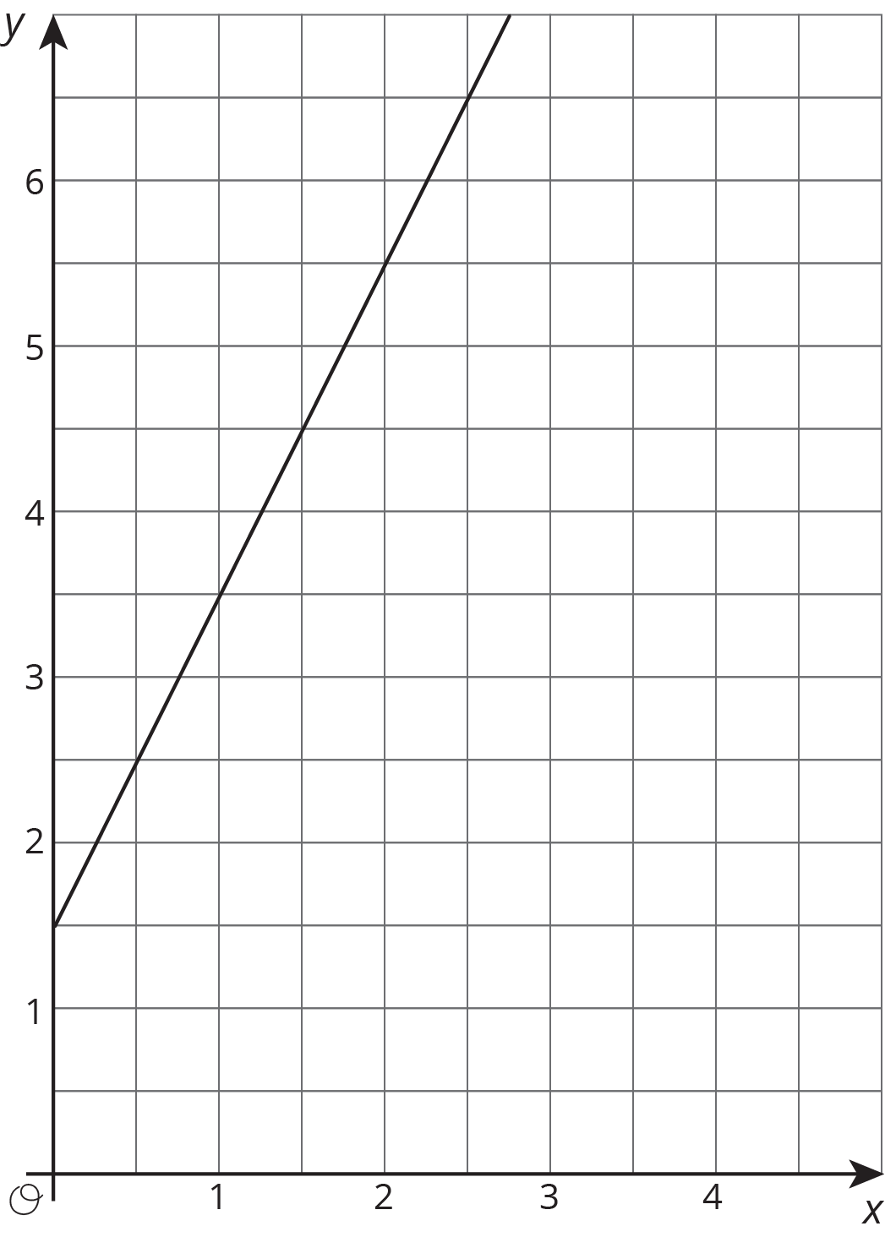
- (From Unit 3, Lesson 7.)
© CC BY Open Up Resources. Adaptations CC BY IM.

