Unit 4 Lesson 5: Working with Ratios in Right Triangles

1 Launch Pad (Warm up)

Student Task Statement
When a rocket is launched, it climbs 50 feet for every 13 feet it travels horizontally. Draw a diagram to represent the situation. Then estimate the rocket’s launch angle.

2 Pythagorean Triples

Student Task Statement
- Sketch the triangle with side lengths 7, 24, and 25 units. Label the smallest angle $A$.
- Find the 3 ratios of side lengths for angle $A$.
- Estimate the acute angles in this triangle.

3 Solve All the Triangles

Images for Launch
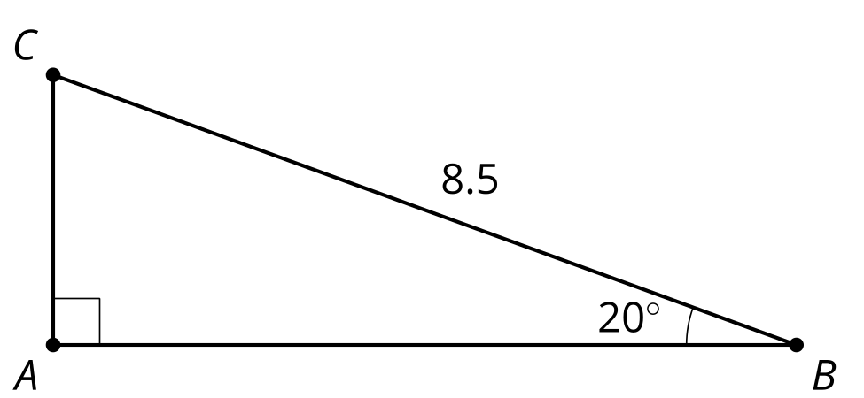

Student Task Statement
- What is the length of segment $AB$?
- In a right triangle with one angle measuring 40 degrees, the leg opposite the 40 degree angle is 5 cm. What is the length of the hypotenuse?
- What is the length of segment $DE$?
- 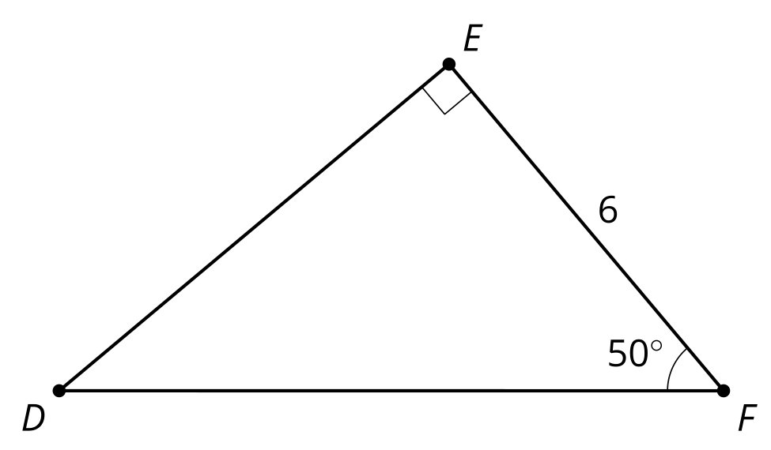
- In a right triangle with one angle measuring 70 degrees, the leg opposite the 70 degree angle is 12 cm. What is the length of the leg adjacent to the 70 degree angle?
© CC BY 2019 by Illustrative Mathematics®

