Unit 3 Lesson 7: Subtract Your Way

WU Number Talk: Subtract Two-Digit Numbers (Warm up)

Student Task Statement
Find the value of each expression mentally.
- $50−10$
- $58−10$
- $258−20$
- $258−24$

1 Strategies to Subtract

Student Task Statement
Find the value of each difference in any way that makes sense to you. Explain or show your reasoning.
- $428−213$
- $505−398$
- $394−127$

2 Base-ten Drawings

Student Task Statement
- Jada and Han made drawings to show how they used base-ten blocks to find the value of $262−135$. Their drawings are shown.
- Jada's drawing
- 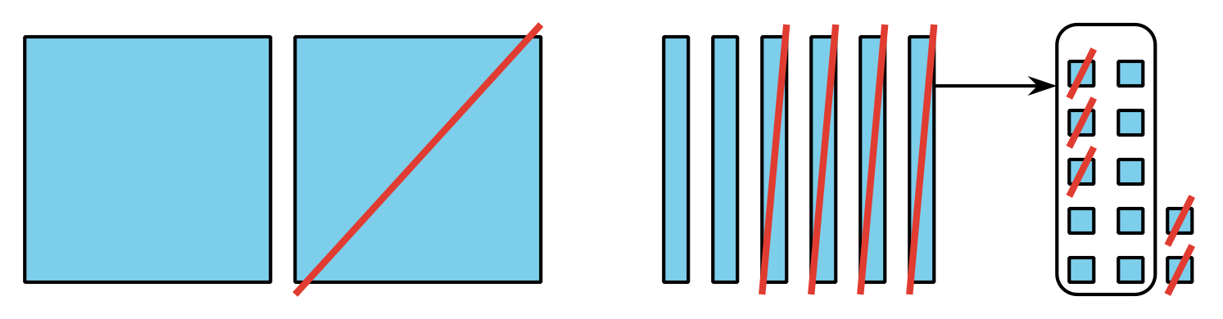
- Han's drawing
- 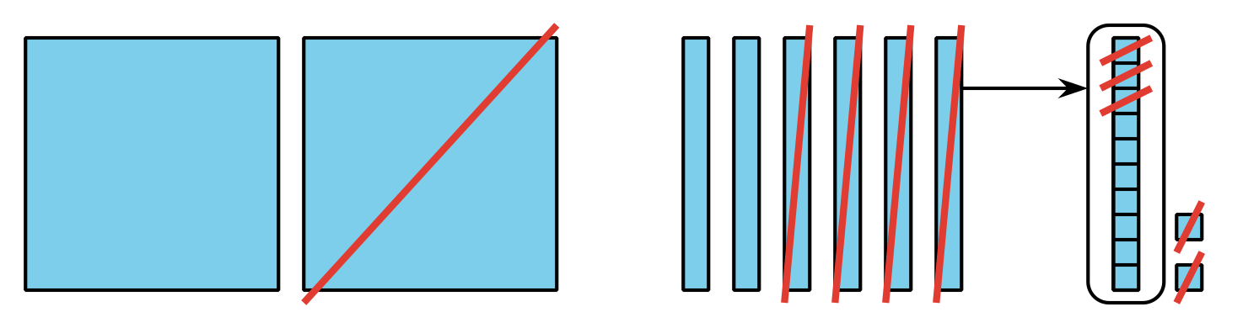
- How are their drawings alike? How are they different?
- Here are three expressions, followed by three diagrams. Write each expression next to the diagram that represents it. Then, find the value of the expression.
- $252−181$
- $262−135$
- $252−132$

  - 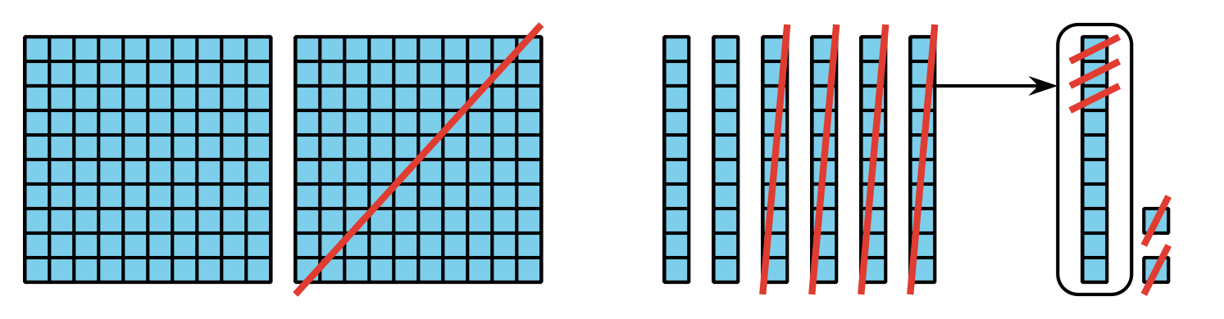

  - 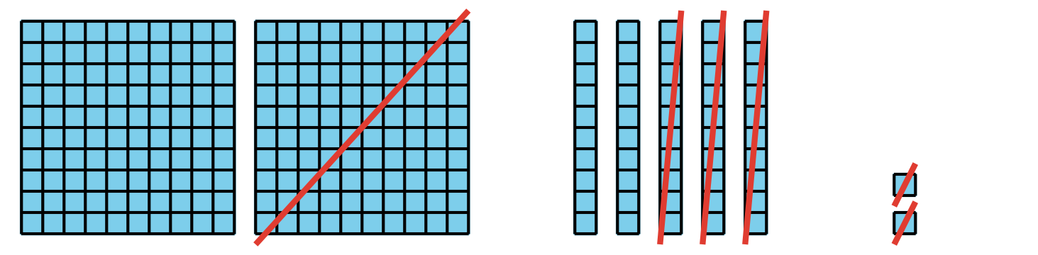

  - 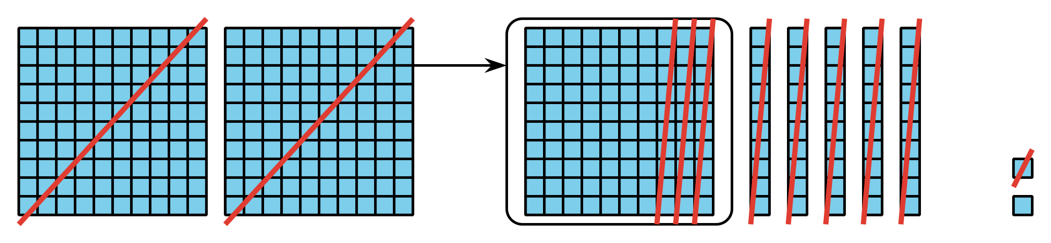
© CC BY 2021 Illustrative Mathematics®

