Lesson 6: Story Problems within 10
- Let’s solve story problems.

Warm-up: Notice and Wonder: Han's Cup
What do you notice?
What do you wonder?
Han is playing Shake and Spill.
He has some counters in his cup.
Then he puts more counters in his cup.

6.1: A Shake and Spill Story Problem
Han is playing Shake and Spill.
He has some counters in his cup.
Then he puts 3 more counters in his cup.
Now he has 10 counters in his cup.
How many counters did he start with?
Show your thinking using drawings, numbers, or words.
Equation: ________________________________
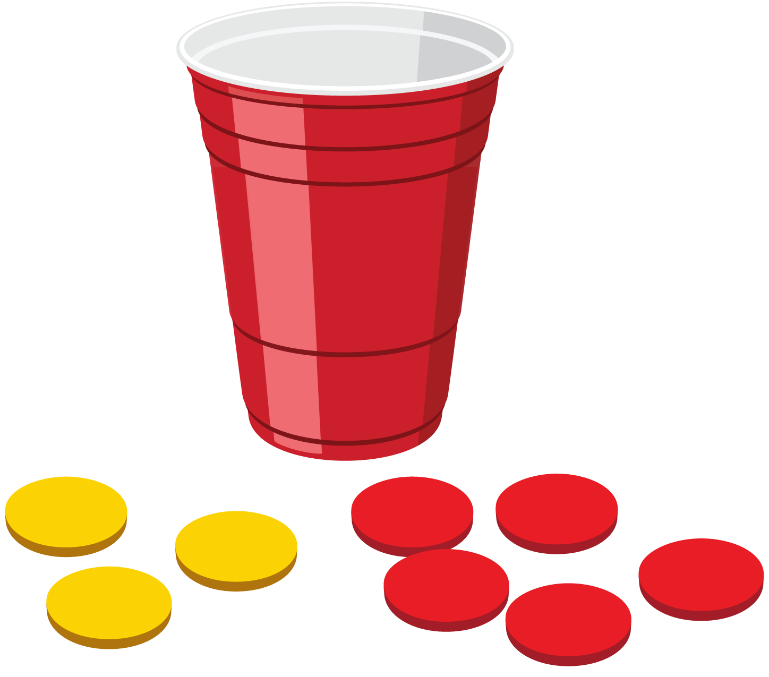

6.2: Shake and Spill Story Problems
- Noah is playing Shake and Spill with 10 counters.
4 of the counters fall out of the cup.
How many counters are still in the cup?
Show your thinking using drawings, numbers, or words.
- Equation: ________________________________
- Kiran has 4 counters in a cup.
He doesn’t have enough so he puts more counters in.
Now he has 7 counters in his cup.
How many more counters did Kiran put in his cup?
Show your thinking using drawings, numbers, or words.
- Equation: ________________________________
- Clare has some counters in a cup.
She puts 3 more counters in her cup.
Now she has 9 counters in her cup.
How many counters were in her cup before she added more?
Show your thinking using drawings, numbers, or words.
- Equation: ________________________________
- Priya has some counters in a cup.
She has 2 red counters and 8 yellow counters.
How many counters does she have?
Show your thinking using drawings, numbers, or words.
- Equation: ________________________________

Section Summary
Section Summary
We practiced adding within 10.
We counted on.
$4+3=\boxed{7}$
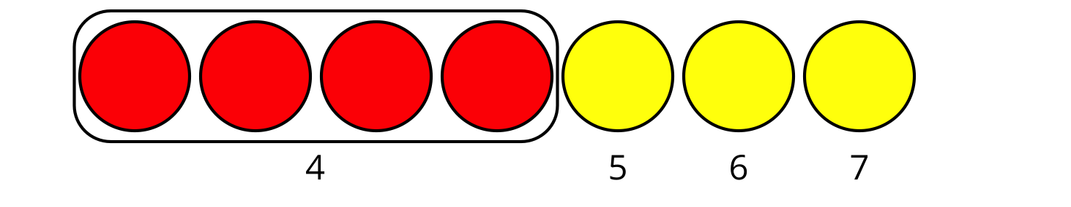
We added in any order.
$4+3$ is the same amount as $3+4$.
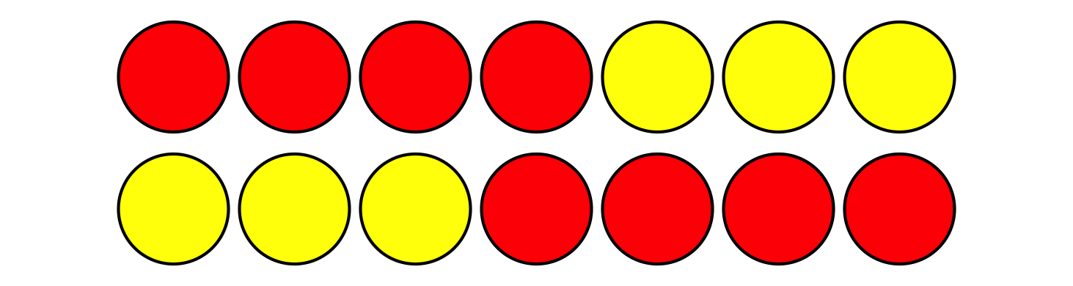
We learned that when expressions have the same value, you can show that with an equal sign.
$4+3=3+4$
We learned that we can use addition to find the difference between 2 numbers.
10−6=7
6+7=10
Since I know 6 + 4 = 10, then I know 10 - 6 = 4.
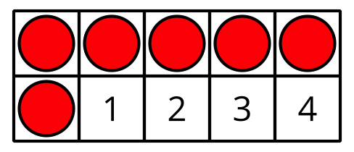
© CC BY 2021 Illustrative Mathematics®

