Lesson 21: Compare Two-Digit Numbers Shown in Different Ways
- Let’s compare numbers.

Warm-up: Number Talk: Addition Within 20
Find the value of each expression mentally.
- $10+6$
- $9+6$
- $10+7$
- $8+7$

21.1: Elena and Kiran Compare Collections
Elena and Kiran are comparing their collections.
Elena says, “I have 5 tens 32 ones.”
Kiran says, “I have 7 tens 2 ones.”
Who has more in their collection?
Show your thinking using drawings, numbers, words, or expressions.

21.2: Base-Ten Representation Compare
- What do you notice?
- 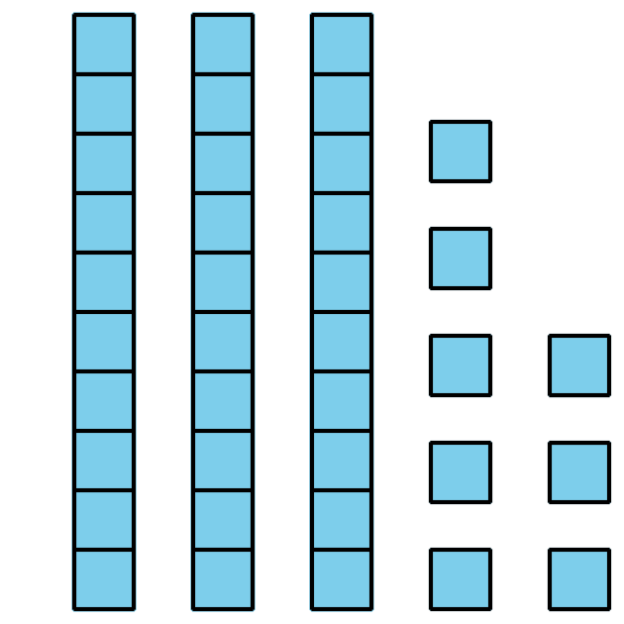
- 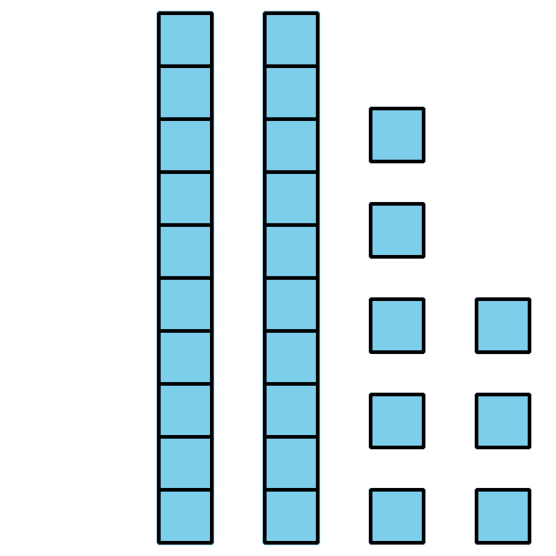
- aaaiaaai aaaiaaappa_ aaaiaaai
- Circle the representation that shows the greater number.
Write a number to match each representation.
Then write a comparison statement using <, >, or =.

  - 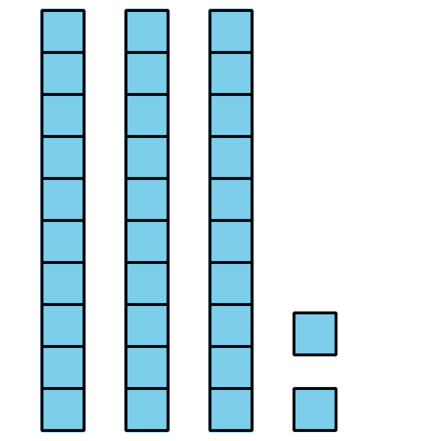
  - 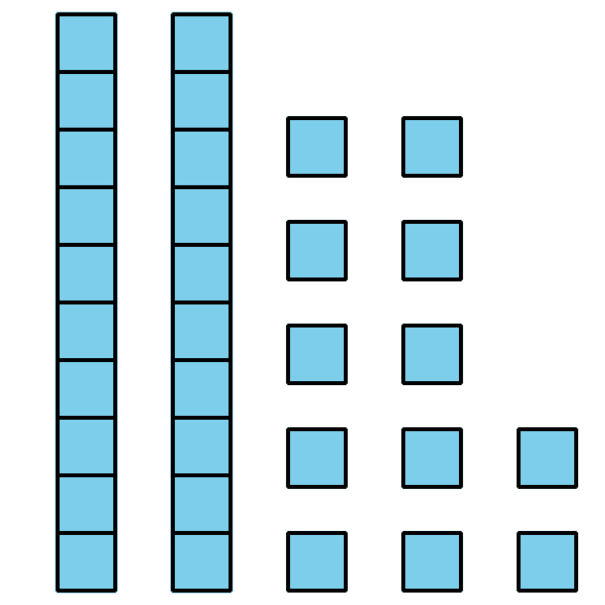
  - aaaiaaai aaaiaaappa_ aaaiaaai

  - 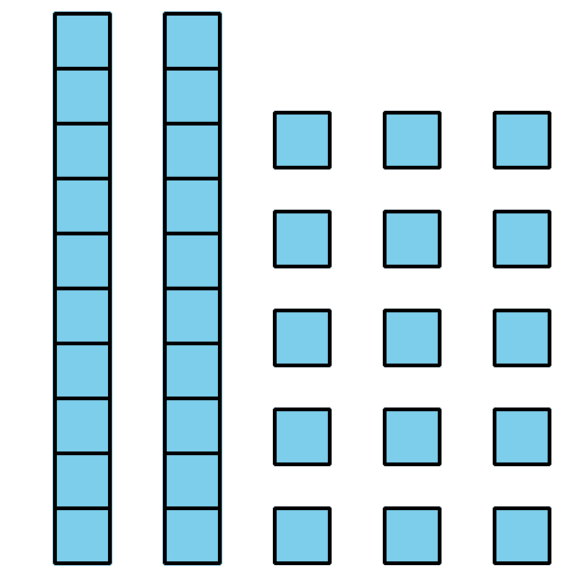
  - 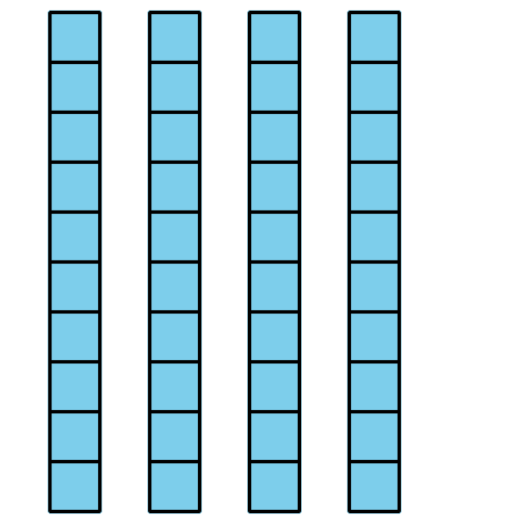
  - aaaiaaai aaaiaaappa_ aaaiaaai
  - 5 tens 2 ones
  - 12 ones 3 tens
  - aaaiaaai aaaiaaappa_ aaaiaaai
  - 1 ten 25 ones
  - 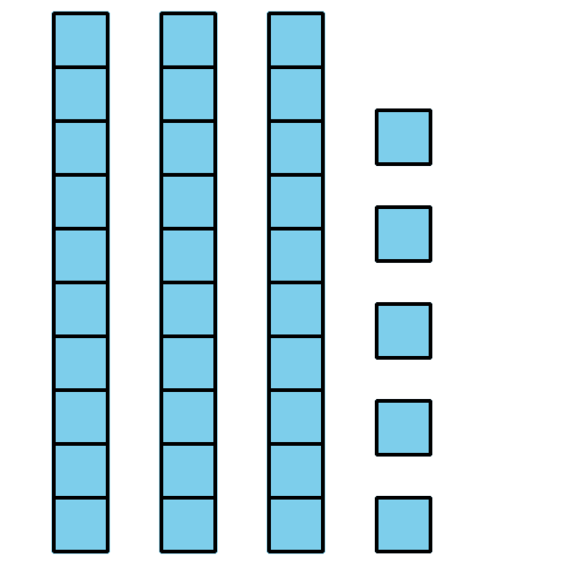
  - aaaiaaai aaaiaaappa_ aaaiaaai
  - 7 tens 29 ones
  - $50+39$
  - aaaiaaai aaaiaaappa_ aaaiaaai

Section Summary
Section Summary
We made two-digit numbers with different amounts of tens and ones.
Each of these representations shows 37.
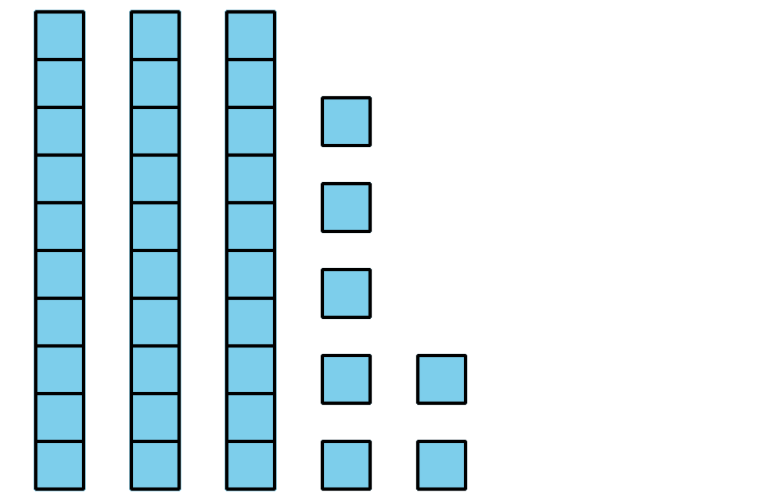
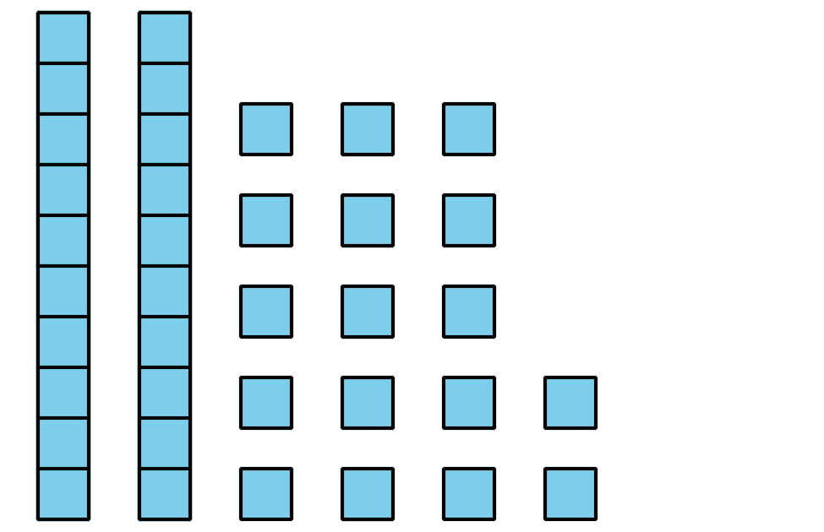
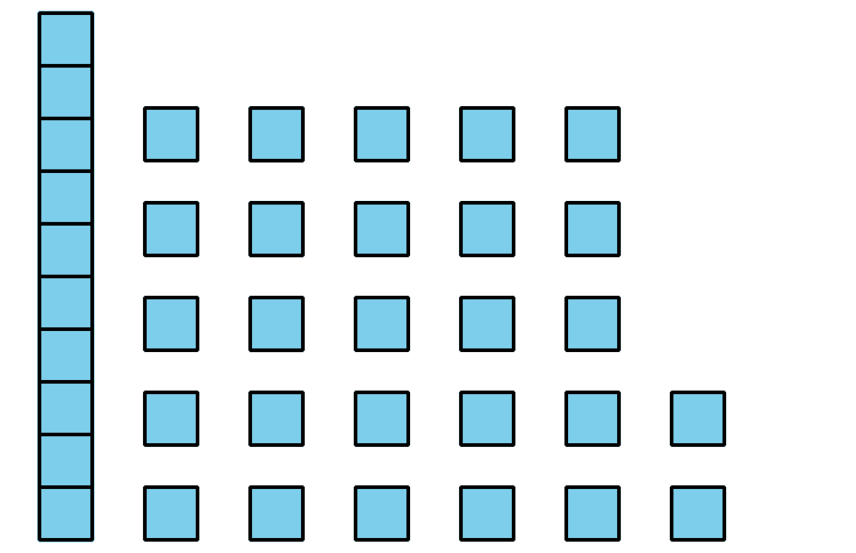
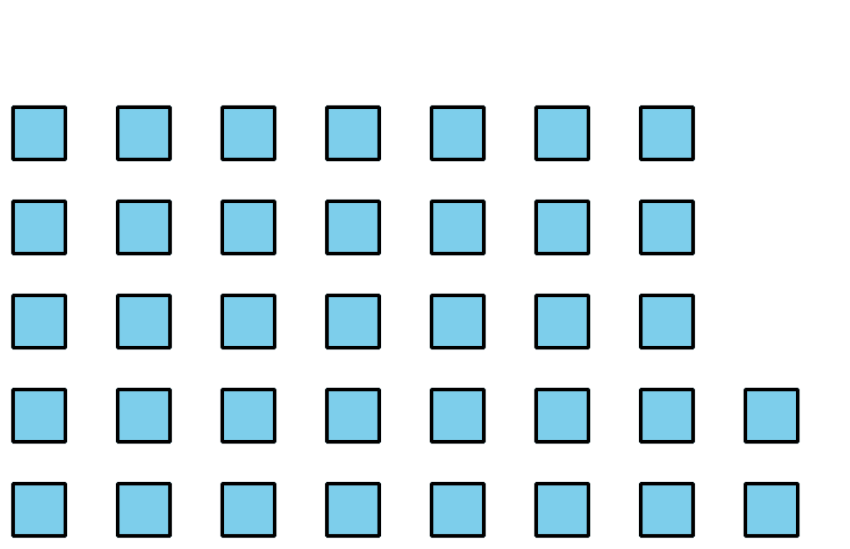
We compared two-digit numbers that were made with tens and ones in different ways.
5 tens 2 ones and 12 ones 3 tens
$52>42$
© CC BY 2021 Illustrative Mathematics®

