Lesson 12 Practice Problems

  - What is the volume of a cube with a side length of
    - 4 centimeters?
    - $\sqrt[3]{11}$ feet?
    - $s$ units?
  - What is the side length of a cube with a volume of
    - 1,000 cubic centimeters?
    - 23 cubic inches?
    - $v$ cubic units?
- Write an equivalent expression that doesn’t use a cube root symbol.
  - $\sqrt[3]{1}$
  - $\sqrt[3]{216}$
  - $\sqrt[3]{8000}$
  - $\sqrt[3]{\frac{1}{64}}$
  - $\sqrt[3]{\frac{27}{125}}$
  - $\sqrt[3]{0.027}$
  - $\sqrt[3]{0.000125}$
- Find the distance between each pair of points. If you get stuck, try plotting the points on graph paper.
  - $X=\left(5,0\right)$ and $Y=\left(\text{-}4,0\right)$
  - $K=\left(\text{-}21,\text{-}29\right)$ and $L=\left(0,0\right)$
- (From Unit 8, Lesson 11.)
- Here is a 15-by-8 rectangle divided into triangles. Is the shaded triangle a right triangle? Explain or show your reasoning.
- 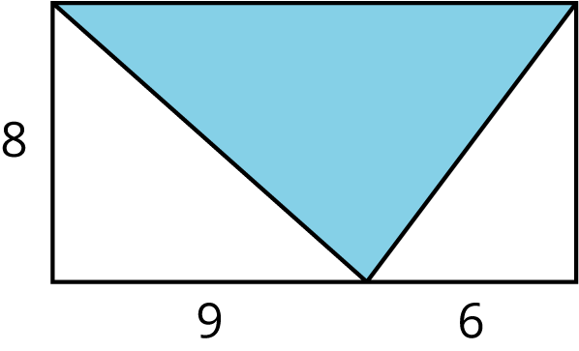

- (From Unit 8, Lesson 9.)
- Here is an equilateral triangle. The length of each side is 2 units. A height is drawn. In an equilateral triangle, the height divides the opposite side into two pieces of equal length.
- 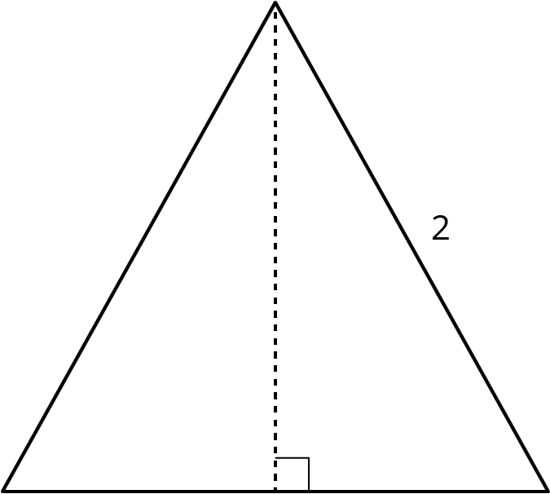
  - Find the exact height.
  - Find the area of the equilateral triangle.
  - (Challenge) Using $x$ for the length of each side in an equilateral triangle, express its area in terms of $x$.
- (From Unit 8, Lesson 10.)
© CC BY Open Up Resources. Adaptations CC BY IM.

