### Lesson 12 Practice Problems

1. Diego measured the diameter and circumference of several circular objects and recorded his measurements in the table.

|  |  |  |
| --- | --- | --- |
| * object | * diameter (cm) | * circumference (cm) |
| * half dollar coin | * 3 | * 10 |
| * flying disc | * 23 | * 28 |
| * jar lid | * 8 | * 25 |
| * flower pot | * 15 | * 48 |

* One of his measurements is inaccurate. Which measurement is it? Explain how you know.

1. Complete the table. Use one of the approximate values for discussed in class (for example 3.14, , 3.1416). Explain or show your reasoning.

|  |  |  |
| --- | --- | --- |
| * object | * diameter | * circumference |
| * hula hoop | * 35 in |  |
| * circular pond |  | * 556 ft |
| * magnifying glass | * 5.2 cm |  |
| * car tire |  | * 71.6 in |

1. is the center of the circle, and the length of is 15 centimeters.
   1. Name a segment that is a radius. How long is it?
   2. Name a segment that is a diameter. How long is it?

* 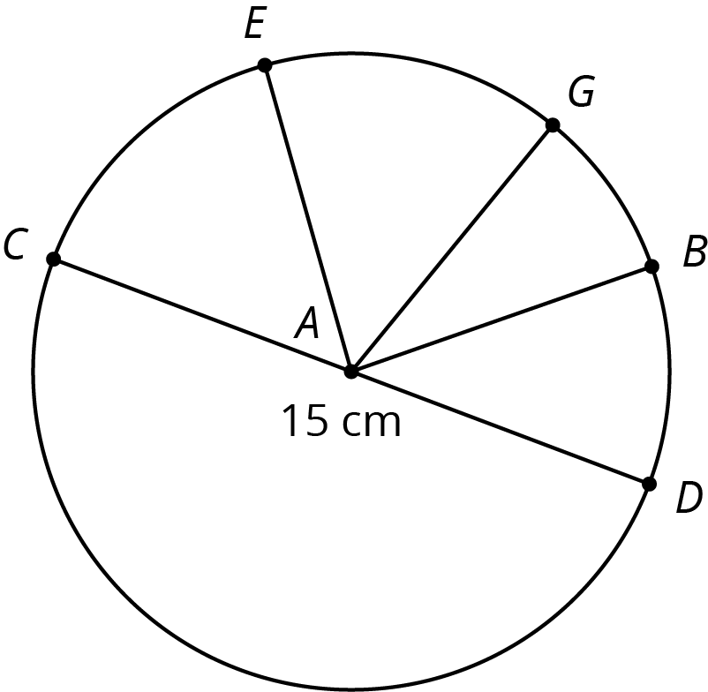
* (From Unit 5, Lesson 11.)
  1. Consider the equation . Find four pairs of and values that make the equation true. Plot the points on the coordinate plane.
  + 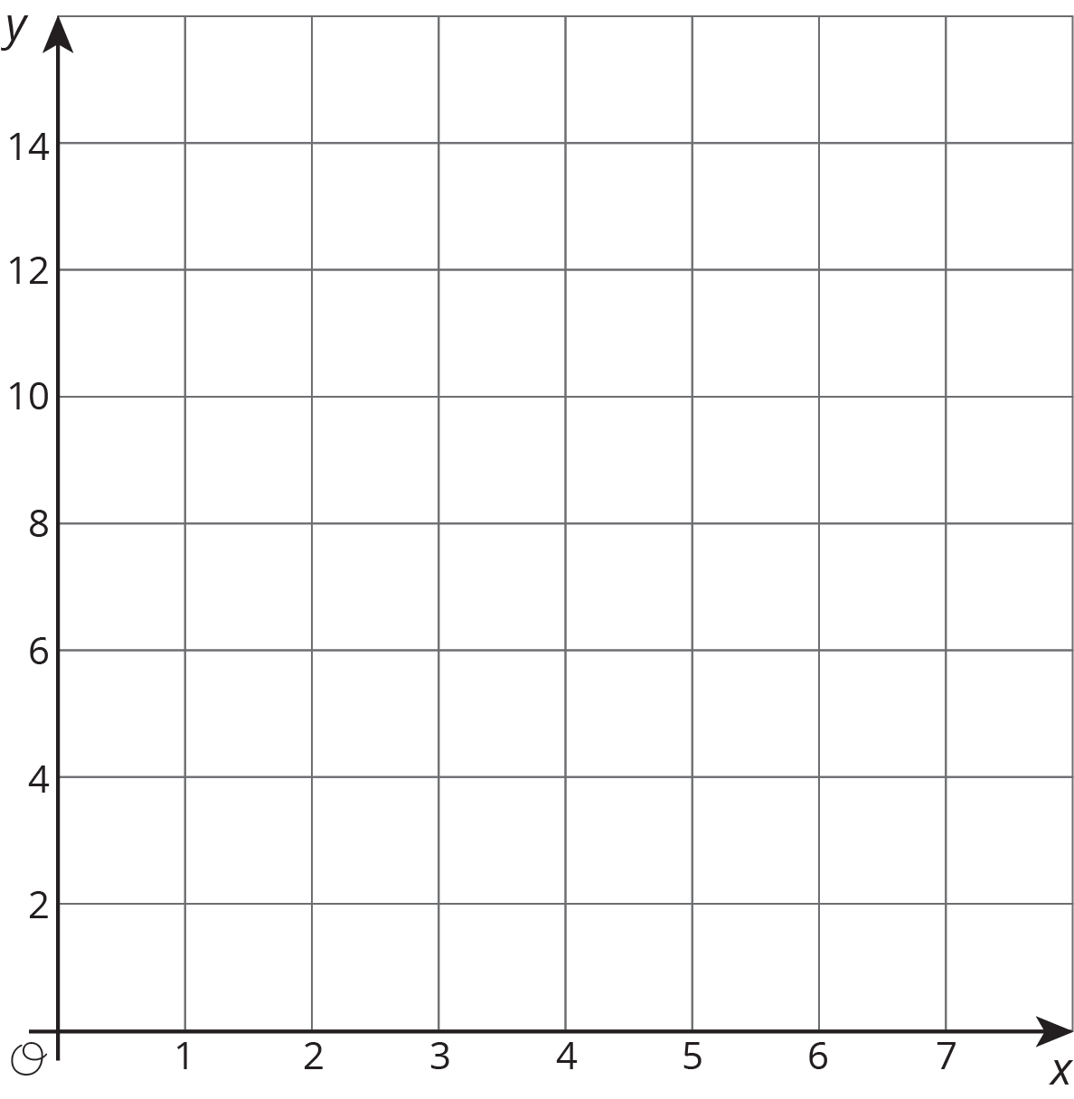
  1. Based on the graph, can this be a proportional relationship? Why or why not?
* (From Unit 5, Lesson 7.)



© CC BY Open Up Resources. Adaptations CC BY IM.