Lesson 16: Minimizing Surface Area
- Let’s investigate surface areas of different cylinders.

16.1: The Least Material
Here are four cylinders that have the same volume.
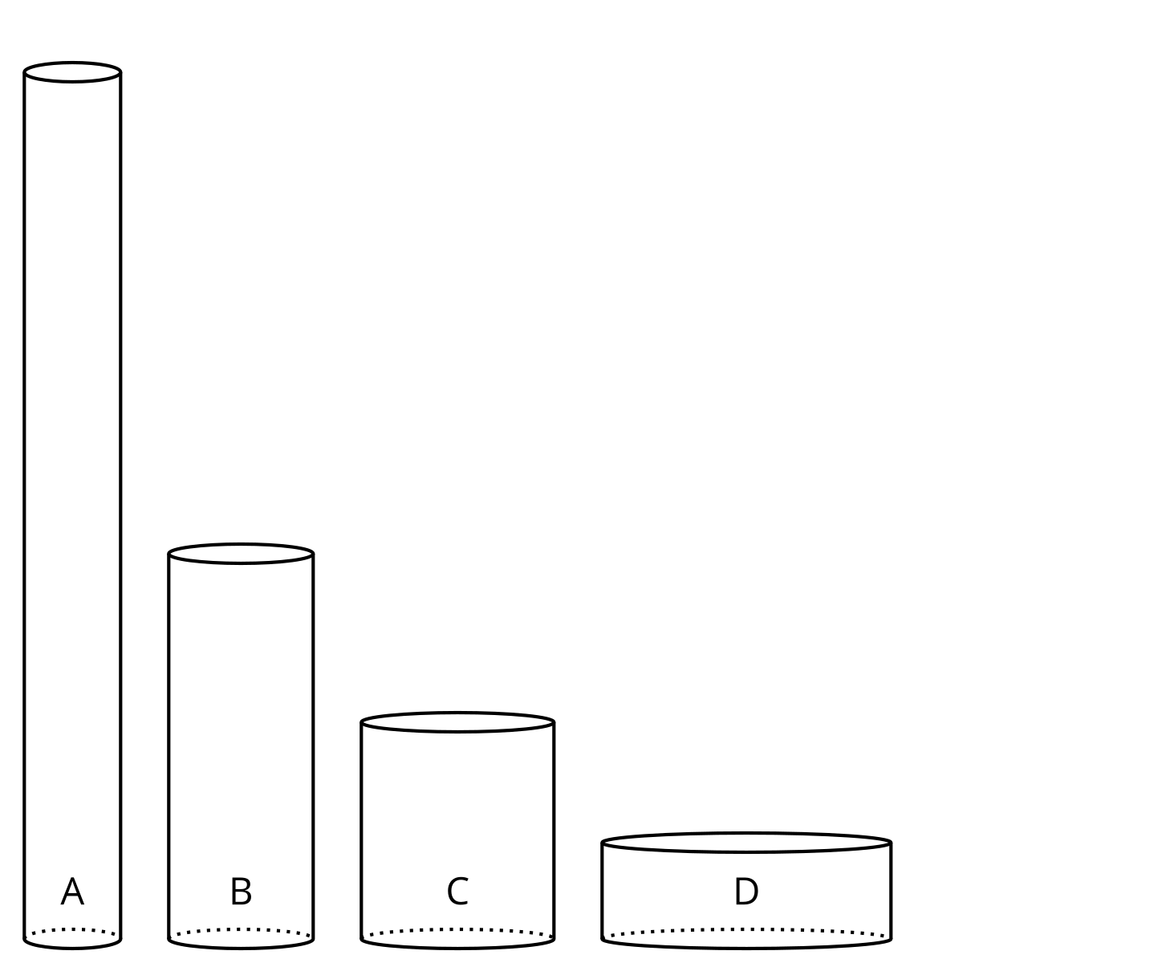
- Which cylinder needs the least material to build?
- What information would be useful to know to determine which cylinder takes the least material to build?

16.2: Figuring Out Cylinder Dimensions
There are many cylinders with volume 452 cm³. Let $r$ represent the radius and $h$ represent the height of these cylinders in centimeters.
- Complete the table.
- volume (cm³) | - radius (cm) | - height (cm)
- 452 | - 1
- 452 | - 2
- 452 | - 3
- 452 | - 4
- 452 | - 5
- 452 | - 6
- 452 | - 7
- 452 | - 8
- 452 | - 9
- 452 | - 10
- 452 | - $r$
- Use graphing technology to plot the pairs $\left(r,h\right)$ from the table on the coordinate plane.
- What do you notice about the graph?

16.3: Calculating Surface Area
There are many cylinders with volume 452 cm³. Let $r$ represent the radius of these cylinders, $h$ represent the height, and $S$ represent the surface area.
- Use the table to explore how the value of $r$ affects the surface area of the cylinder.
- radius (cm) | - height (cm) | - surface area (cm²)
- Use graphing technology to plot the pairs $\left(r,S\right)$ on the coordinate plane.
- What do you notice about the graph?
- Write an equation for $S$ as a function of $r$ when the volume of the cylinder is 452 cm³.

Are you ready for more?
We can model a standard 12 ounce soda can as a cylinder with a volume of 410.5 cubic centimeters, a height of about 12 centimeters and a radius of about 3.3 centimeters.
- How do its dimensions compare to a cylindrical can with the same volume and a minimum surface area?
- What other considerations do manufacturers have when deciding on the dimensions of the cans, besides minimizing the amount of material used?

Lesson 16 Summary
Some relationships cannot be described by polynomial functions. For example, let’s think about the relationship between the radius $r$, in centimeters, and the surface area $S$, in square centimeters, of the set of cylinders with a volume of 330 cm³ (this is a volume of 330 ml). What radius would result in the cylinder with the minimum surface area?
We know these formulas are true for all cylinders with radius $r$, height $h$, surface area $S$, and volume $V$:
$S=2πr^{2}+2πrh$
$V=πr^{2}h$
Since we are only interested in cylinders with a volume of 330 cm³, we can use the volume formula to rewrite the surface area formula as:
$S=2πr^{2}+\frac{660}{r}$
Can you see how? By using the volume formula rearranged as $h=\frac{330}{πr^{2}}$ and then substituting $\frac{330}{πr^{2}}$ for $h$ in the formula for surface area.
We now have an equation giving $S$ as a function of $r$ for cylinders with a volume of 330 cm³. From the graph of $S$ shown here, we can quickly identify that a radius of about 3.75 cm results in a cylinder with minimum surface area and a volume of 330 cm³.​​​​​
$S$ is an example of a rational function. Rational functions are fractions with polynomials in the numerator and denominator. Polynomial functions are a type of rational function with 1 in the denominator.
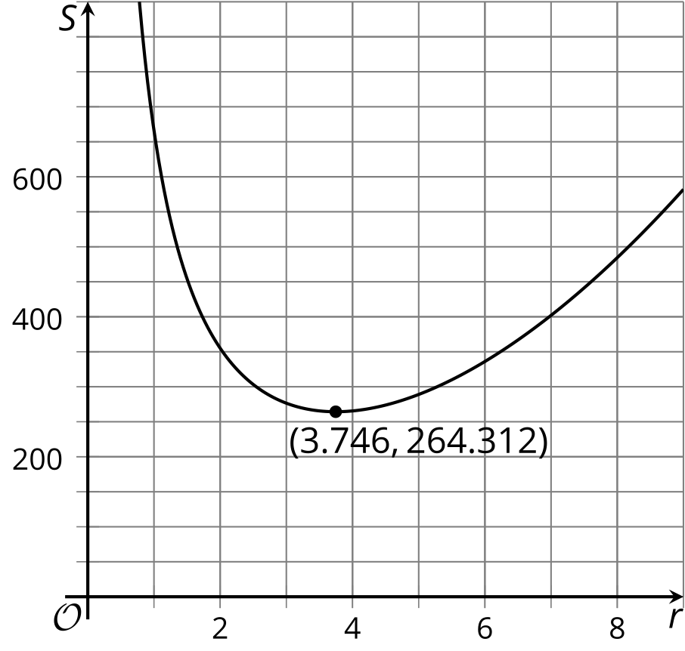
​​​​​​
In this situation, the height of a cylinder with fixed volume varies inversely with the square of the radius, $h=\frac{330}{πr^{2}}$, which means that as the value of $r^{2}$ increases, the value of the height decreases, and vice versa. In later lessons, we’ll learn more about different features of rational functions, like why their graphs can look like they are made of two separate curves.
© CC BY 2019 by Illustrative Mathematics®

