Unit 2 Lesson 12 Cumulative Practice Problems
- Select all the points that are on the line through $(0,5)$ and $(2,8)$.
  - $(4,11)$
  - $(5,10)$
  - $(6,14)$
  - $(30,50)$
  - $(40,60)$
- All three points displayed are on the line. Find an equation relating $x$ and $y$.
- 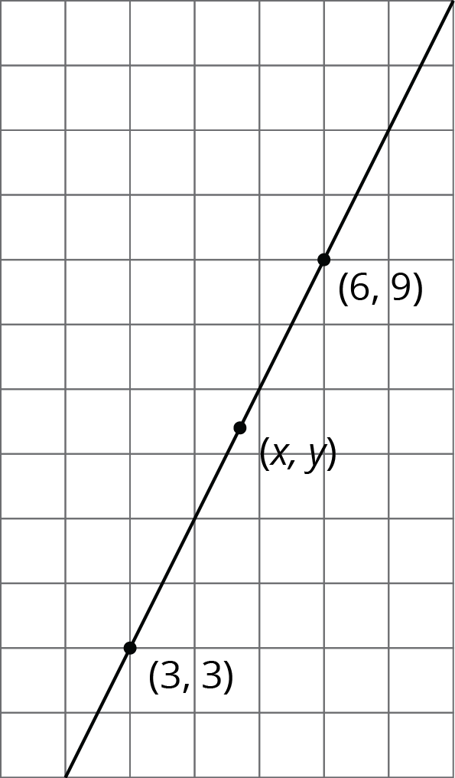
- Here is triangle $ABC$.
- 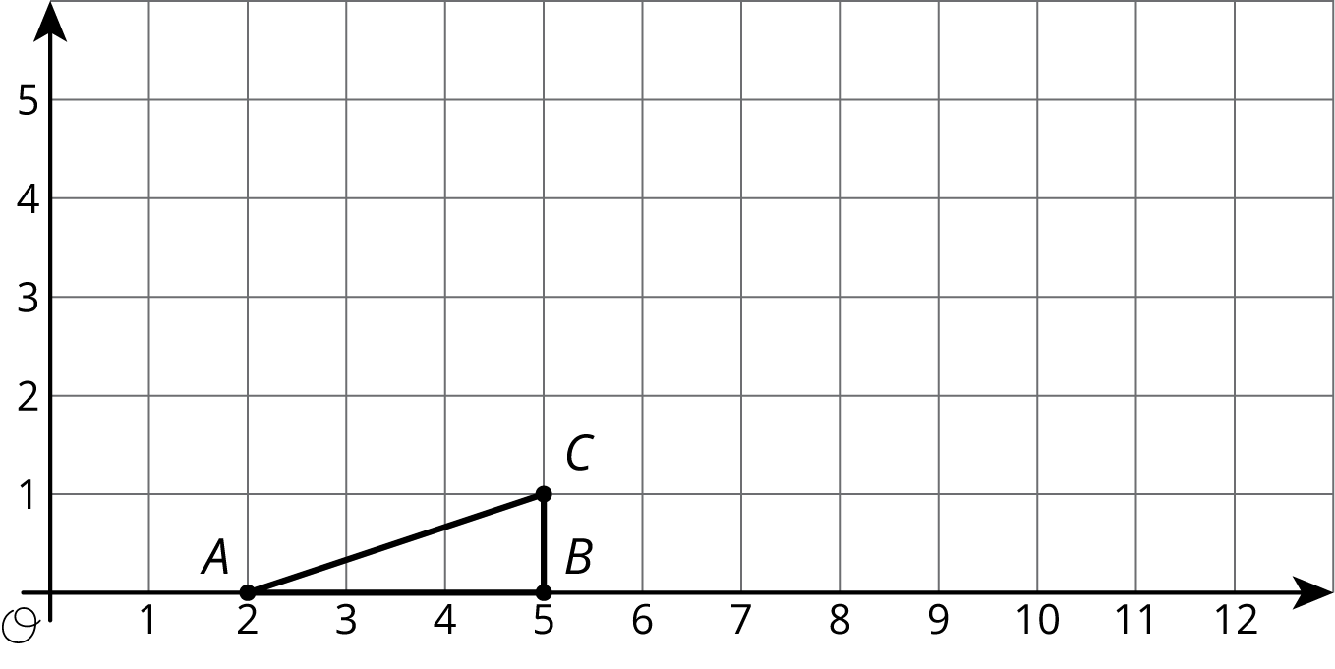
  - Draw the dilation of triangle $ABC$ with center $(2,0)$ and scale factor 2.
  - Draw the dilation of triangle $ABC$ with center $(2,0)$ and scale factor 3.
  - Draw the dilation of triangle $ABC$ with center $(2,0)$ and scale factor $\frac{1}{2}$.
  - What are the coordinates of the image of point $C$ when triangle $ABC$ is dilated with center $(2,0)$ and scale factor $s$?
  - Write an equation for the line containing all possible images of point $C$.
- Here are some line segments.
- 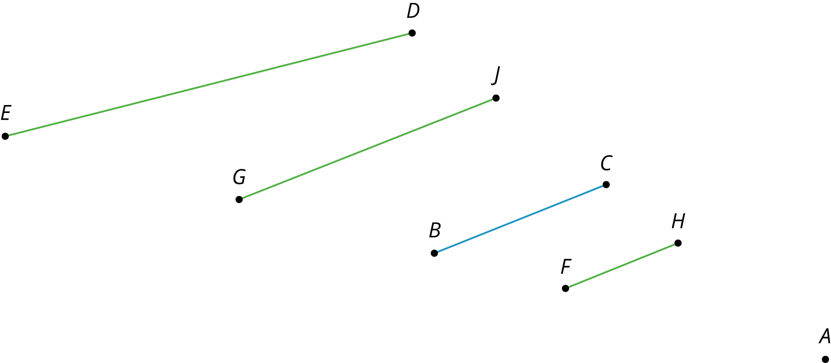
  - Which segment is a dilation of $\overline{BC}$ using $A$ as the center of dilation and a scale factor of $\frac{2}{3}$?
  - Which segment is a dilation of $\overline{BC}$ using $A$ as the center of dilation and a scale factor of $\frac{3}{2}$?
  - Which segment is not a dilation of $\overline{BC}$, and how do you know?
- (From Unit 2, Lesson 4.)
© CC BY Open Up Resources. Adaptations CC BY IM.

