Unit 3 Lesson 8: Translating to $y=mx+b$

1 Lines that Are Translations (Warm up)

Student Task Statement
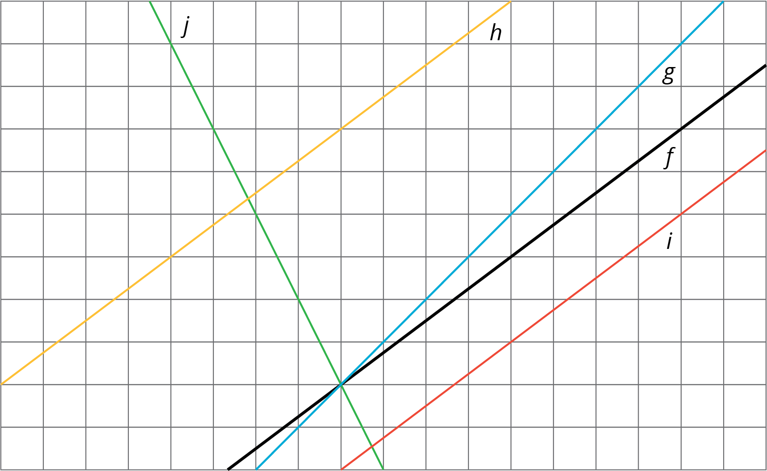
The diagram shows several lines. You can only see part of the lines, but they actually continue forever in both directions.
- Which lines are images of line $f$ under a translation?
- For each line that is a translation of $f$, draw an arrow on the grid that shows the vertical translation distance.

2 Increased Savings

Student Task Statement
- Diego earns $10 per hour babysitting. Assume that he has no money saved before he starts babysitting and plans to save all of his earnings. Graph how much money, $y$, he has after $x$ hours of babysitting.
- 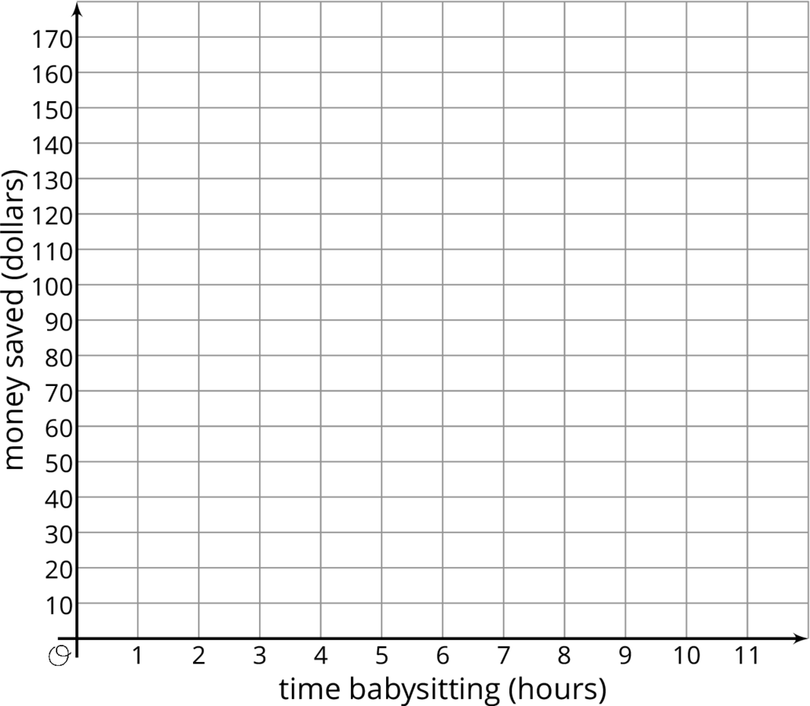
- Now imagine that Diego started with $30 saved before he starts babysitting. On the same set of axes, graph how much money, $y$, he would have after $x$ hours of babysitting.
- Compare the second line with the first line. How much more money does Diego have after 1 hour of babysitting? 2 hours? 5 hours? $x$ hours?
- Write an equation for each line.

3 Translating a Line

Student Task Statement
This graph shows two lines.
Line $a$ goes through the origin $(0,0)$.
Line $h$ is the image of line $a$ under a translation.
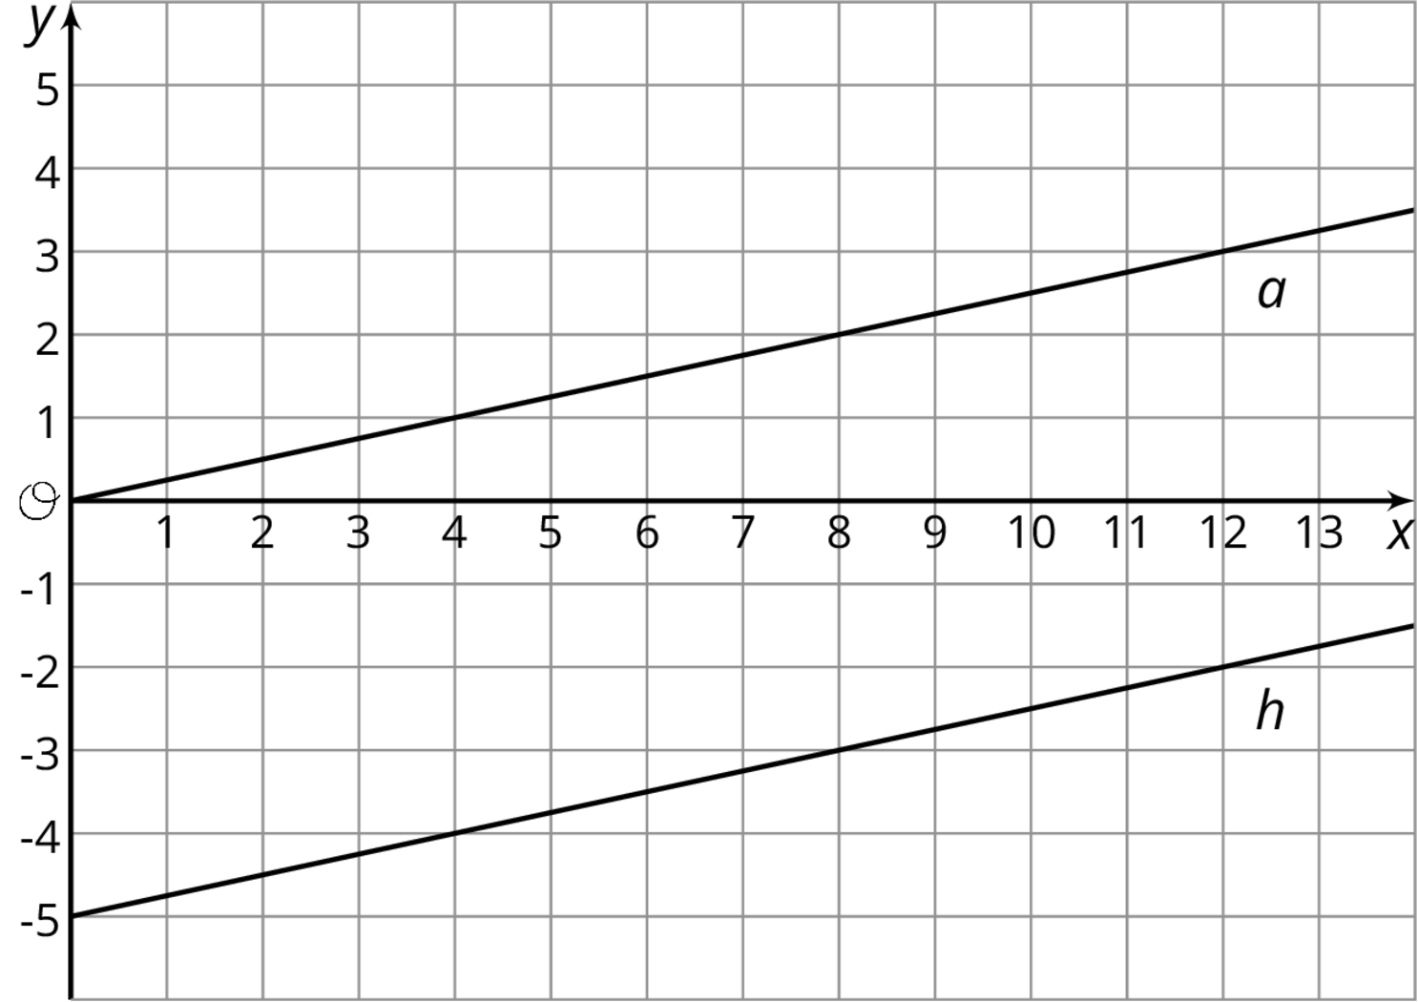
- Select all of the equations whose graph is line $h$.
  - $y=\frac{1}{4}x−5$
  - $y=\frac{1}{4}x+5$
  - $\frac{1}{4}x−5=y$
  - $y=\text{-}5+\frac{1}{4}x$
  - $\text{-}5+\frac{1}{4}x=y$
  - $y=5−\frac{1}{4}x$
- Your teacher will give you 12 cards. There are 4 pairs of lines, A–D, showing the graph, $a$, of a proportional relationship and the image, $h$, of $a$ under a translation. Match each line $h$ with an equation and either a table or description. For the line with no matching equation, write one on the blank card.
© CC BY Open Up Resources. Adaptations CC BY IM.

