Lesson 3: Add It, Explain It
- Let’s add numbers and write equations to show our work.

Warm-up: Number Talk: Add More Tens
Find the value of each expression mentally.
- $13+21$
- $13+31$
- $23+31$
- $33+41$

3.1: Lin and Han Add
Lin and Han are both finding the value of $32+54$.
Look at how each student started.
What should they do next to find the value?
Write equations to represent your thinking.
Be ready to explain your thinking in a way that others will understand.
- Lin started by putting 3 tens and 5 tens together.
She recorded her first step like this: $30+50=80$.
- Han started with 54 and added 3 tens.
He recorded his first step like this: $54+30=84$.

3.2: I Heard You Say
Find the value of $23+74$ using Lin’s or Han’s method.
Write equations to represent your thinking.
$23+74$

Section Summary
Section Summary
We added numbers within 100. We learned different methods to add by thinking about tens and ones and record our thinking with equations.
$23+45$
Add on tens then ones:
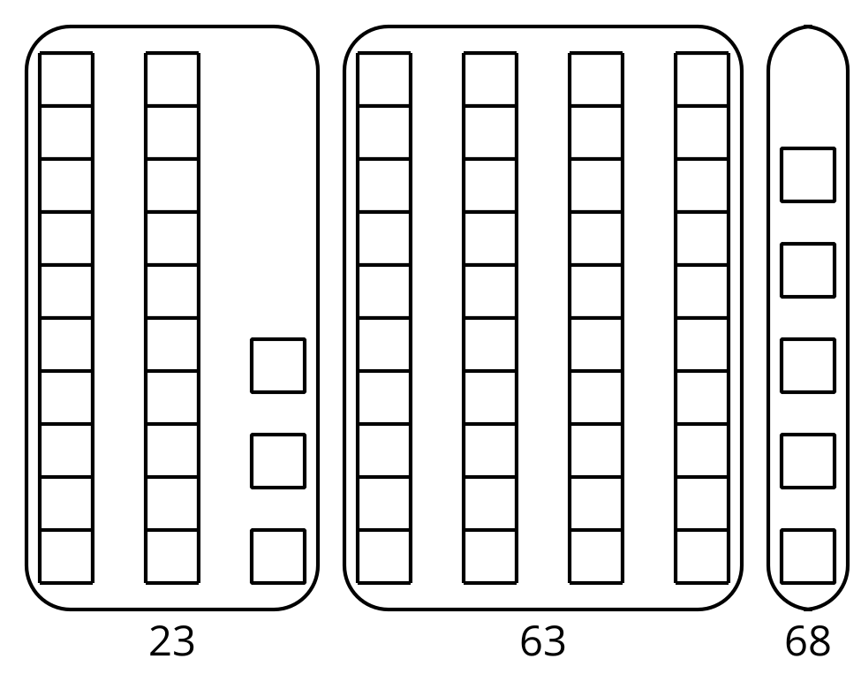
$23+40=63$
$63+5=68$
Add tens and tens and ones and ones:
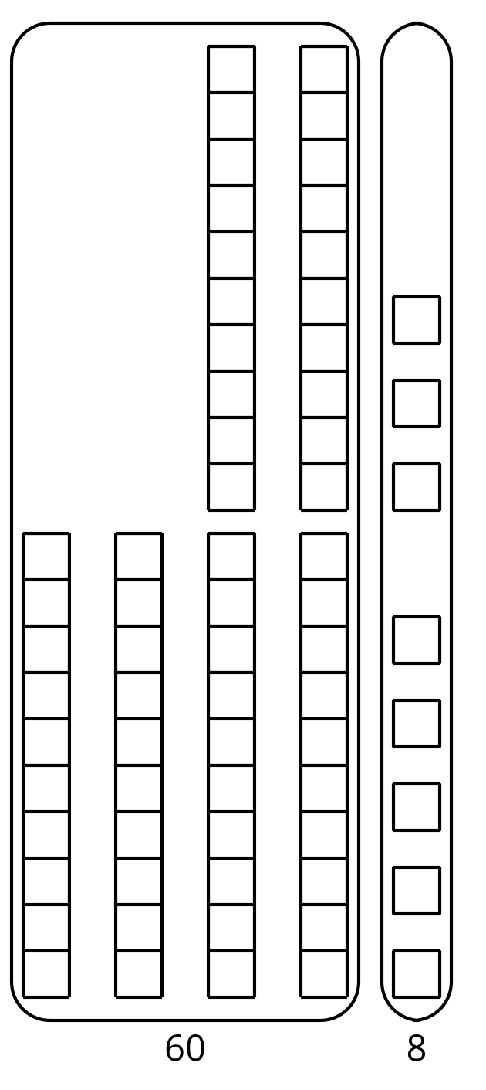
$20+40=60$
$3+5=8$
$60+8=68$
© CC BY 2021 Illustrative Mathematics®

