Unit 3 Lesson 12: Saree Silk Stories: Friendship Bracelets

WU True or False: Place Value Comparisons (Warm up)

Student Task Statement
Decide if each statement is true or false. Be prepared to explain your reasoning.
- $24=10+14$
- $15+12=27$
- $26=10+6+10$
- $58=20+20+8$

1 Share Ribbon with Friends

Student Task Statement
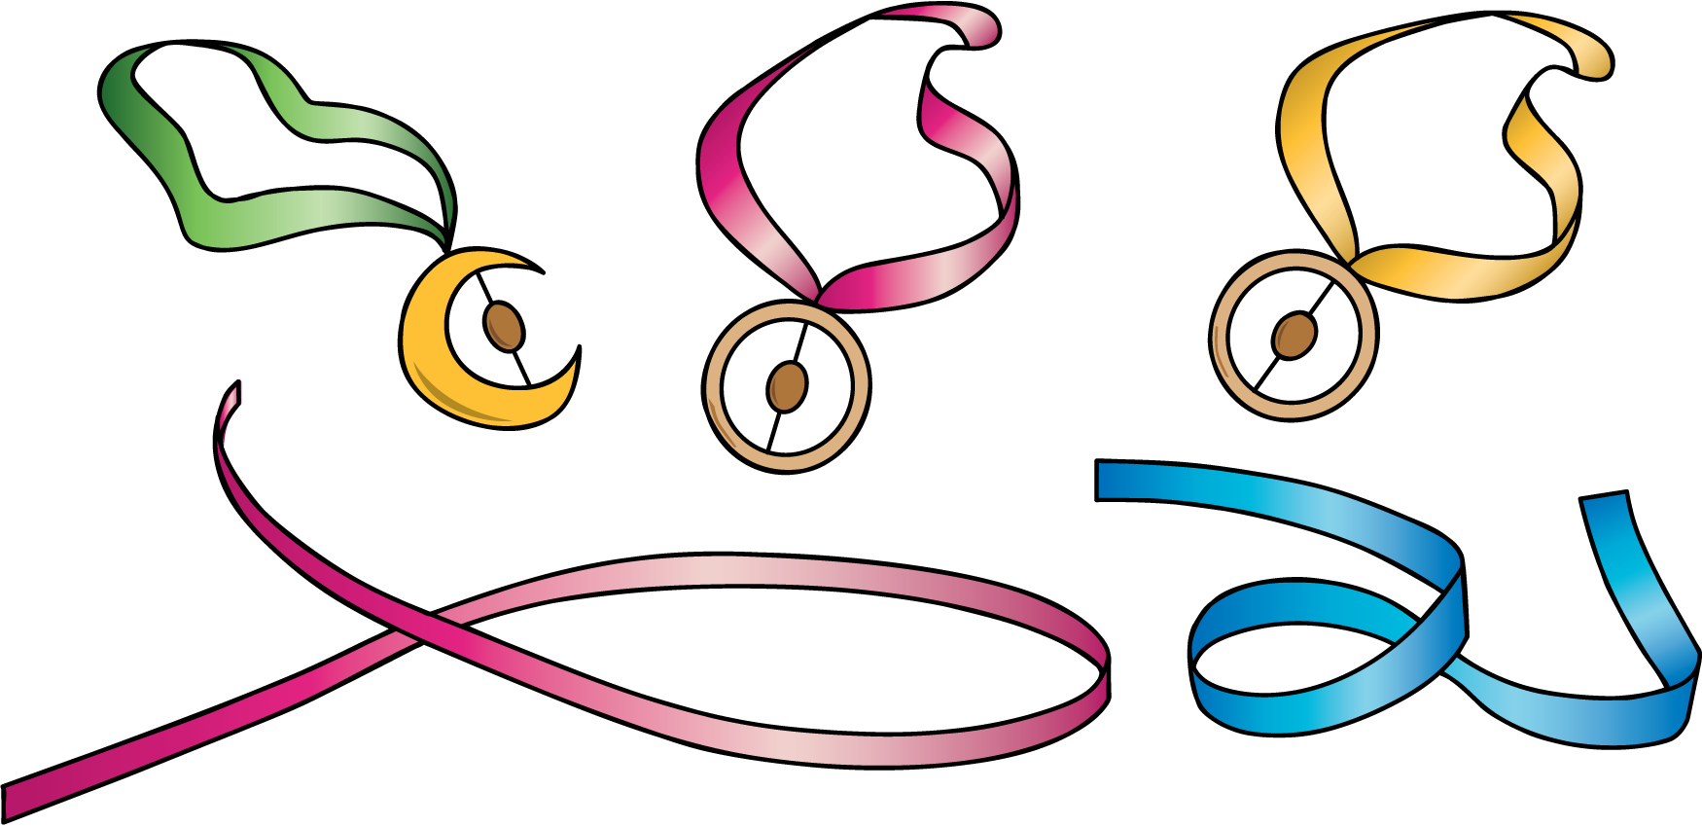
- Solve. Show your thinking. Use a diagram if it helps. Don’t forget the units.
  - Lin found a piece of ribbon that is 92 cm long. She cut a piece for Noah that is 35 cm. How much ribbon does Lin have left?
  - Then, Lin cut off 28 cm of ribbon for Jada. How much ribbon does Lin have left now?

2 Friendship Bracelets and Gifts

Student Task Statement
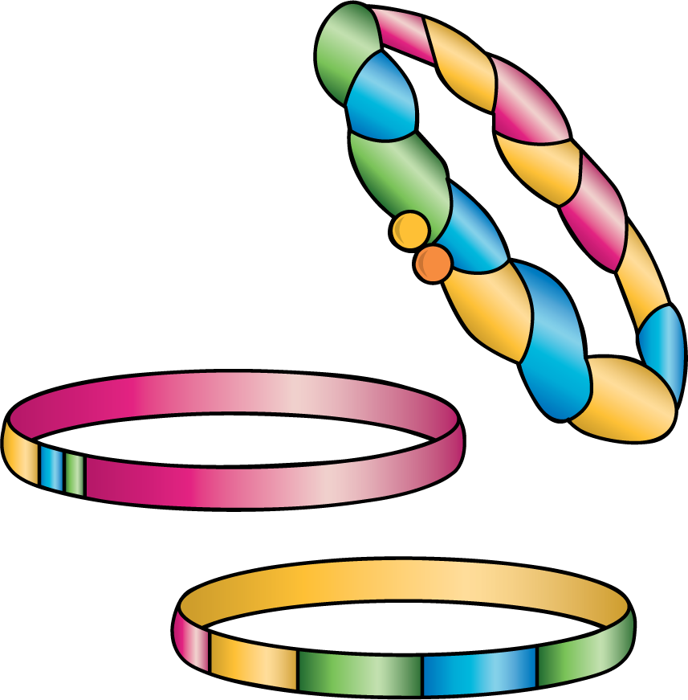
- Solve. Show your thinking. Don’t forget the units. Use a diagram if it helps.
  - Han has 82 inches of ribbon. He only needs 48 inches. How much should he cut off?
  - Han gives the ribbon he doesn’t need to Clare. Clare uses it to make her ribbon longer. Her ribbon was 27 inches. How long is Clare’s ribbon now?
- Solve. Show your thinking. Don’t forget the units. Use a diagram if it helps.
  - Andre’s ribbon is too short. He has 28 inches of ribbon, but he needs it to be 50 inches long. How much more ribbon does he need?
  - Andre got the ribbon he needed from Mai. Mai now has 49 inches of ribbon left. How much ribbon did Mai start with?
© CC BY 2021 Illustrative Mathematics®

