Lesson 7: What is an Array?
- Let’s learn about arrays.

Warm-up: Which One Doesn’t Belong: Counter Collections
Which one doesn’t belong?
A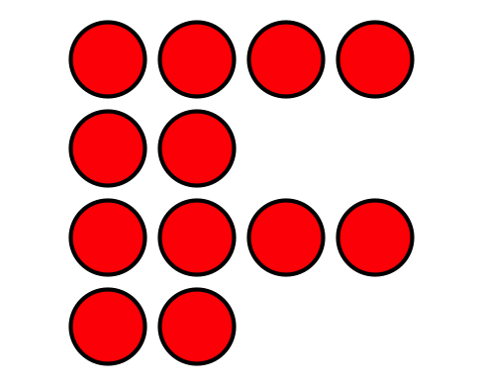
B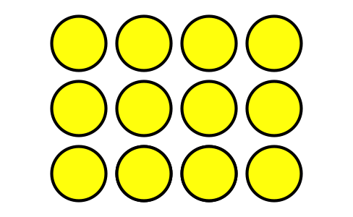
C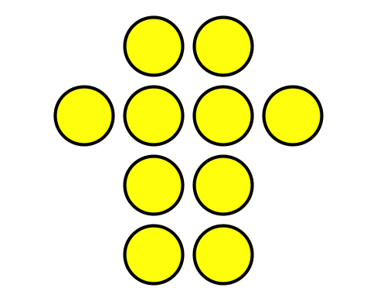
D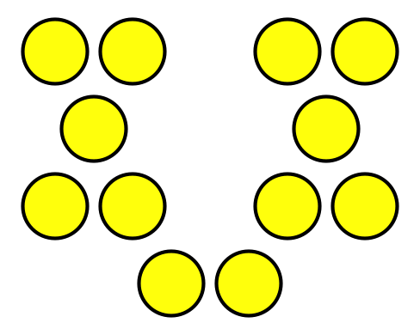

7.1: What is an Array?
Arrange each set of counters into equal rows with no extra counters.
- How many counters are there in all? _____
- Show how you arranged them using words, drawings, or numbers.
- How many counters are there in all? _____
- Show how you arranged them using words, drawings, or numbers.
- How many counters are there in all? _____
- Show how you arranged them using words, drawings, or numbers.

7.2: Rows of Counters

- 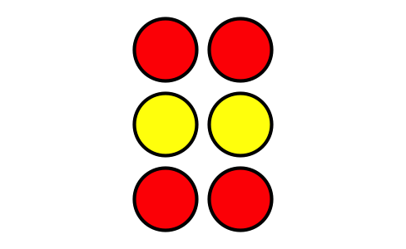
  - How many rows are in this array?
  - How many counters are in each row?
  - How many counters are there in all?

- 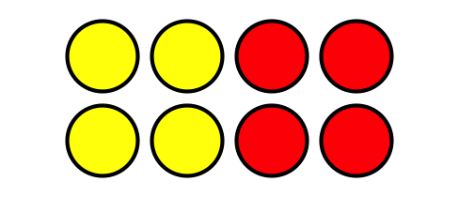
  - How many rows are in this array?
  - How many counters are in each row?
  - How many counters are there in all?
- Use 6 counters to make 2 rows with the same number in each row. How many counters are in each row?
- Use 20 counters to make 4 rows with the same number in each row. How many counters are in each row?
© CC BY 2021 Illustrative Mathematics®

