Unit 3 Lesson 11: Analyze Subtraction Algorithms

WU Number Talk: Subtract within 1,000 (Warm up)

Student Task Statement
Find the value of each expression mentally.
- $400−200$
- $450−200$
- $450−205$
- $450−215$

1 Compare Two Subtraction Algorithms

Student Task Statement
- The first steps of two algorithms are shown.
- Algorithm A, step 1
- 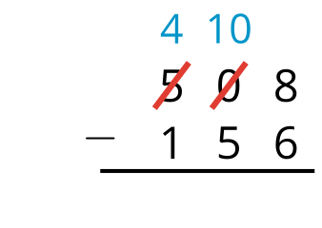
- Algorithm B, step 1
- 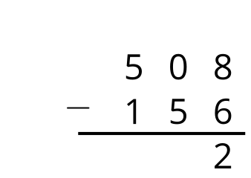
- How are the steps different?
- Use each algorithm to find the value of $824−541$.

2 Use an Algorithm?

Student Task Statement
Noah wanted to find the value of $301−167$ and wrote:
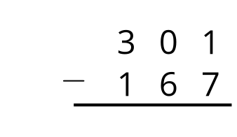
Elena said that we can’t subtract this way because we would need more ones to subtract 7 ones, but there’s a zero in the tens place of 301.
- Do you agree with Elena's statement? Explain your reasoning.
- Show how you would use an algorithm (either Noah's or another algorithm) to find the difference between 301 and 167.
© CC BY 2021 Illustrative Mathematics®

