Lesson 1: Make Sense of Data

Standards Alignments
Building On | 2.MD.D, 2.MD.D.10
Building Towards | 3.MD.B.3

Teacher-facing Learning Goals
- Interpret picture graphs and bar graphs to generate questions (orally and in writing) about the data.

Student-facing Learning Goals
- Let’s read and ask questions about data.

Lesson Purpose
The purpose of this lesson is to elicit students’ prior understandings of single-unit scale picture graphs and bar graphs in preparation for upcoming work with scaled bar graphs.
In grade 2, students learned how to draw and label single-unit scale bar graphs and picture graphs and used categorical data presented in graphs to solve simple problems. In this lesson, students revisit the structure of picture graphs and bar graphs, the features of graphs that help communicate information clearly, and the information they can learn by analyzing a graph. Students learn that a key is the part of a picture graph that tells what each picture represents. Students contextualize and make sense of the data based on the title, the given values, and their own experiences (MP2).
Math Community
Prepare a space, such as a piece of poster paper, titled “Math Community” and a T-chart with the headers “Doing Math” and “Norms.” Partition each of the columns into two sections: students and teacher. The two sections encourage the students and teachers to be mindful that both respective parties are responsible for the way math is being done in the classroom.
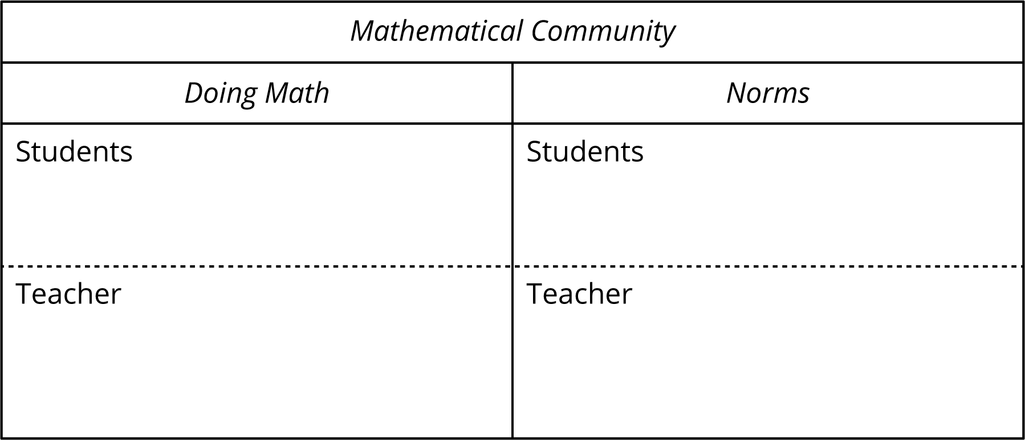

Access for:

Students with Disabilities
- Representation (Activity 1)

English Learners
- MLR8 (Activity 2)

Instructional Routines
Notice and Wonder (Warm-up)

Lesson Timeline
Warm-up | 15 min
Activity 1 | 10 min
Activity 2 | 20 min
Lesson Synthesis | 10 min
Cool-down | 5 min

Teacher Reflection Question
Today’s lesson provided an opportunity to learn from your students. How were you able to incorporate your students’ lived experience into the lesson?

Cool-down
(to be completed at the end of the lesson) 5min
Describe and Ask

Standards Alignments
Building On | 2.MD.D
Building Towards | 3.MD.B.3

Student-facing Task Statement
A group of students were asked, “How do you get home from school each day?”
Their responses are shown in this bar graph:
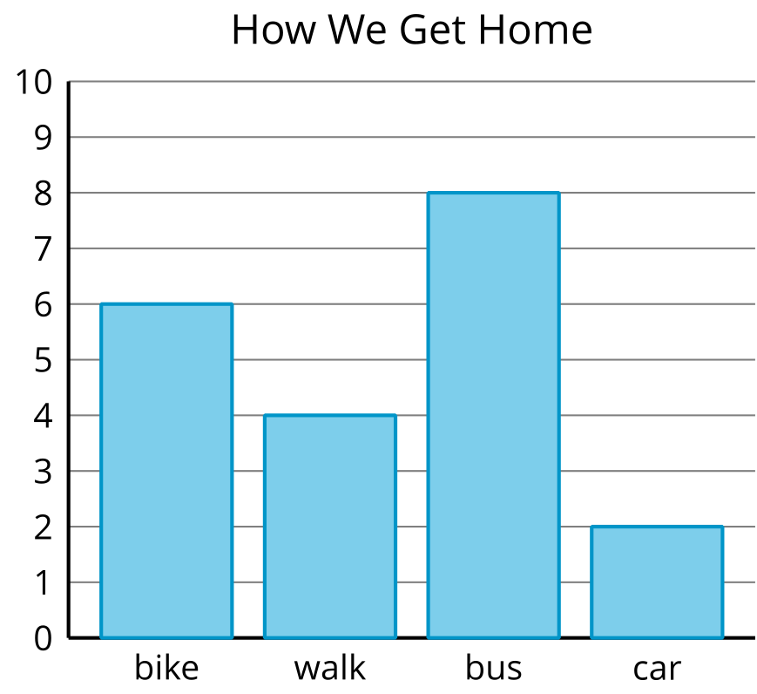
Based on the data shown on the graph:
- Write one fact you learned about how the students get home.
- Write one question you could ask about how the students get home from school.

Student Responses
Sample responses:
- More students take the bus home than ride bikes. Eight students take the bus home. Two students ride in a car.
- How many more students take the bus than walk home? How many students ride their bikes home?

