Lesson 5: Calculating Measures of Center and Variability
- Let’s calculate measures of center and measures of variability and know which are most appropriate for the data.

5.1: Calculating Centers
Decide if each situation is true or false. Explain your reasoning.
- The mean can be found by adding all the numbers in a data set and dividing by the number of numbers in the data set.
- The mean of the data in the dot plot is 4.
- 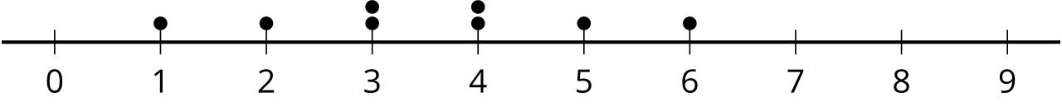
- The median of the data set is 9 for the data: 4, 5, 9, 1, 10.
- The median of the data in the dot plot is 3.5.
- 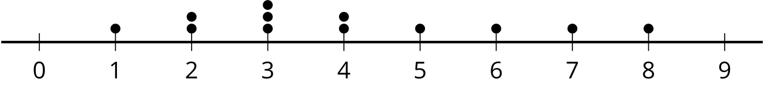

5.2: Heartbeats: Part 1
The heart rates of eight high school students are listed in beats per minute:
72 | 75 | 81 | 76 | 76 | 77 | 79 | 78

- What is the interquartile range?
- How many values in the data set are:
  - less than Q1?
  - between Q1 and the median?
  - between the median and Q3?
  - greater than Q3?
- A pod of dolphins contains 800 dolphins of various ages and lengths. The median length of dolphins in this pod is 5.8 feet. What information does this tell you about the length of dolphins in this pod?
- The same vocabulary test with 50 questions is given to 600 students from fifth to tenth grades and the number of correct responses is collected for each student in this group. The interquartile range is 40 correct responses. What information does this tell you about the number of correct responses for students taking this test?

5.3: Heartbeats: Part 2
- Calculate the MAD using the same data from the previous activity by finding the average distance from each data value to the mean. You may find it helpful to organize your work by completing the table provided.
- data values | - mean | - deviation from mean  (data value - mean) | - absolute deviation |deviation|
- 72
- 75
- 81
- 76
- 76
- 77
- 79
- 78
- MAD:
- For another data set, all of the values are either 3 beats per minute above the mean or 3 beats per minute below the mean. Is that enough information to find the MAD for this data set? If so, find the MAD. If not, what other information is needed? Explain your reasoning.
- Several pennies are placed along a meter stick and the position in centimeters of each penny is recorded. The mean position is the 50 centimeter mark and the MAD is 10 centimeters. What information does this tell you about the position of the pennies along the meter stick?

Are you ready for more?
Suppose there are 6 pennies on a meter stick so that the mean position is the 50 centimeter mark and the MAD is 10 centimeters.
- Find possible locations for the 6 pennies.
- Find a different set of possible locations for the 6 pennies.

Lesson 5 Summary
The mean absolute deviation, or MAD, and the interquartile range, or IQR, are measures of variability. Measures of variability tell you how much the values in a data set tend to differ from one another. A greater measure of variability means that the data is more spread out while a smaller measure of variability means that the data is more consistent and close to the measure of center.
To calculate the MAD of a data set:
- Find the mean of the values in the data set.
- Find the distance between each data value and the mean on the number line:
- |data value – mean|
- Find the mean of the distances. This value is the MAD.
To calculate the IQR, subtract the value of the first quartile from the value of the third quartile. Recall that the first and third quartile are included in the five number summary.
© CC BY 2019 by Illustrative Mathematics®

