Unit 4 Lesson 6: Working with Trigonometric Ratios

1 This Time with Strategies (Warm up)

Student Task Statement
Estimate the value of $z$.
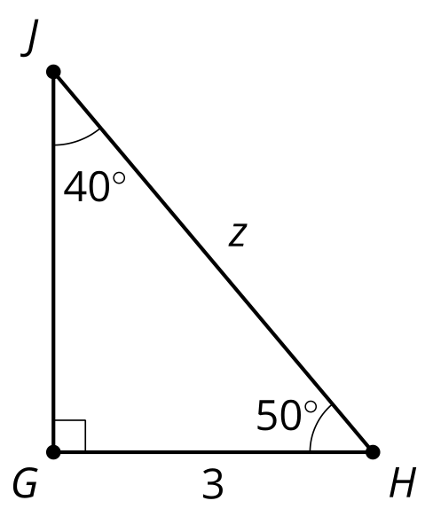

2 New Names, Same Ratios

Student Task Statement
- Use your calculator to determine the values of $cos\left(50\right)$, $sin\left(50\right)$, and $tan\left(50\right)$.
- Use your calculator to determine the values of $cos\left(40\right)$, $sin\left(40\right)$, and $tan\left(40\right)$.
- How do these values compare to your chart?
- Find the value of $z$.

Activity Synthesis

$cos\left(θ\right)=\frac{\text{adjacent}}{\text{hypotenuse}}$
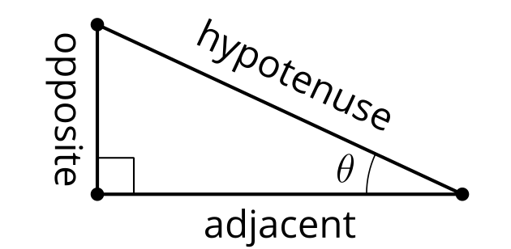

$sin\left(θ\right)=\frac{\text{opposite}}{\text{hypotenuse}}$

$tan\left(θ\right)=\frac{\text{opposite}}{\text{adjacent}}$

3 Solve These Triangles

Student Task Statement
- Solve for $x$.
- 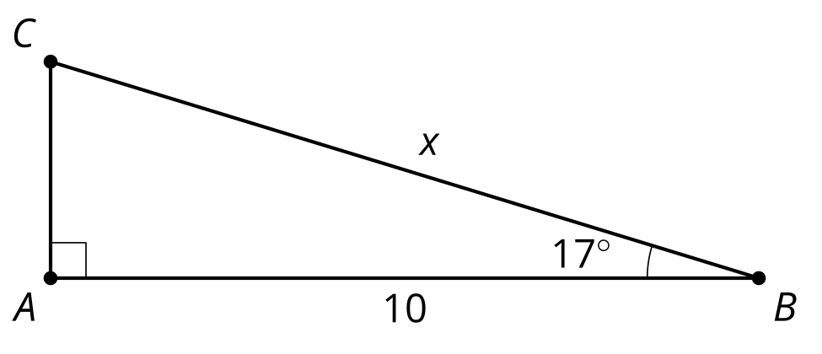
- Solve for $y$.
- 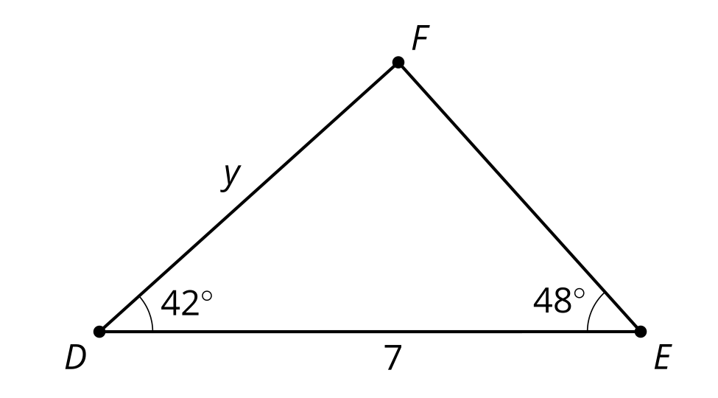
- Find all the missing sides and angle measures.
  - The measure of angle $X$ is 90 degrees and angle $Y$ is 12 degrees. Side $XZ$ has length 2 cm.
  - The measure of angle $K$ is 90 degrees and angle $L$ is 71 degrees. Side $LM$ has length 20 cm.

Images for Activity Synthesis
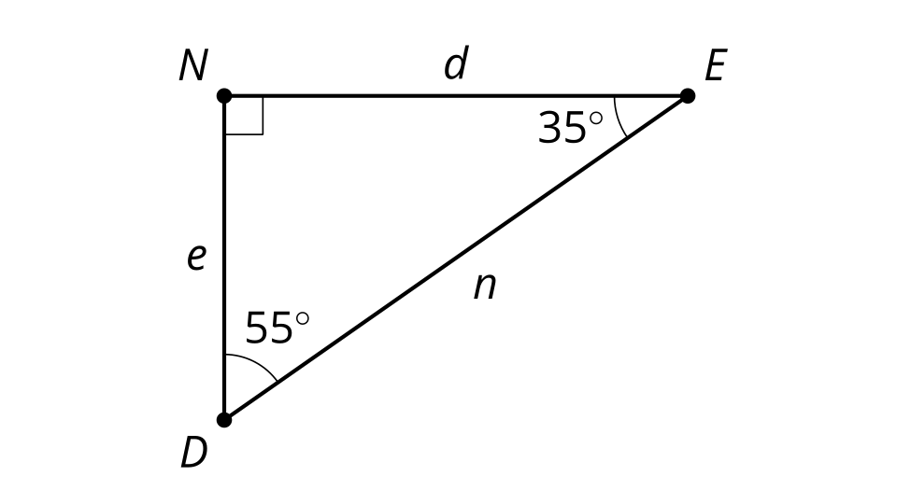
© CC BY 2019 by Illustrative Mathematics®

